1. Introduction

To provide a small Ebay Marketplace that allows user to sell, auction, buy and bid items. The system is high performance with Mongo Nosql data base connection pool and RabbitMQ.

(continue next page)

1. System design
2. Architecture

Client browser

Client browser

REST API

REST API

EbayMarket

User_info_queue

All_items_queue

Cart_queue

Bid_queue

Item_info_queue

User_sale_queue

EbayItemsServer

EbayUserServer

EbaySaleServer

Connection pool

Connection pool

Connection pool

MongoDB

1. Description

* The server system includes one single EbayMarket client and three servers EbayItemsServer, EbaySaleServer, and EbayUserServer.
* **EbayMarket** takes all the requests from users and forward them to the corresponding servers through the RabbitMQs. After receiving the responses from the servers, it sends theresponse back to users.
* **EbayItemsServer** handles tasks like getting list of all products, viewing products information. These tasks are requested very frequently by the users, so they should be handled in a single server.

|  |  |
| --- | --- |
| Queue | Requests |
| All_items_queue | Get list of all products |
| Item_info_queue | Get detail of an auction or “buy it now” product |

* **EbaySaleServer** handles all sale transactions like cart, order, bidding.

|  |  |
| --- | --- |
| Queue | Requests |
| cart_queue | *Add To Cart, get Cart, update Cart, remove Cart Item, Check out*, confirm check out |
| bid_queue | place bid, *get Bid History* |

* **EbayUserServer** handles all requests like signup, profile, viewing sale history, register sale products for a user.

|  |  |
| --- | --- |
| Queue | Requests |
| User_info_queue | *Sing up, update profile* |
| User_sale_queue | *Get all auctions, get all biddings, get all sellings, get sold, get bought* |

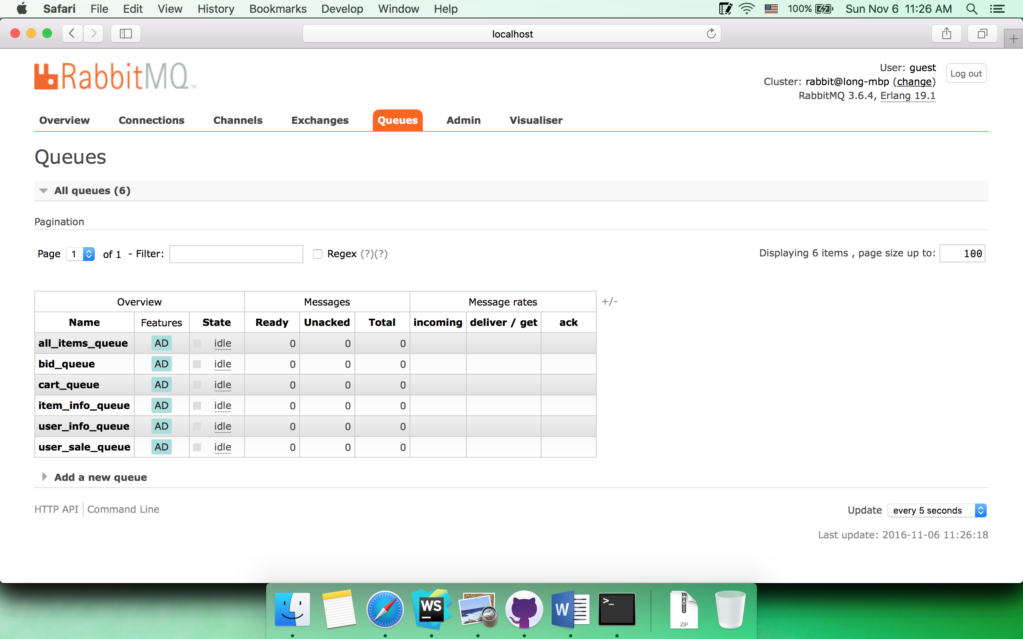

1. Screenshots (**for the client/server running, please look at the printed console log**)
   1. Sign up

Browser

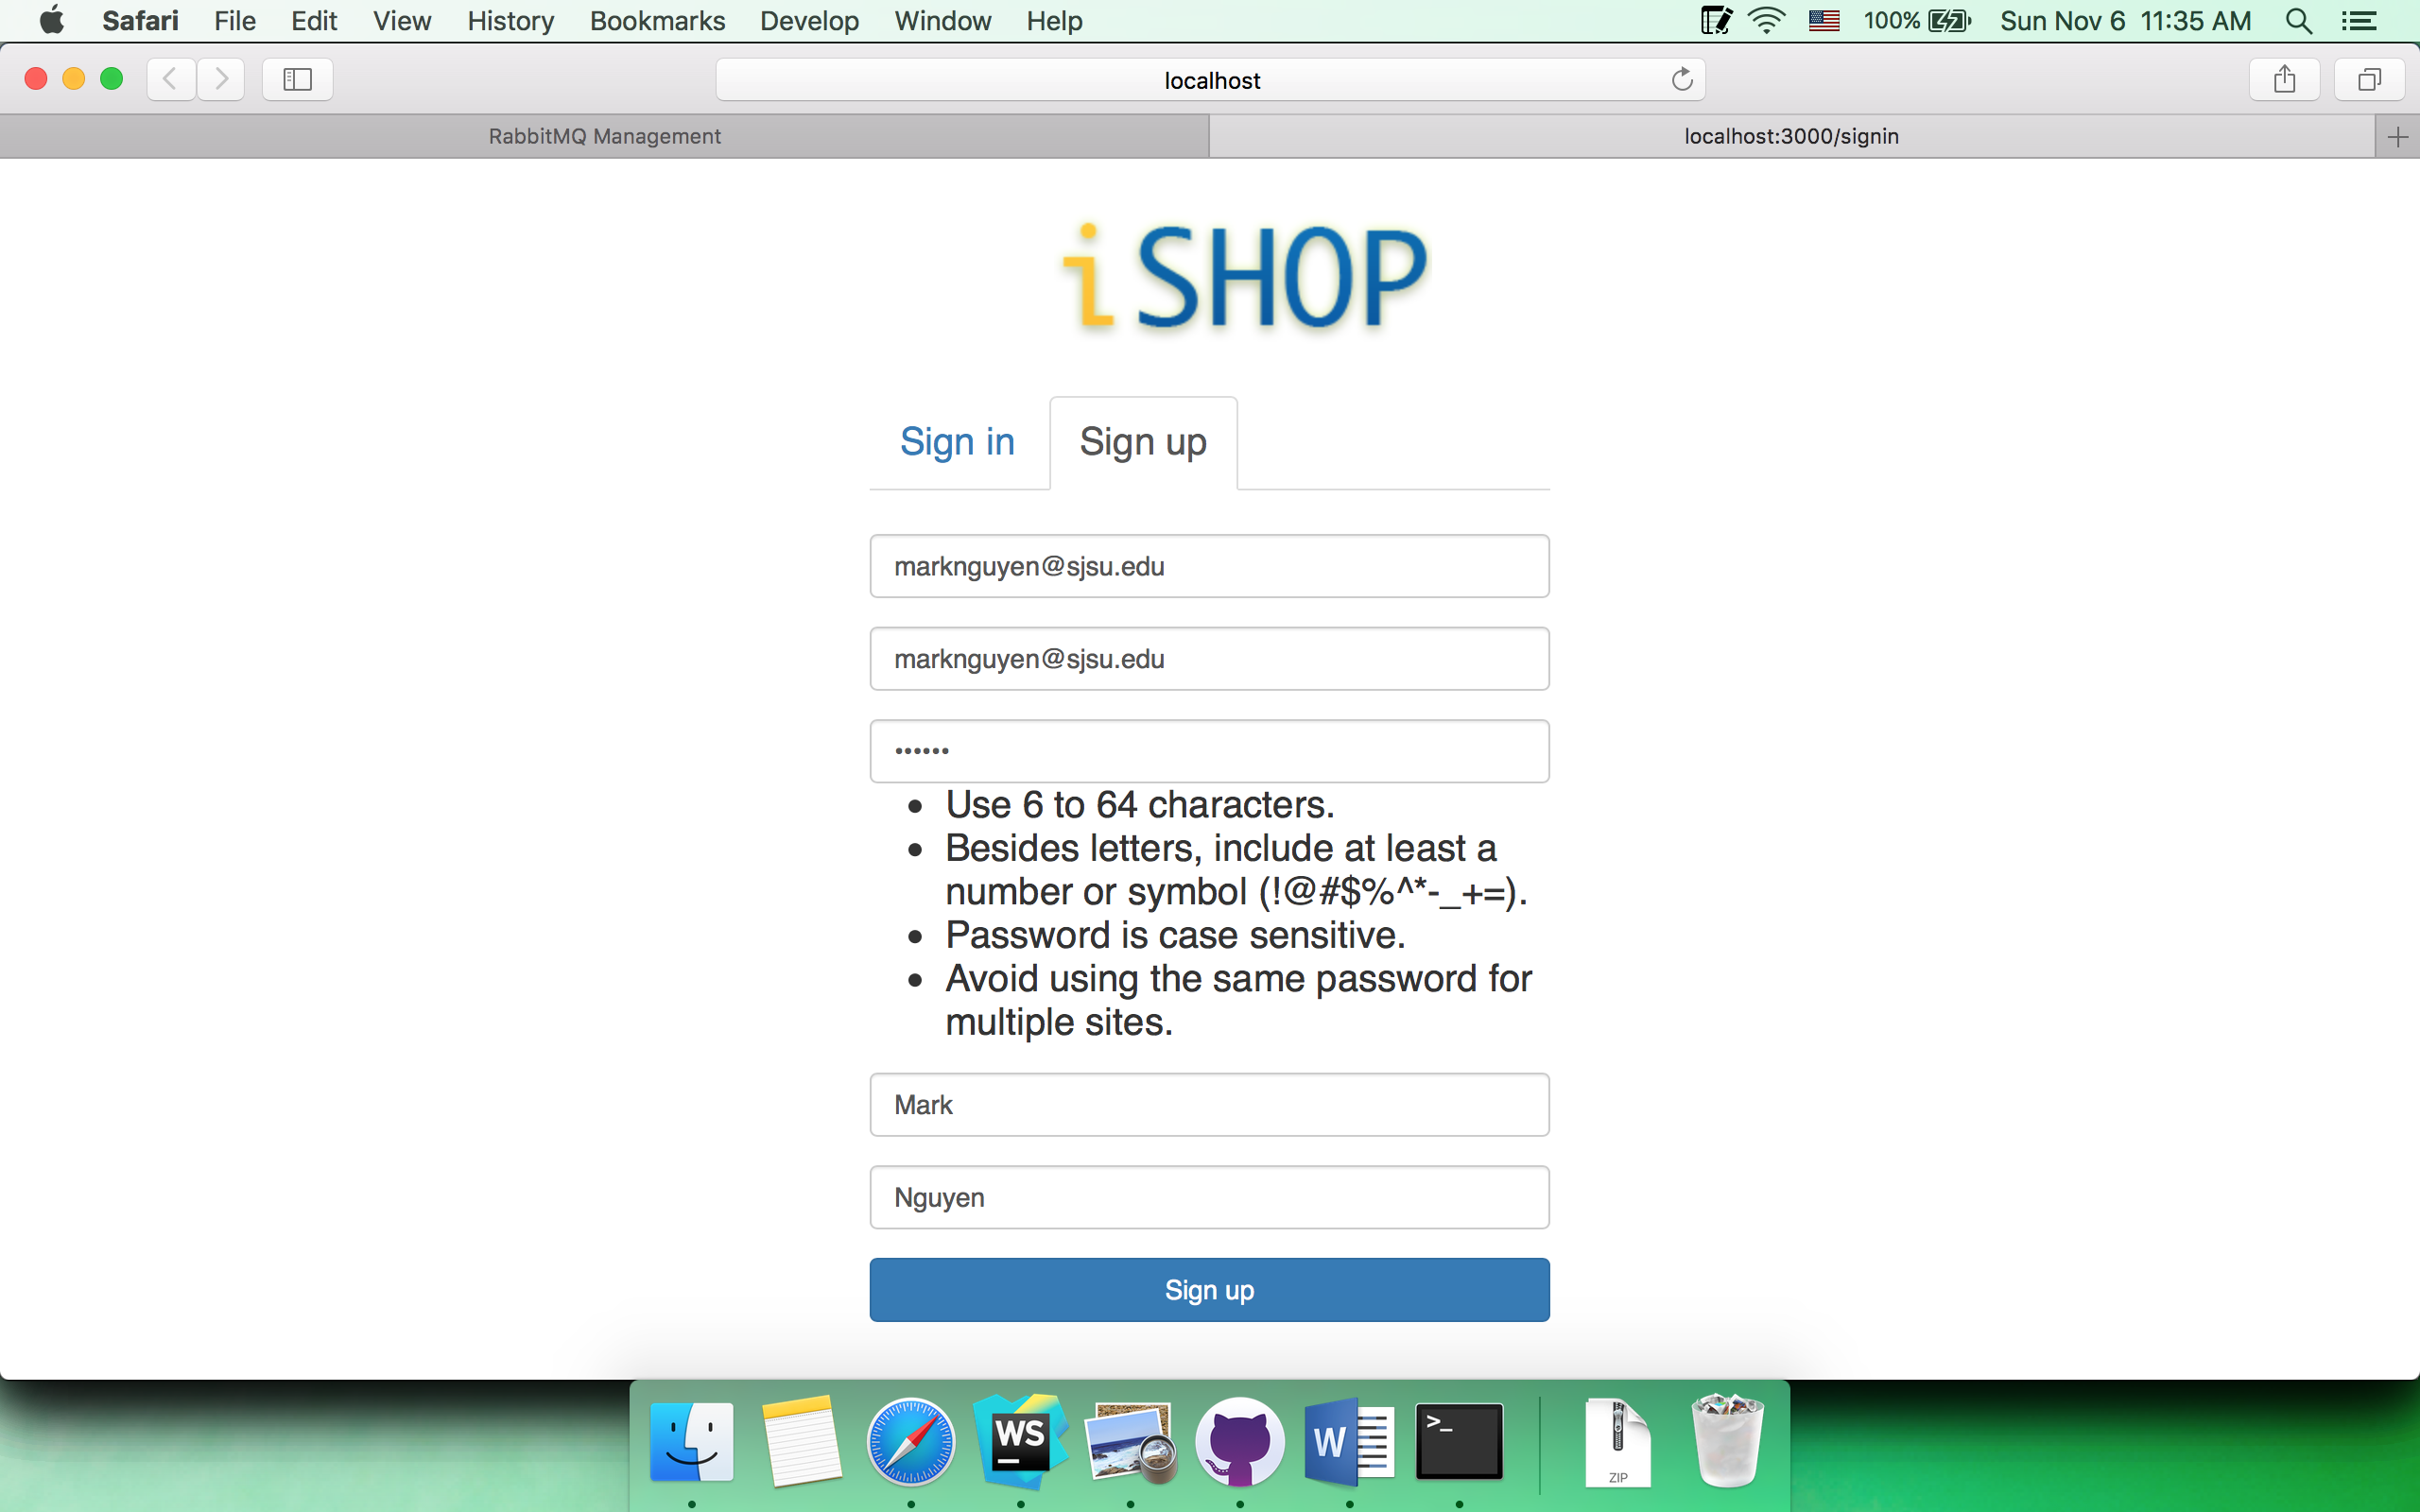

Queue

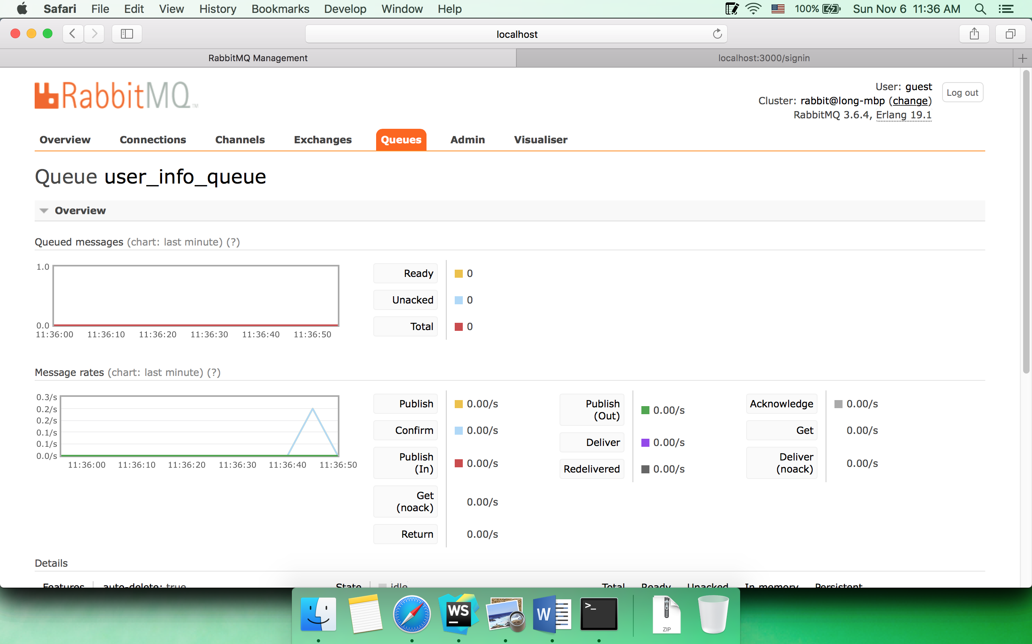

Client

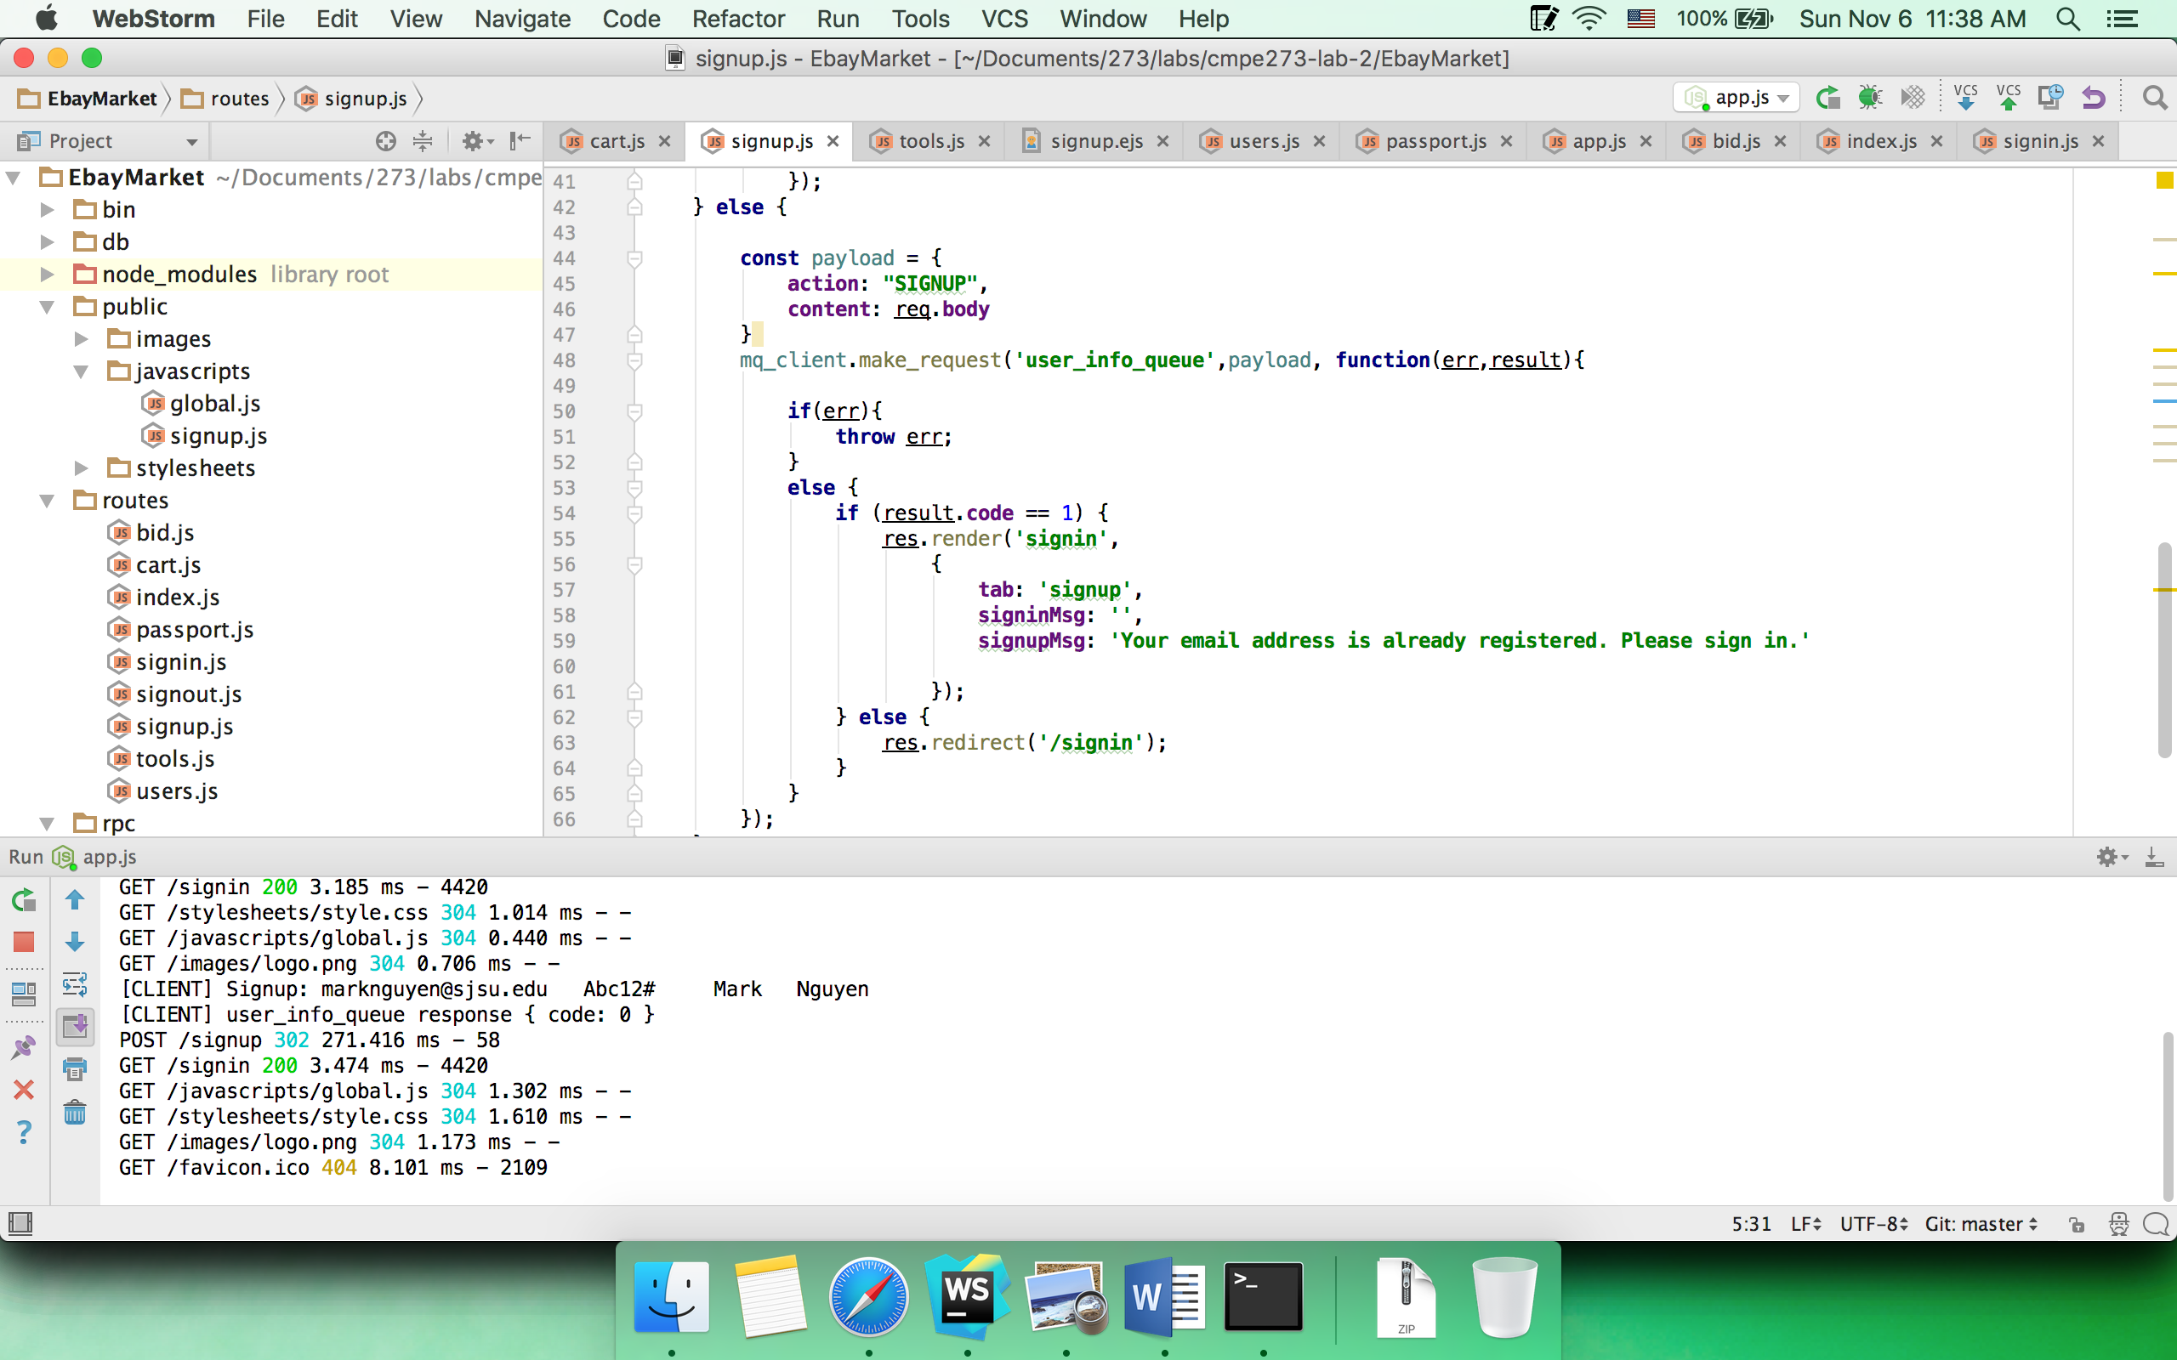

Server

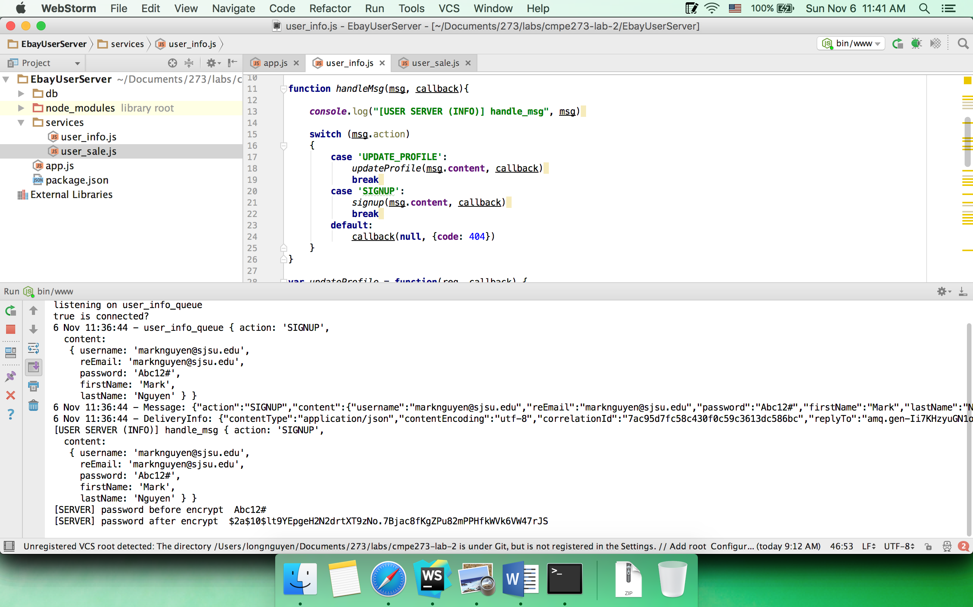

Encrypted password in MongoDB

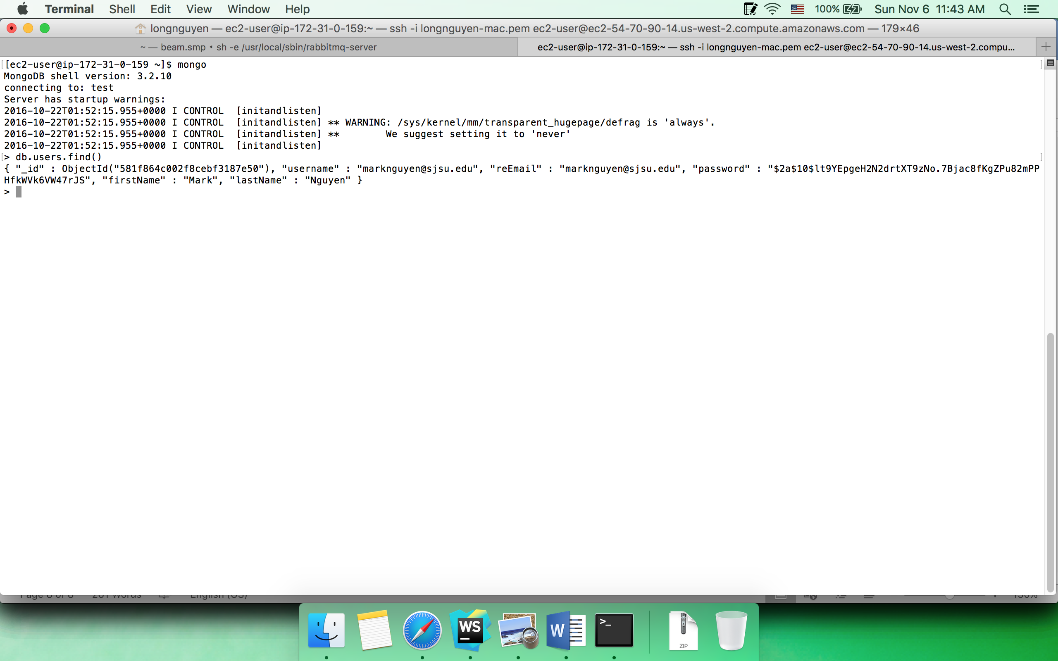

Signup with existing email

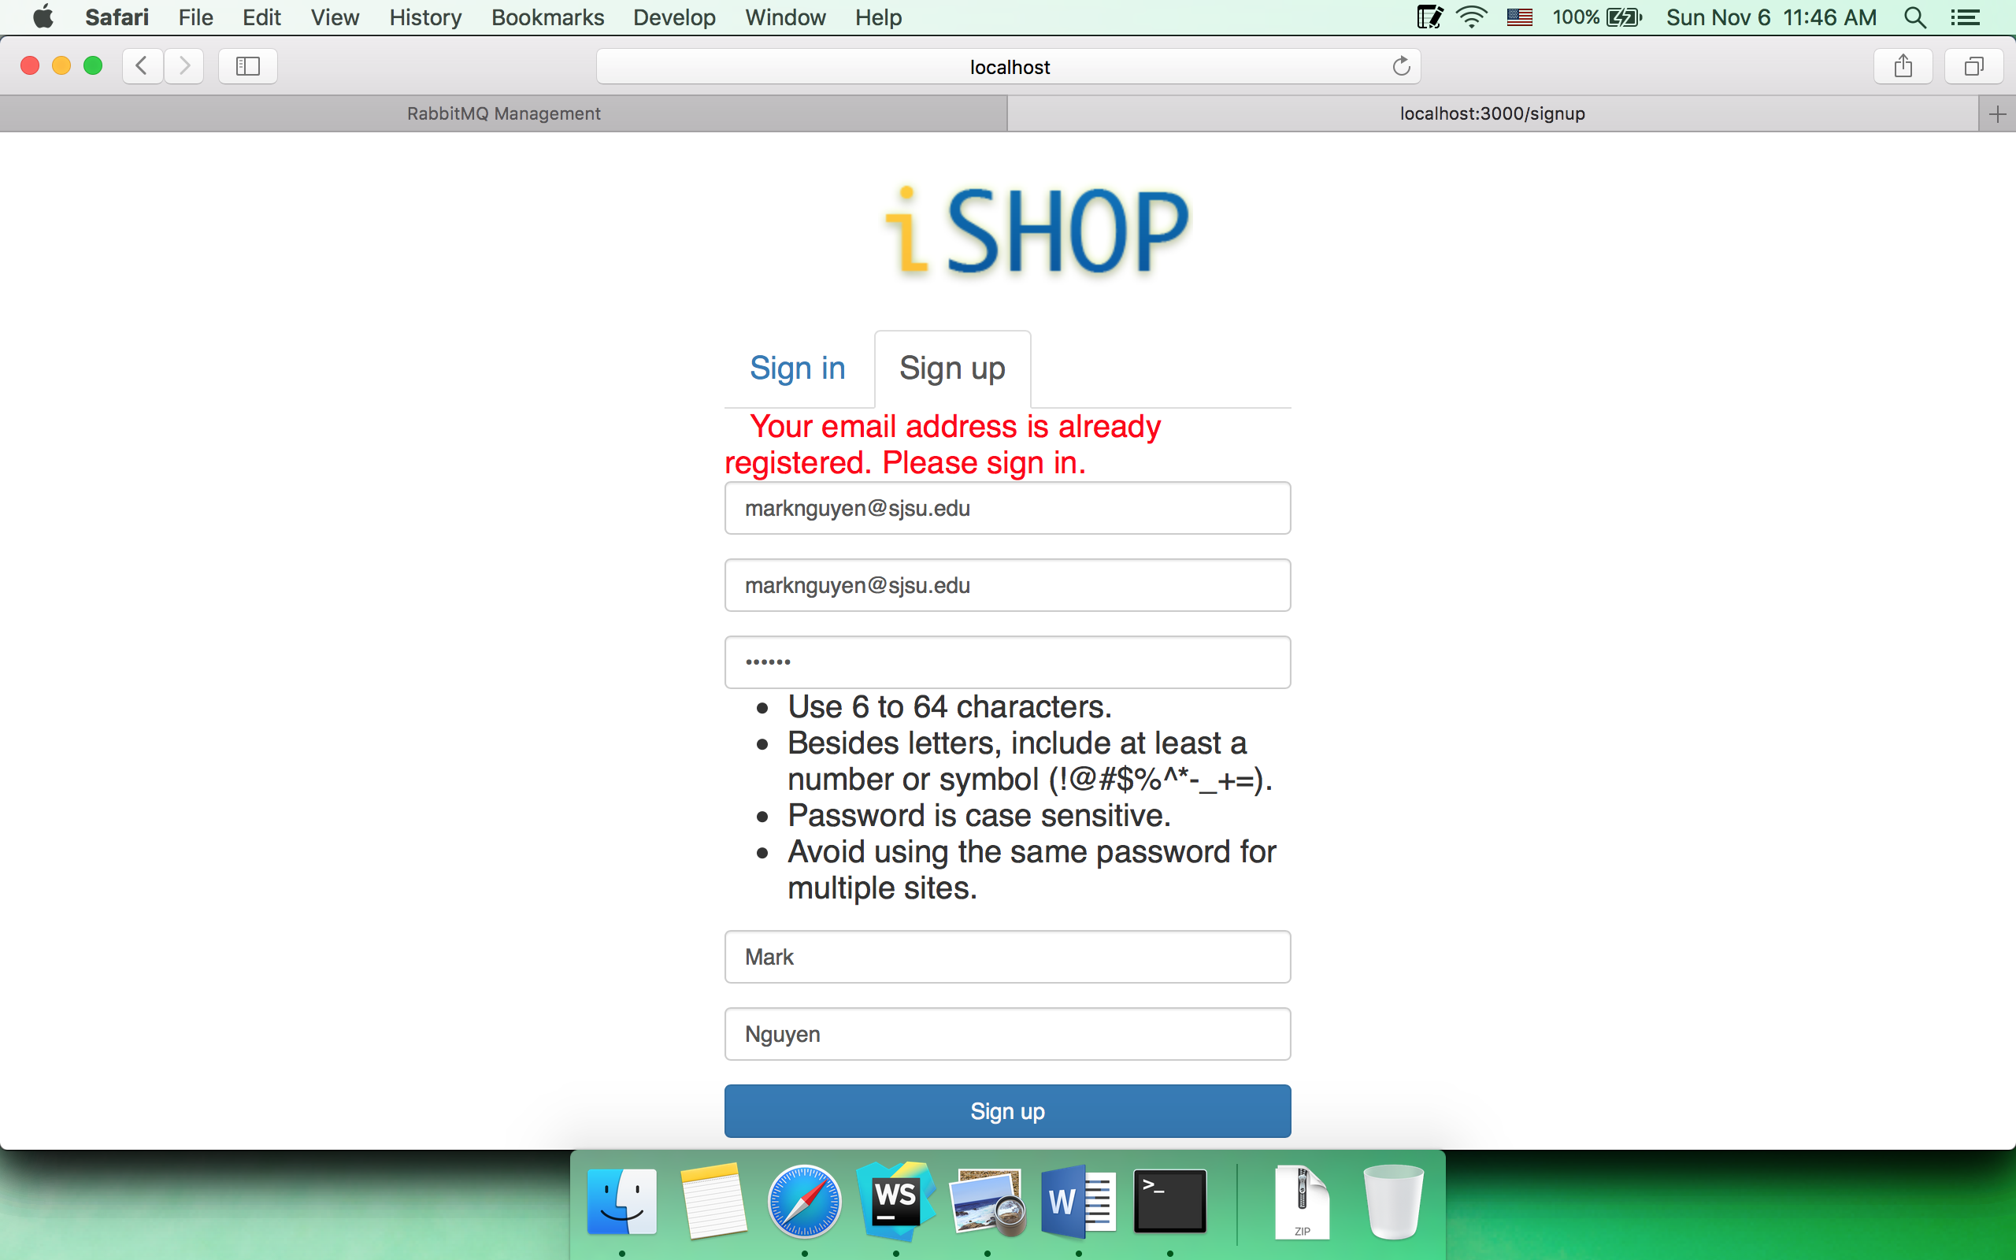

* 1. Sign in

Browser

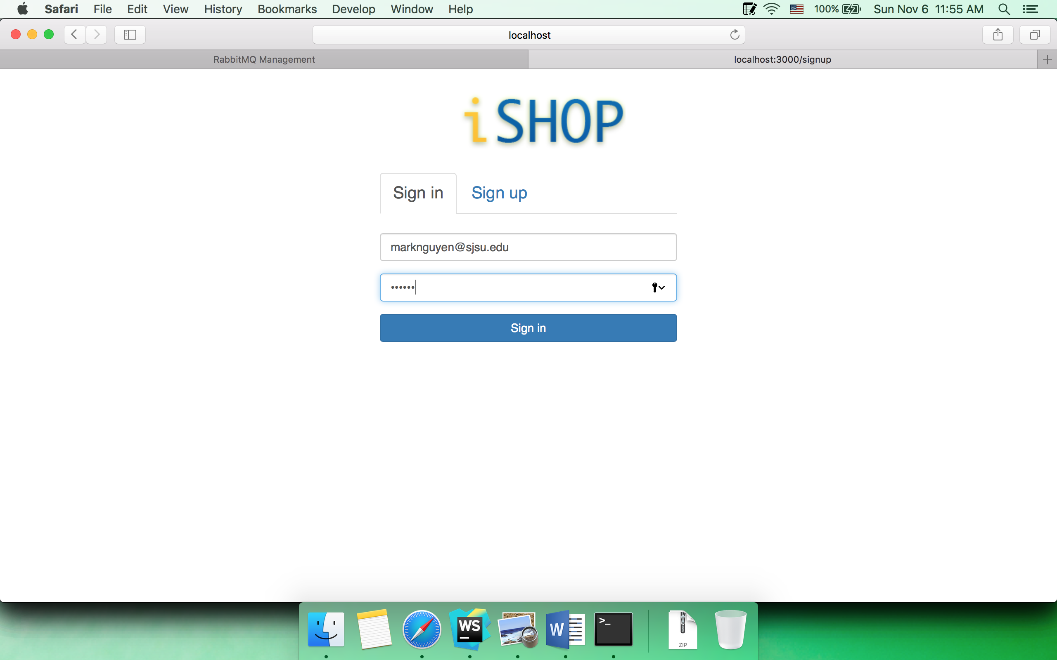

passport handling in client

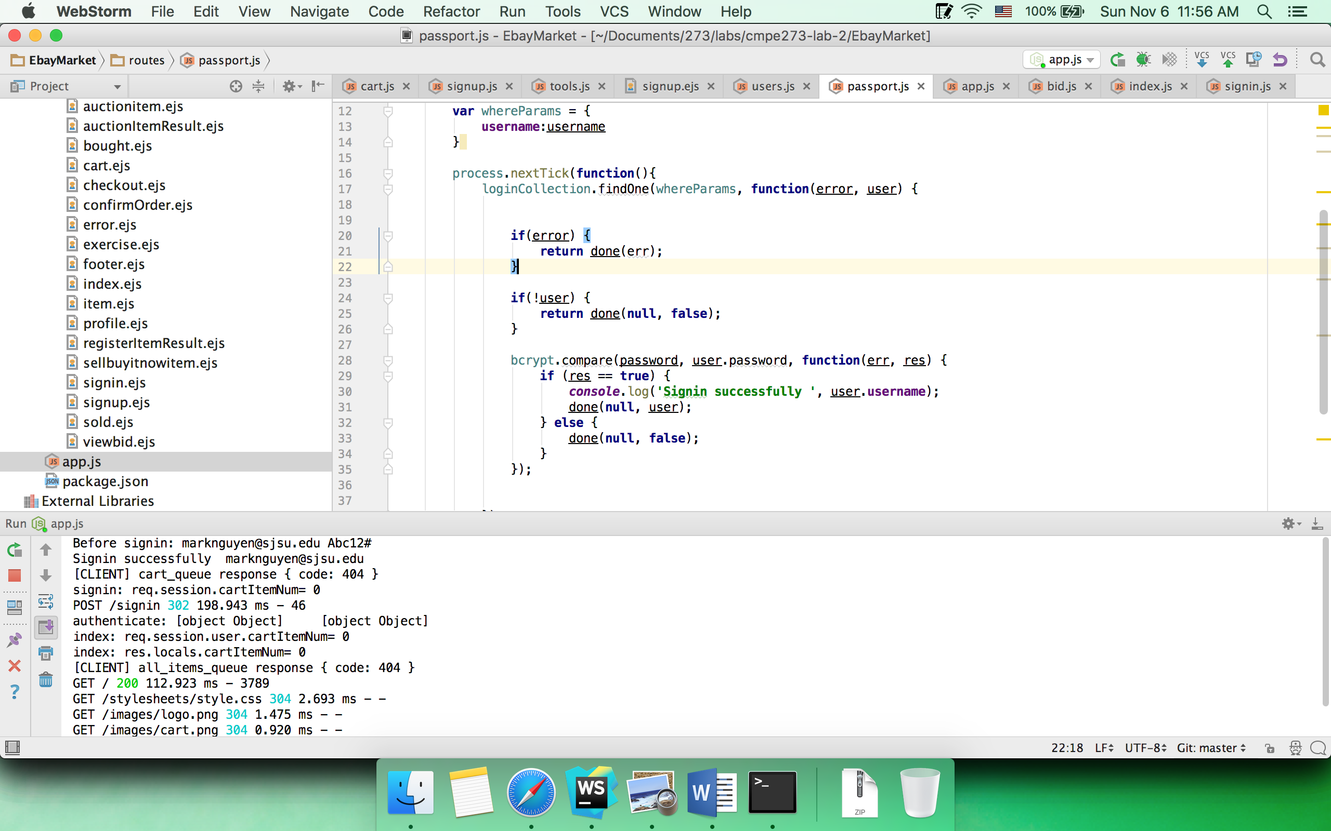

Sign in with wrong password

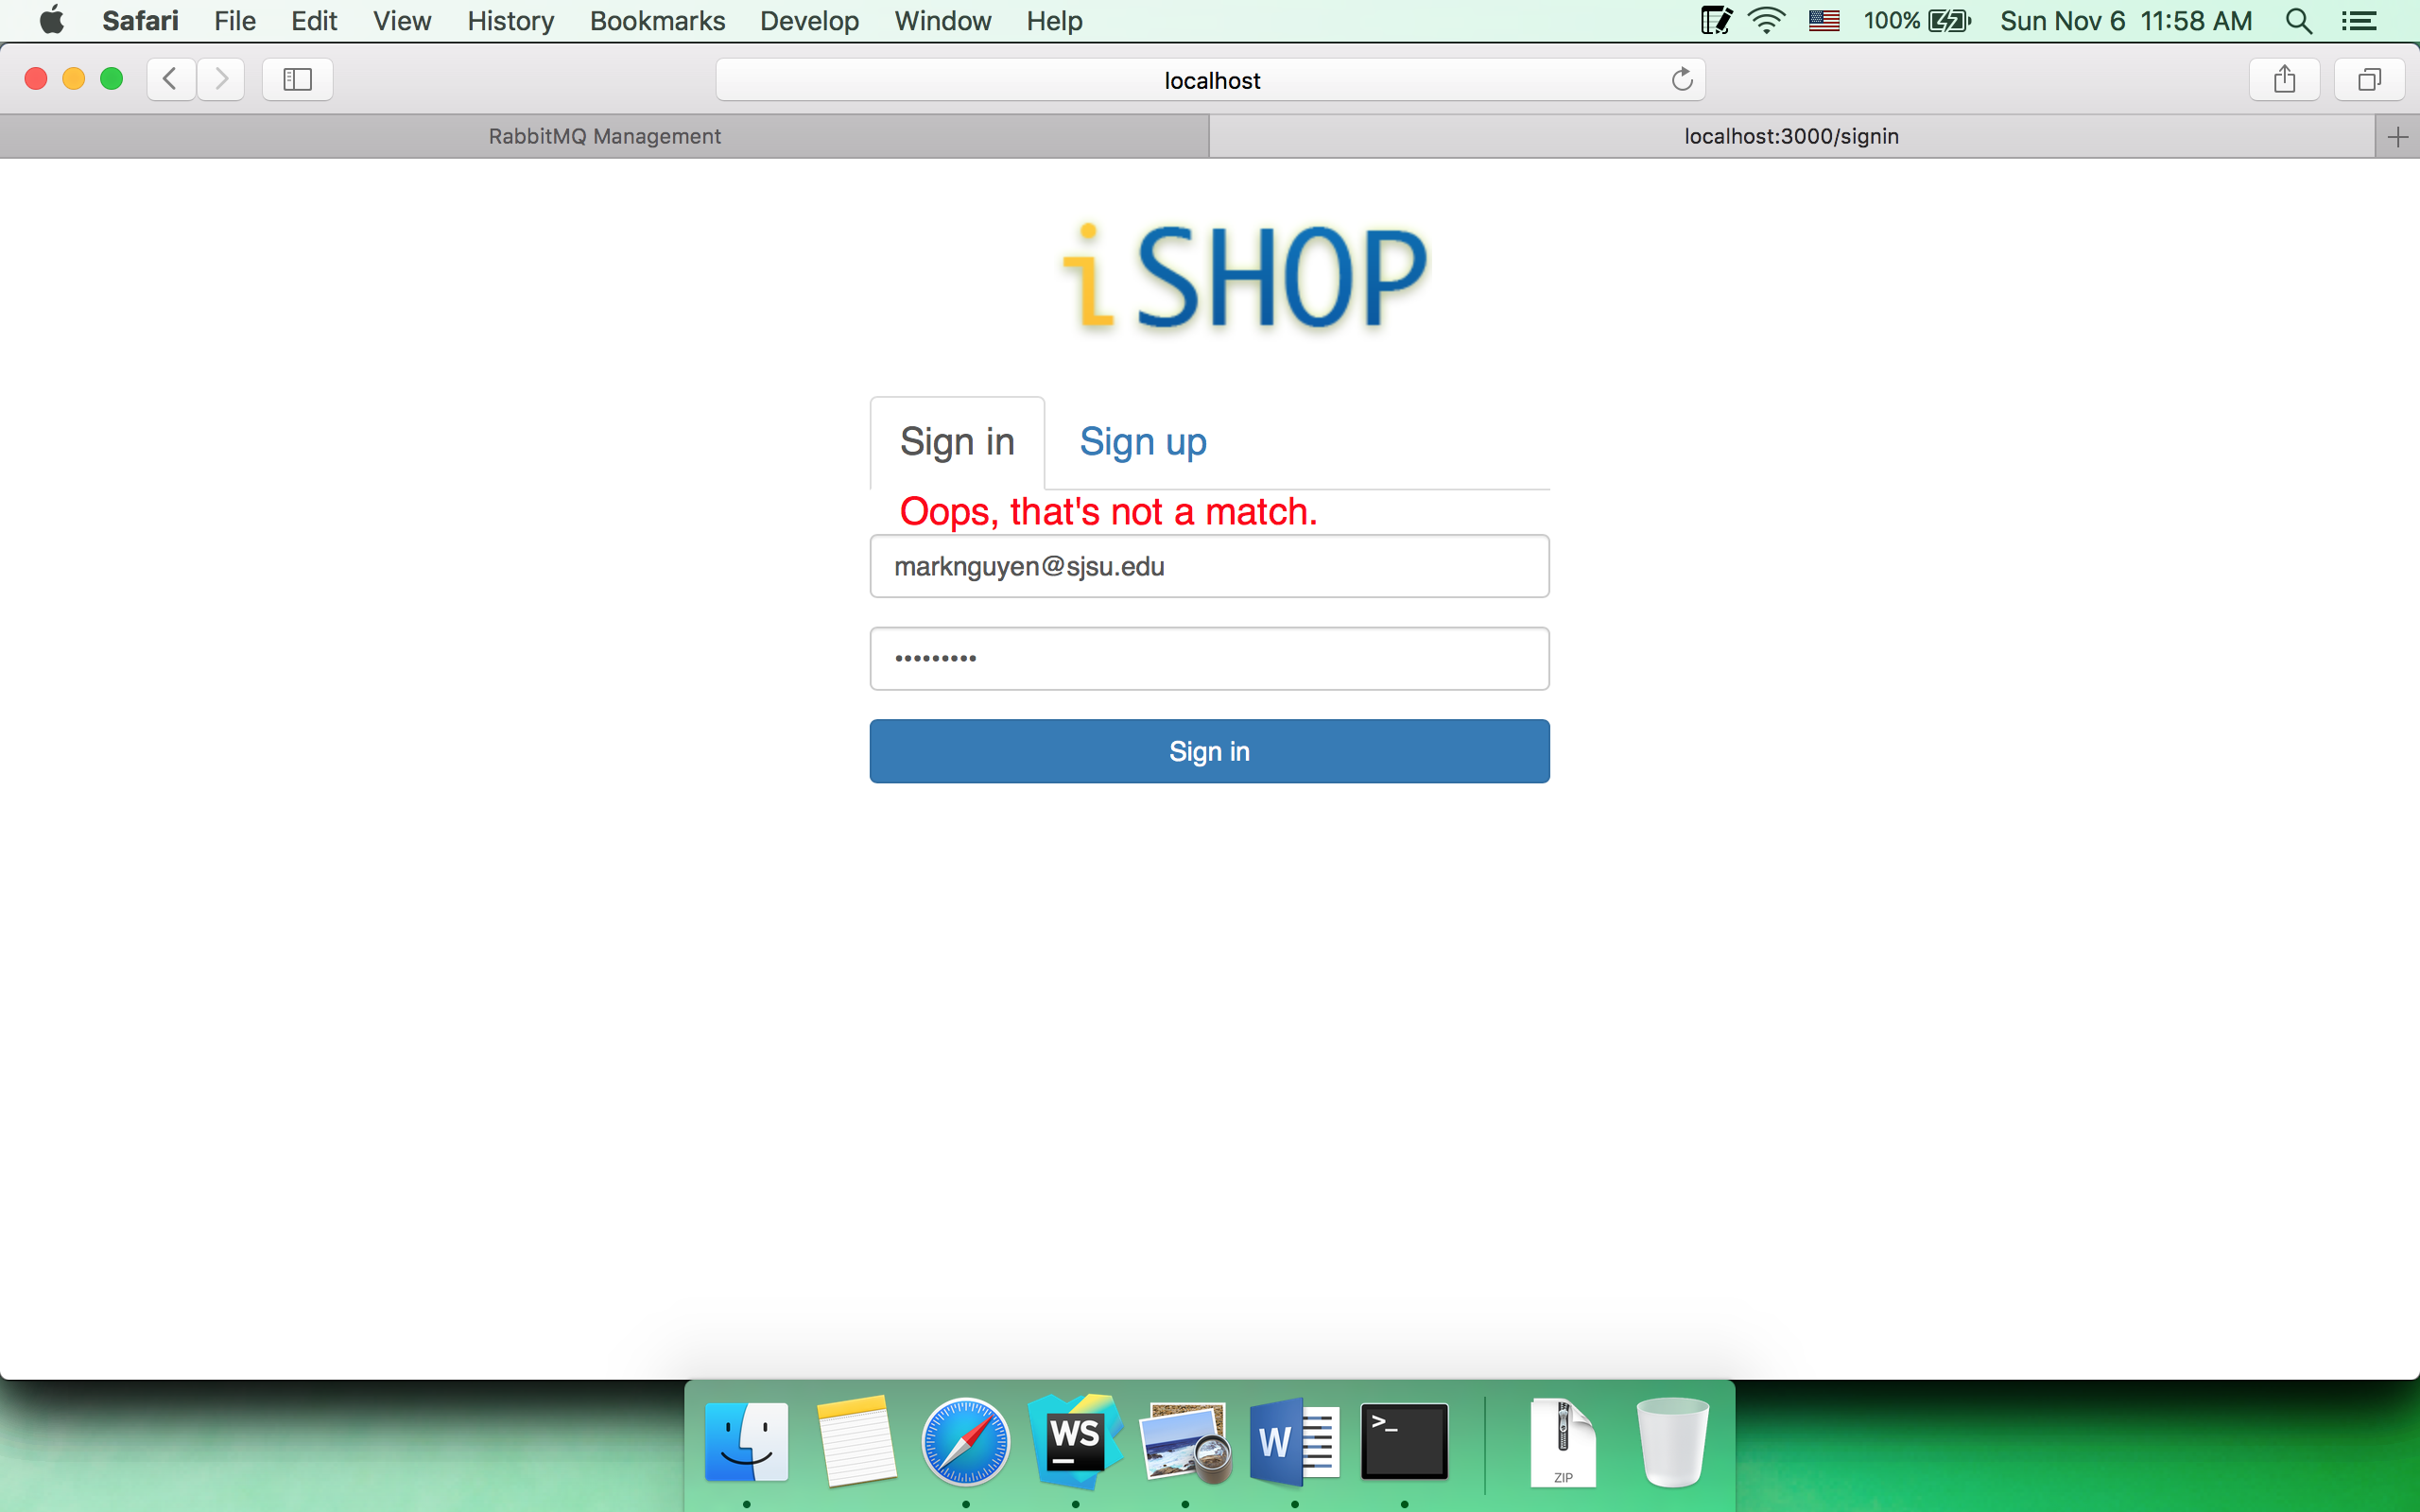

* 1. Home page

Buy it now tab

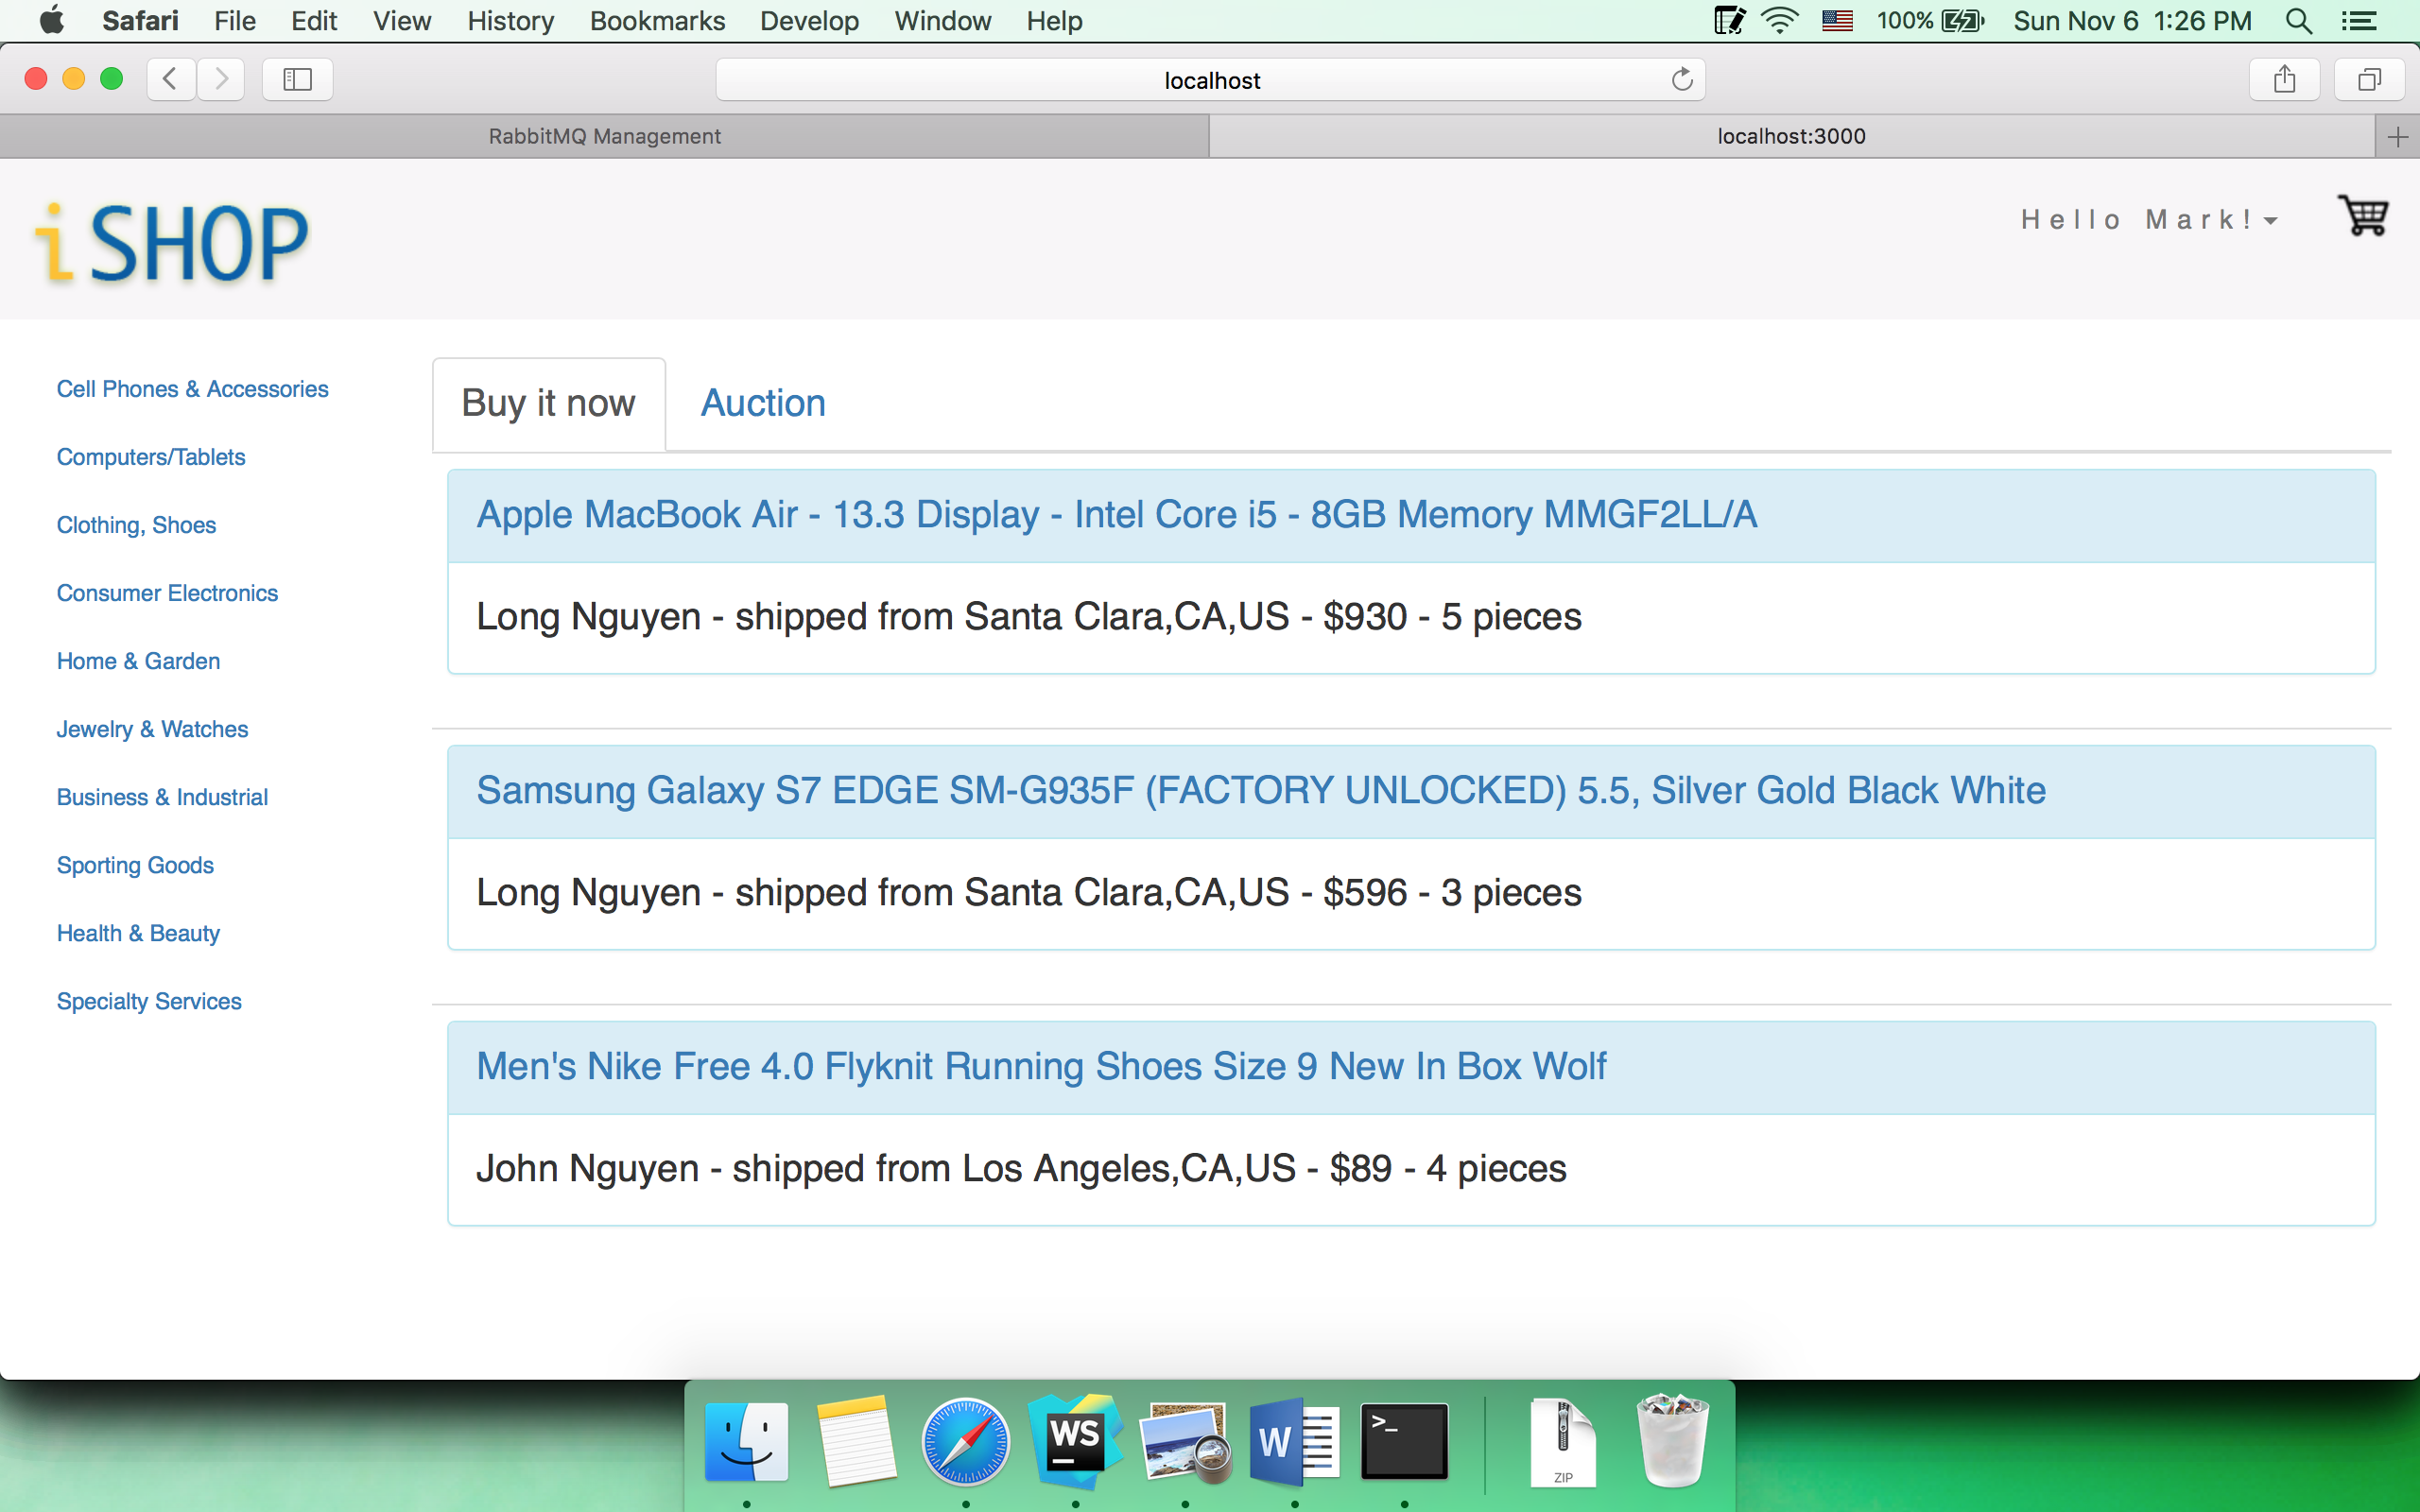

Auction tab

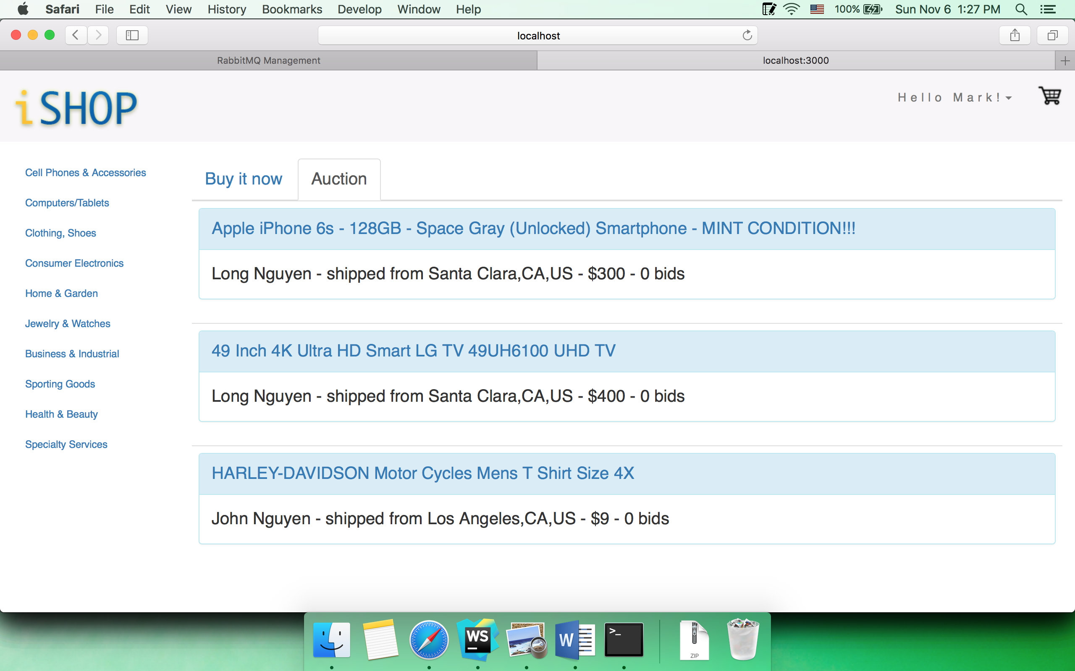

Queue

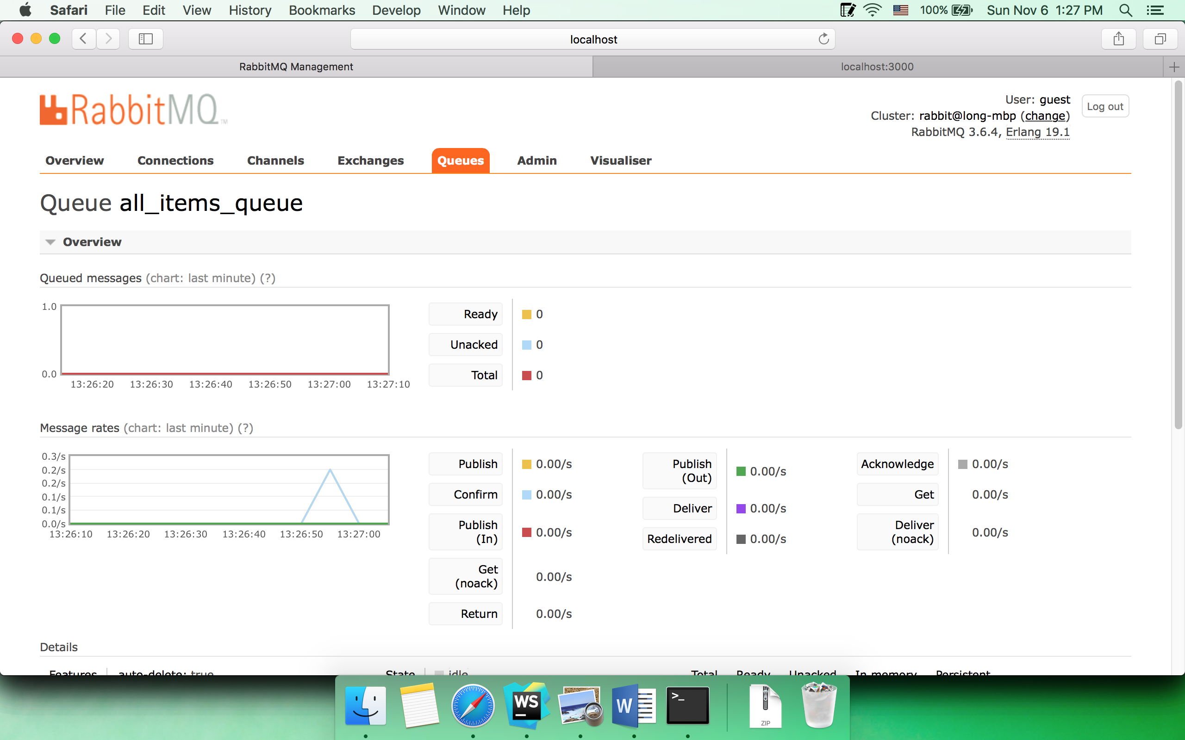

Client

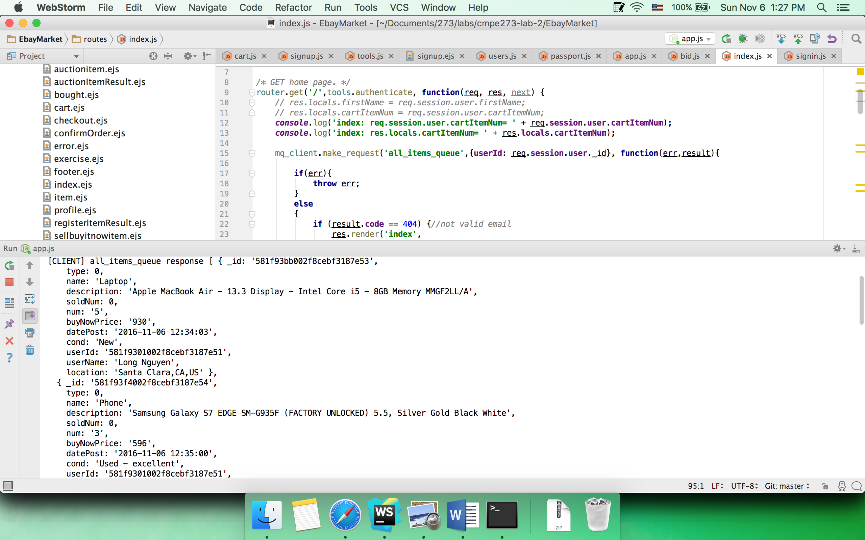

Server

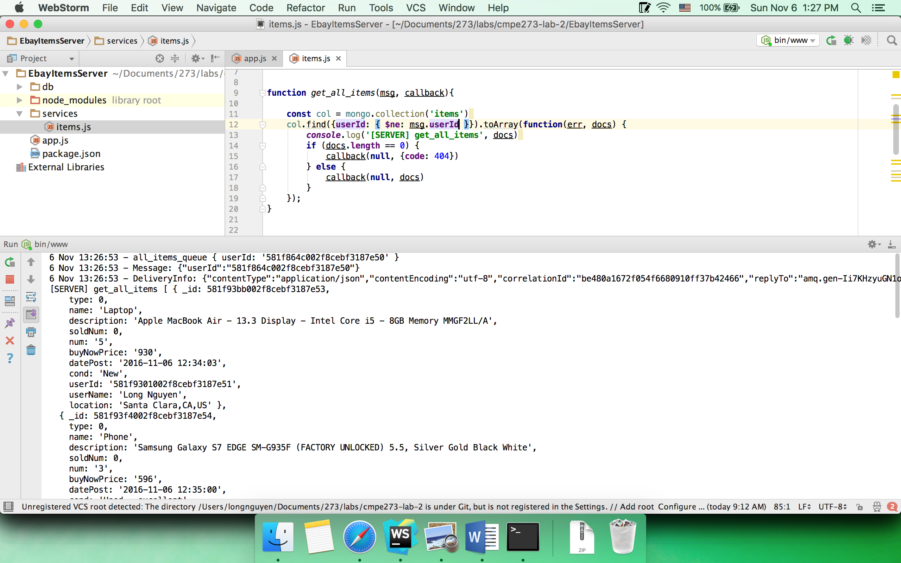

* 1. View auction item detail

Browser

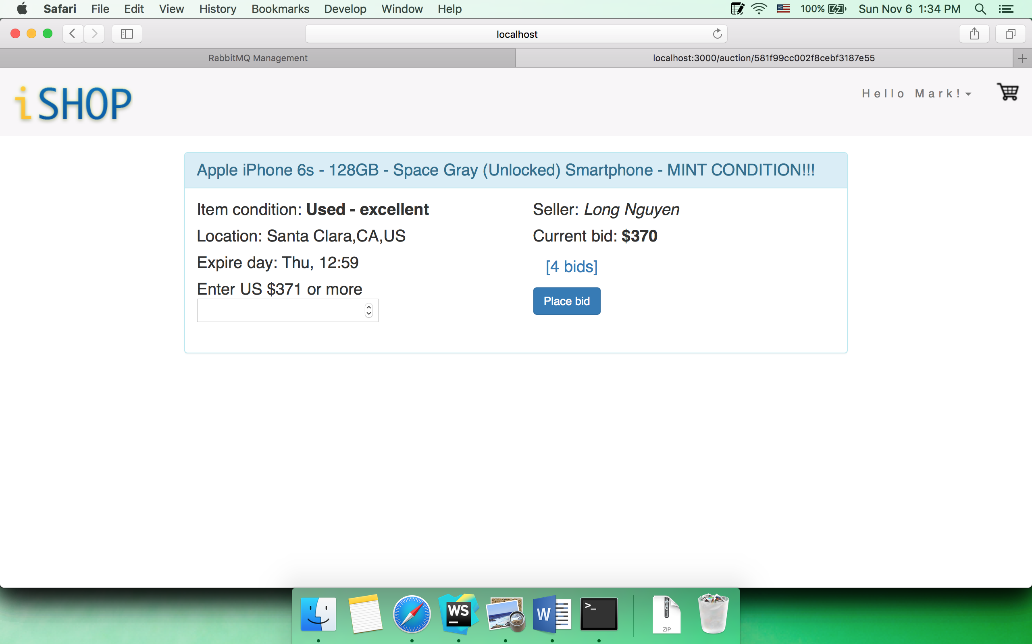

Queue

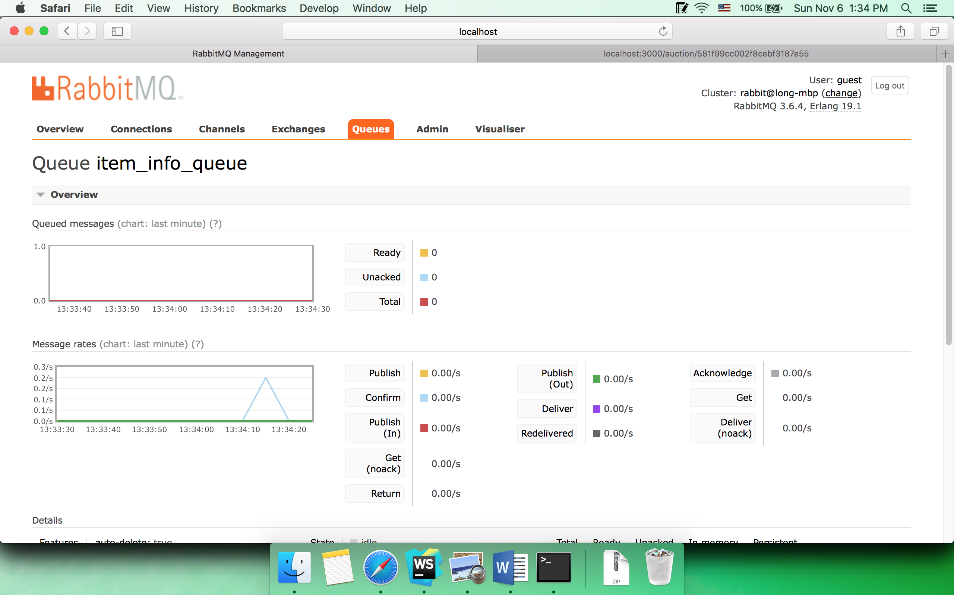

Client

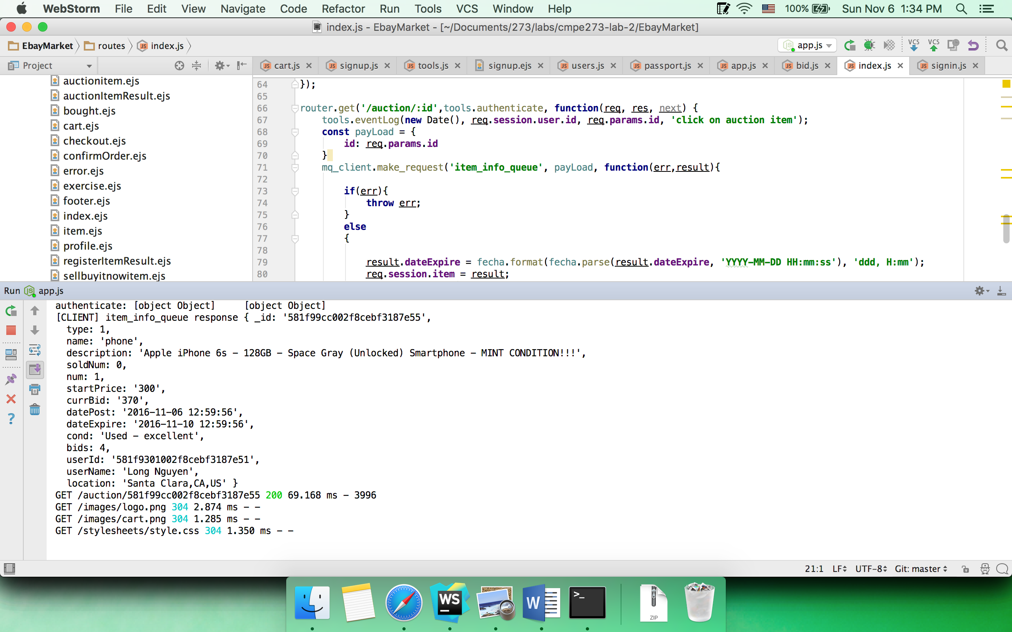

Server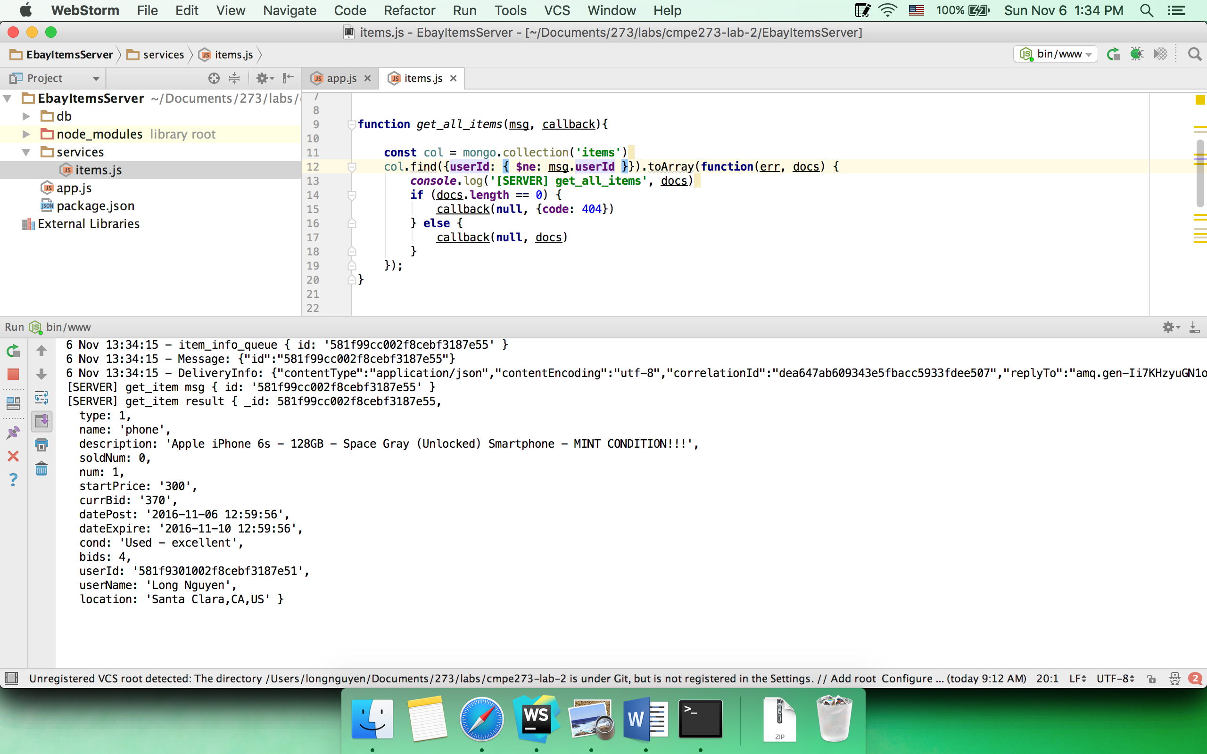

* 1. Place bid

Browser

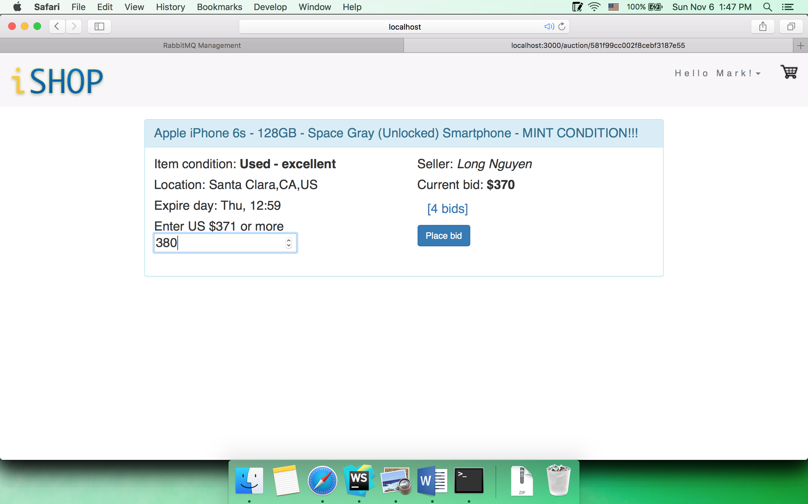

Queue

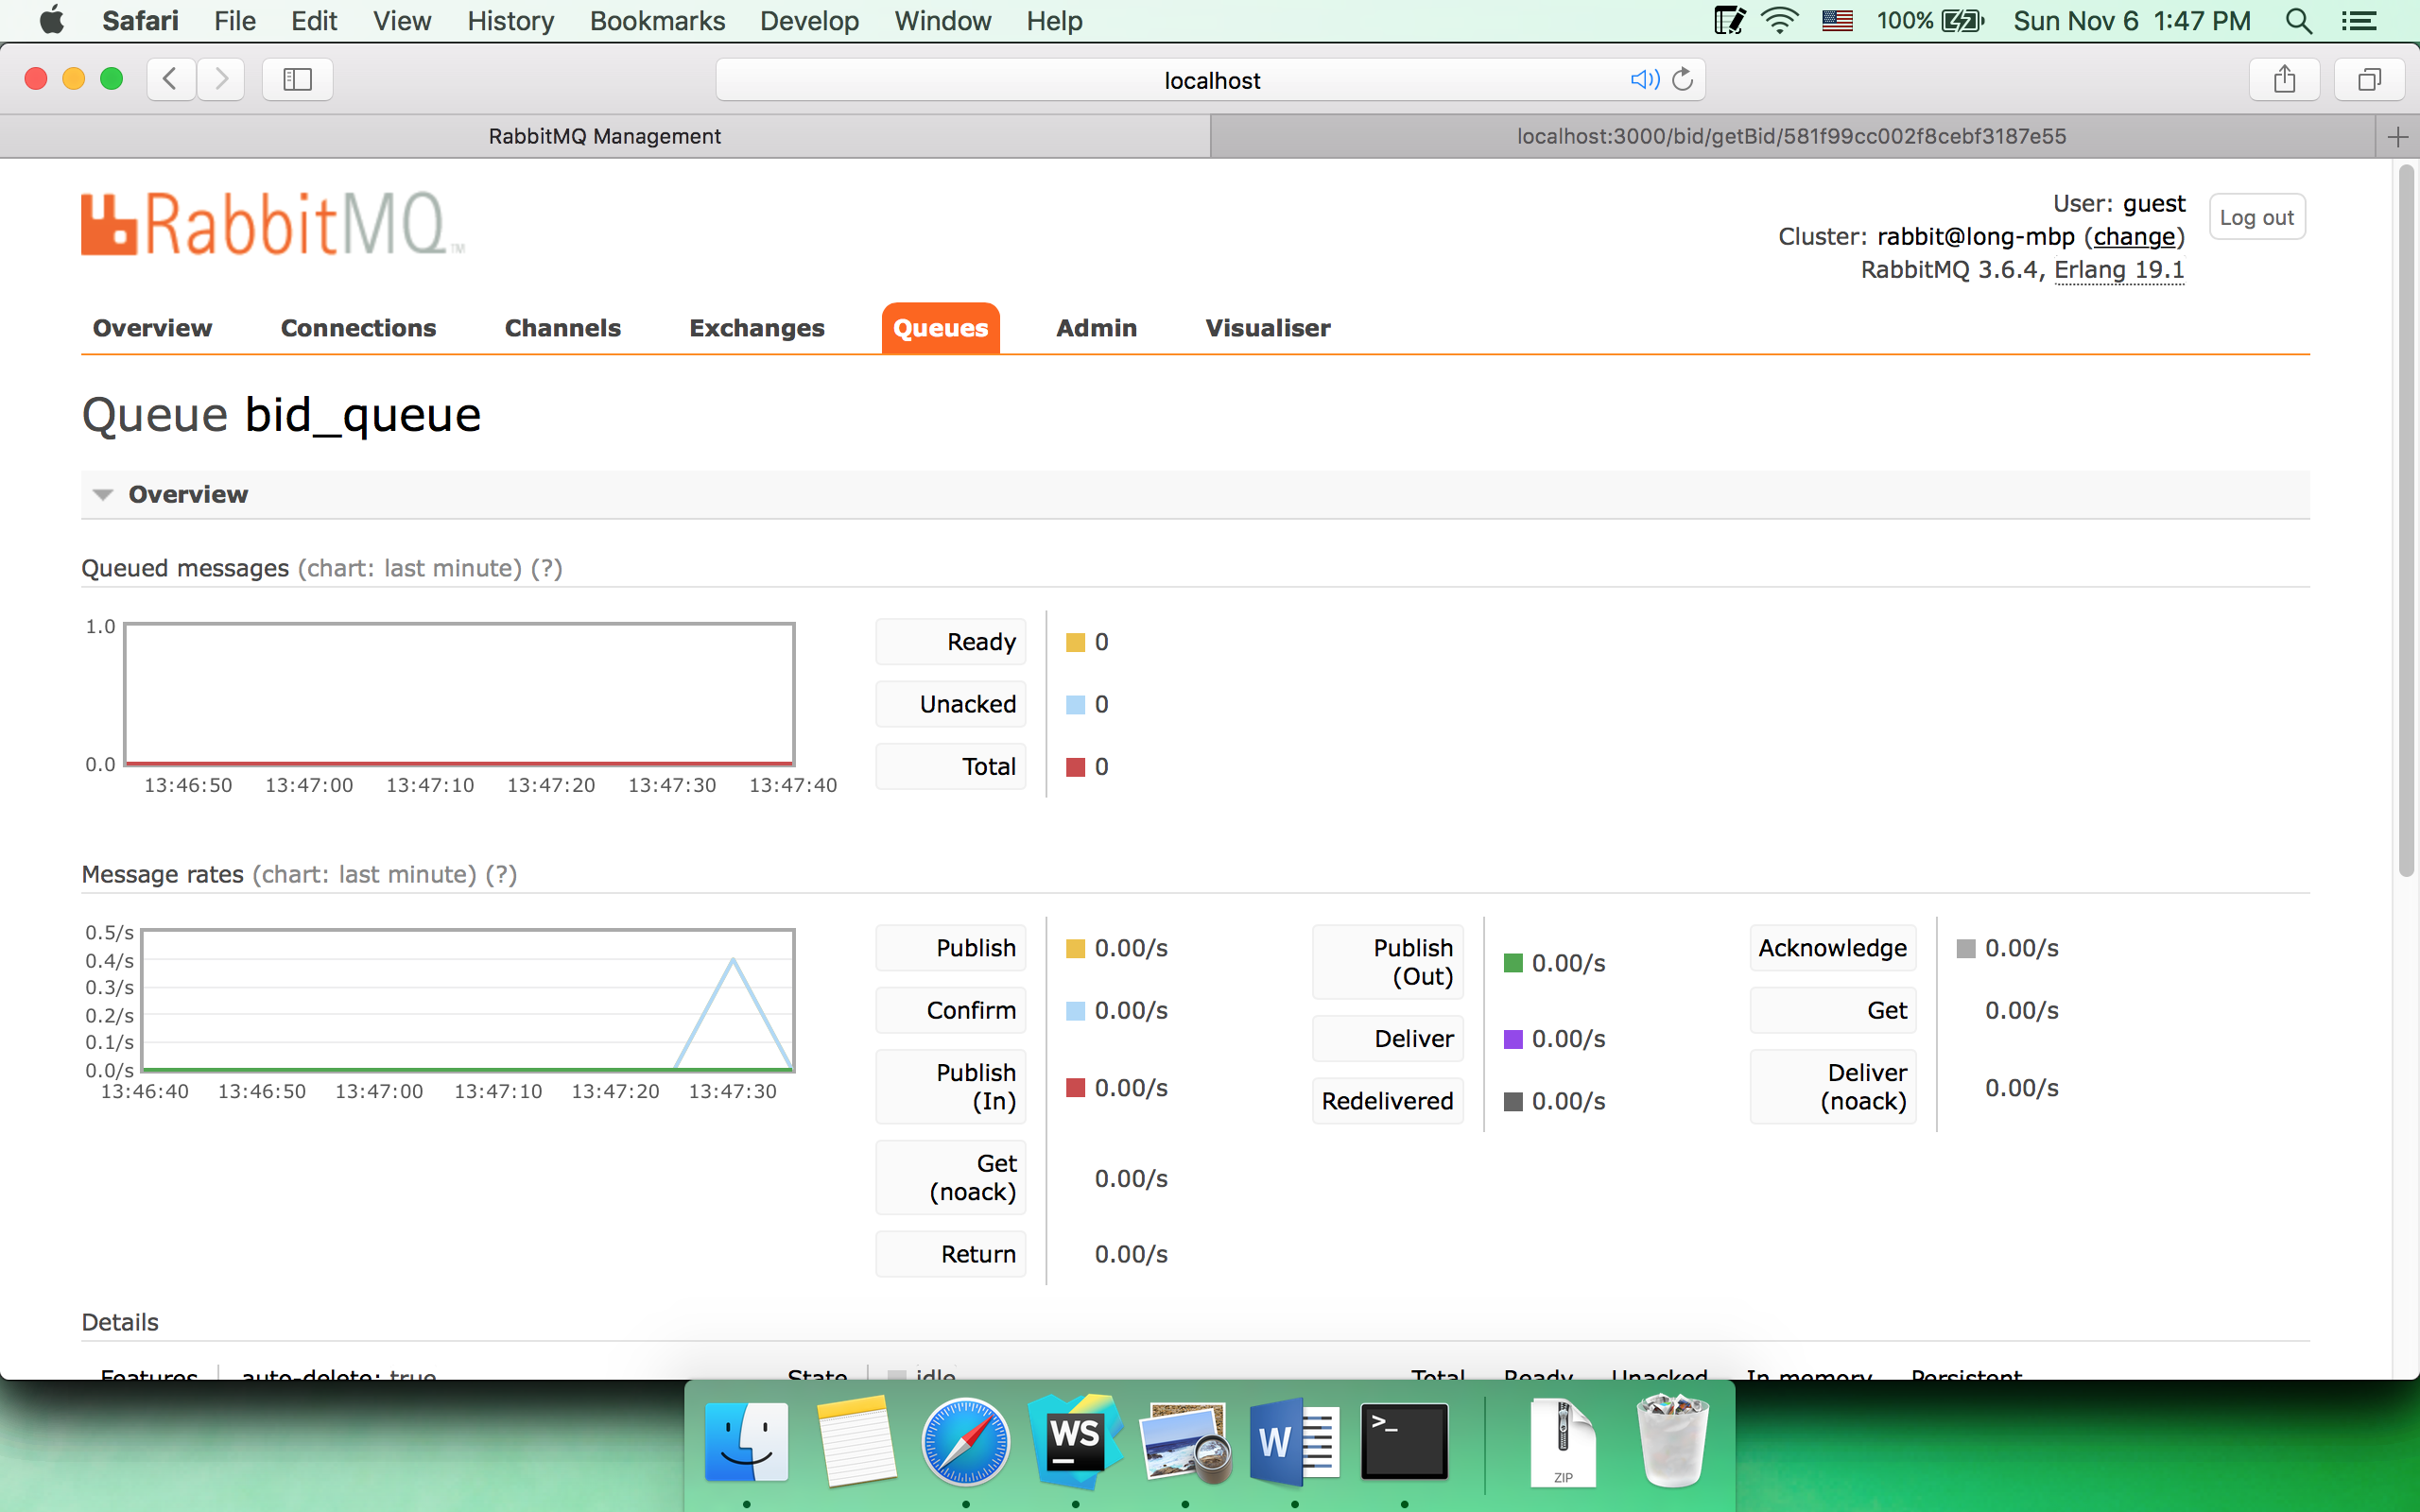

Client

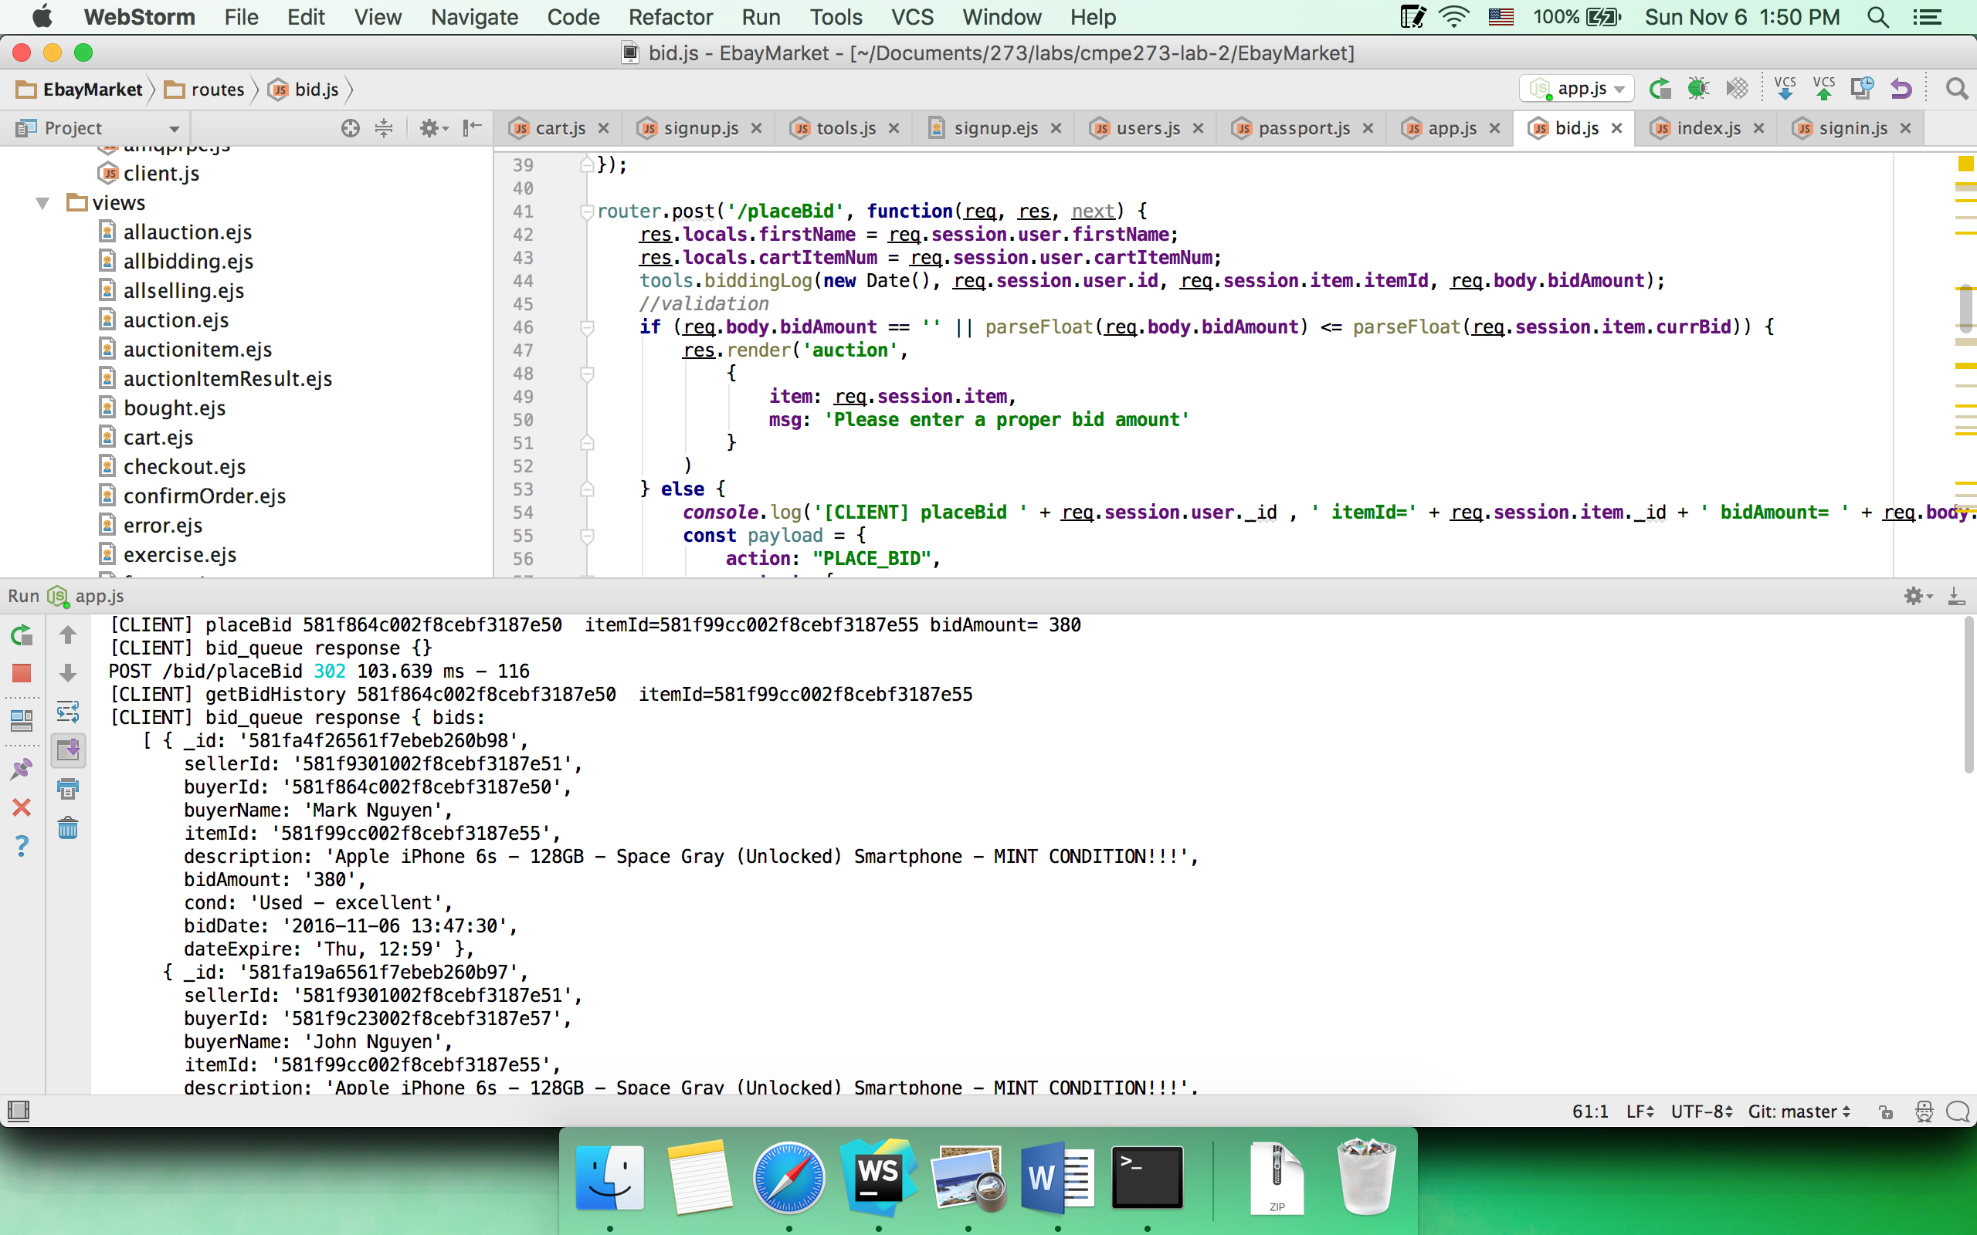

Server

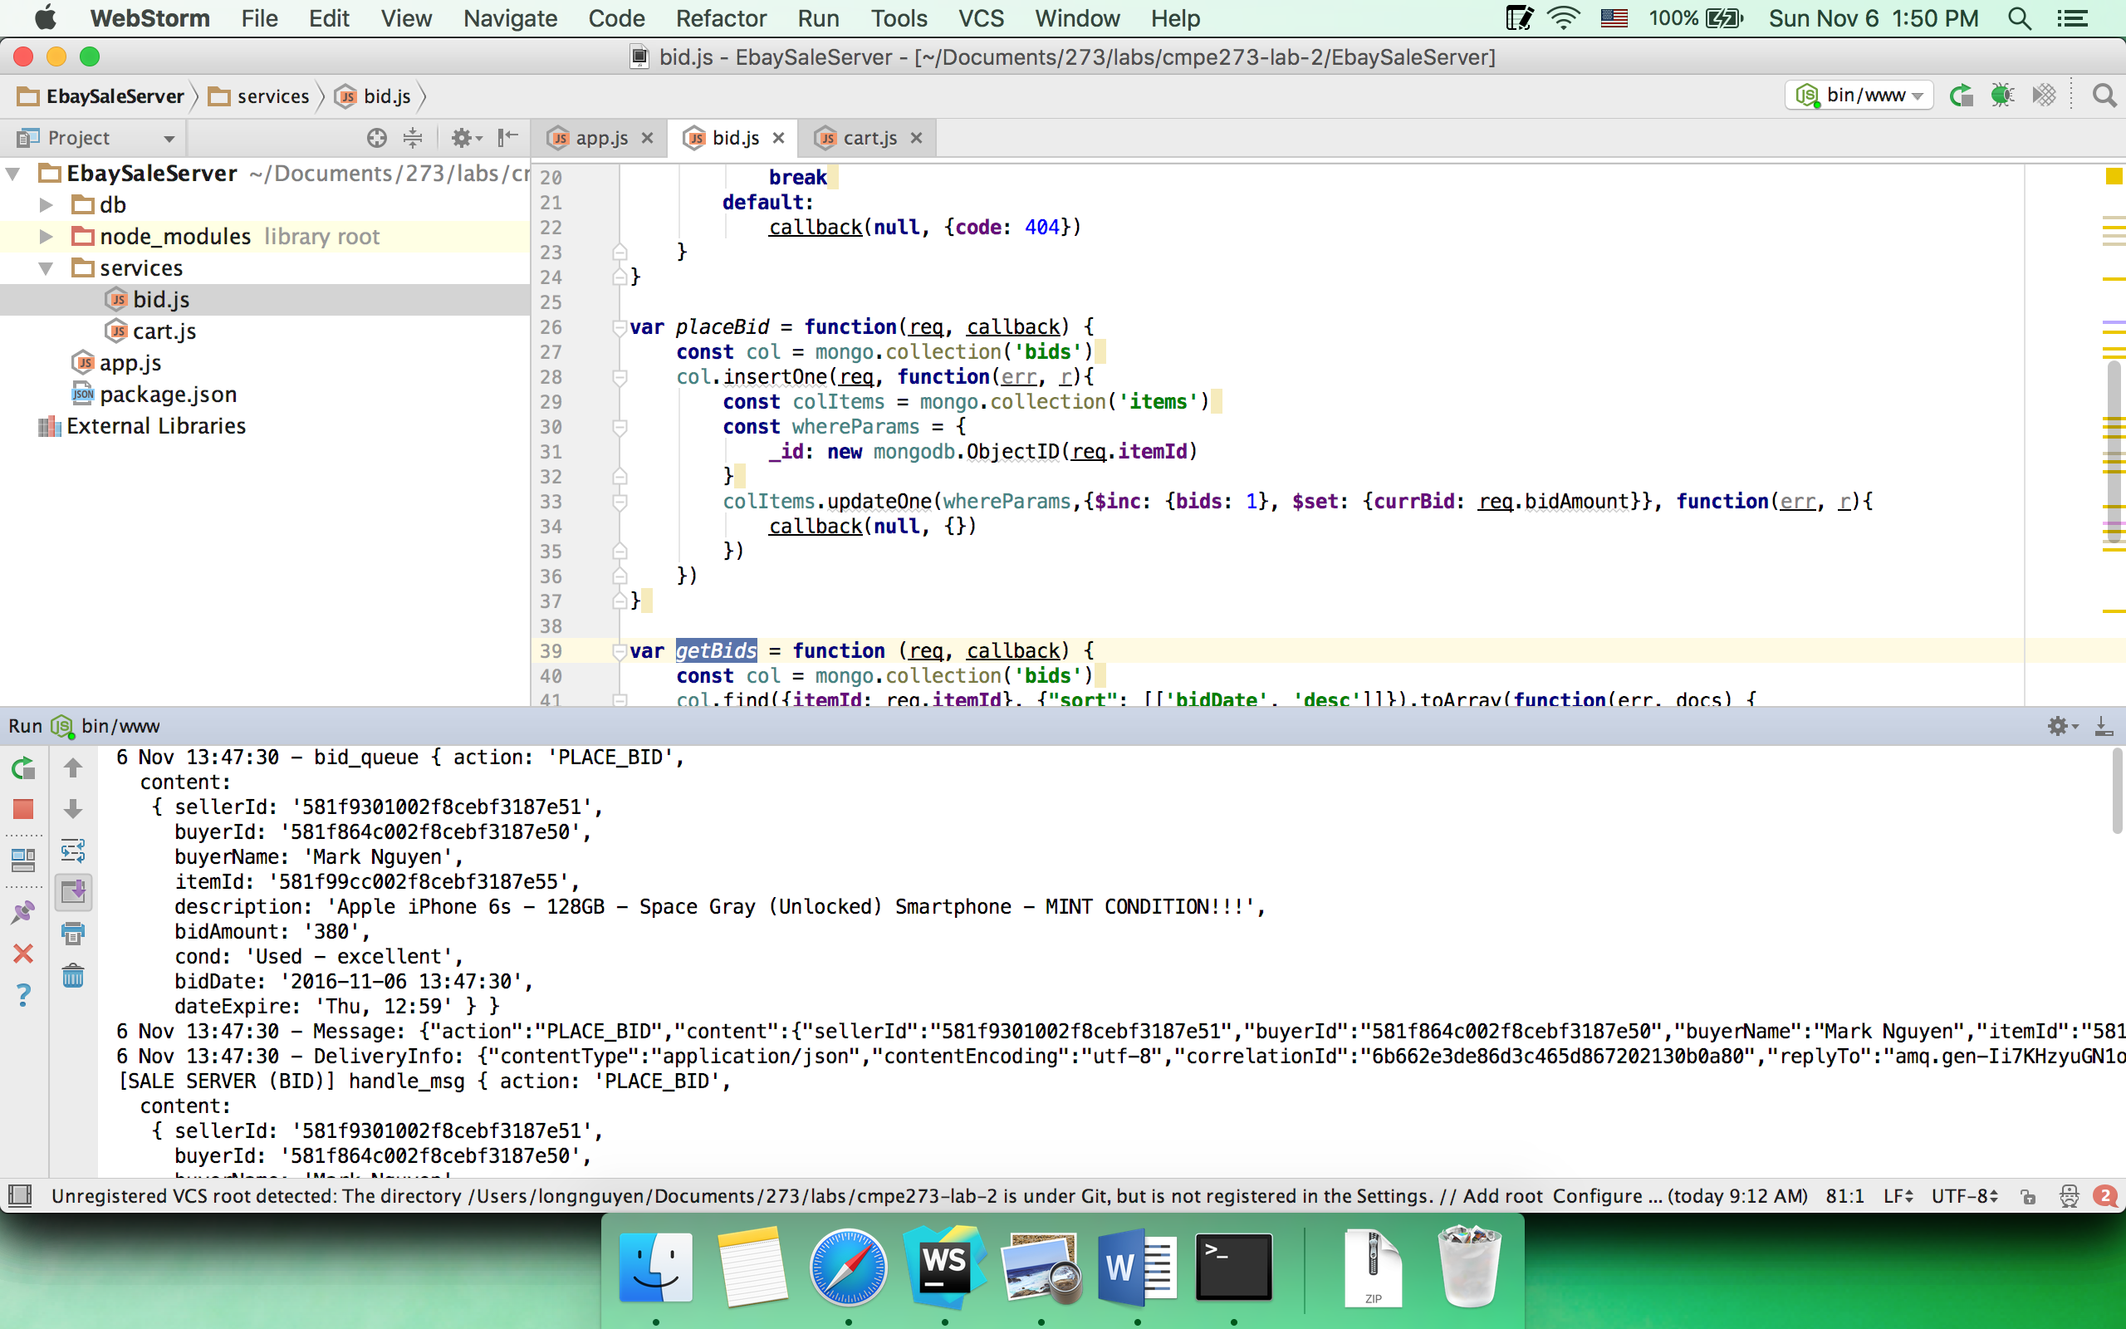

* 1. View bid history

Browser

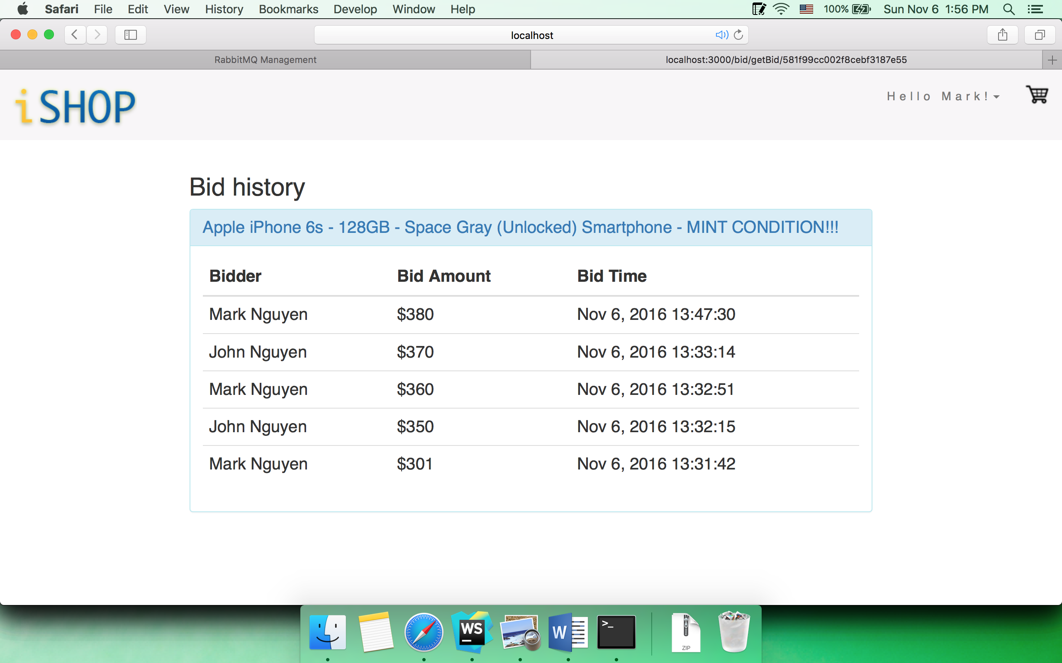

Queue

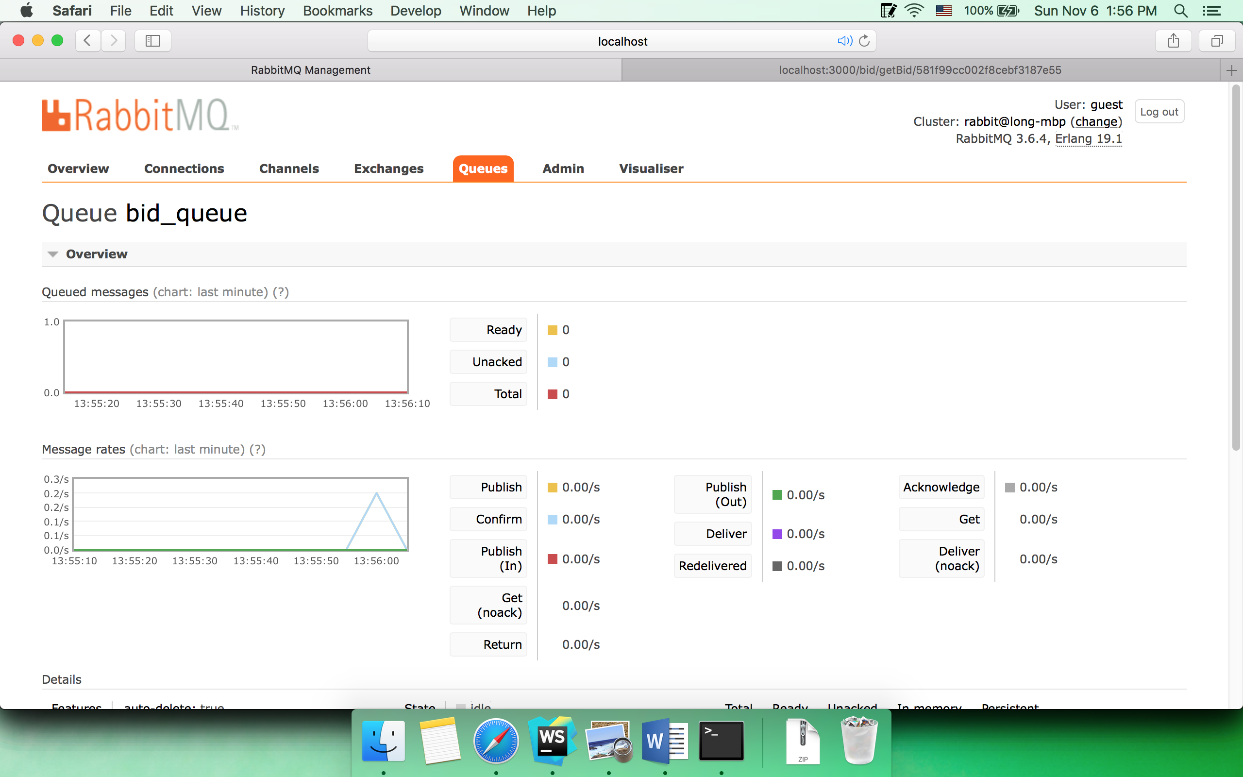

Client

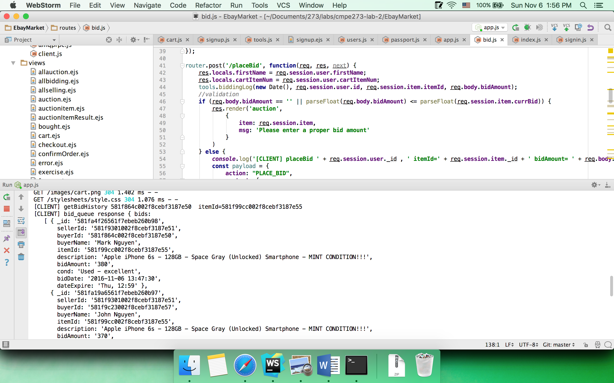

Server

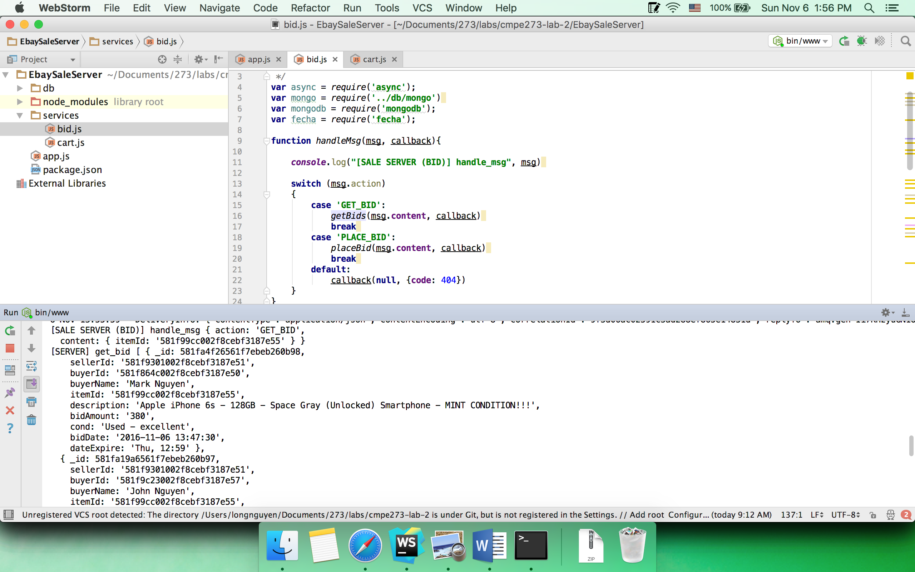

* 1. “buy it now” item detail

Browser

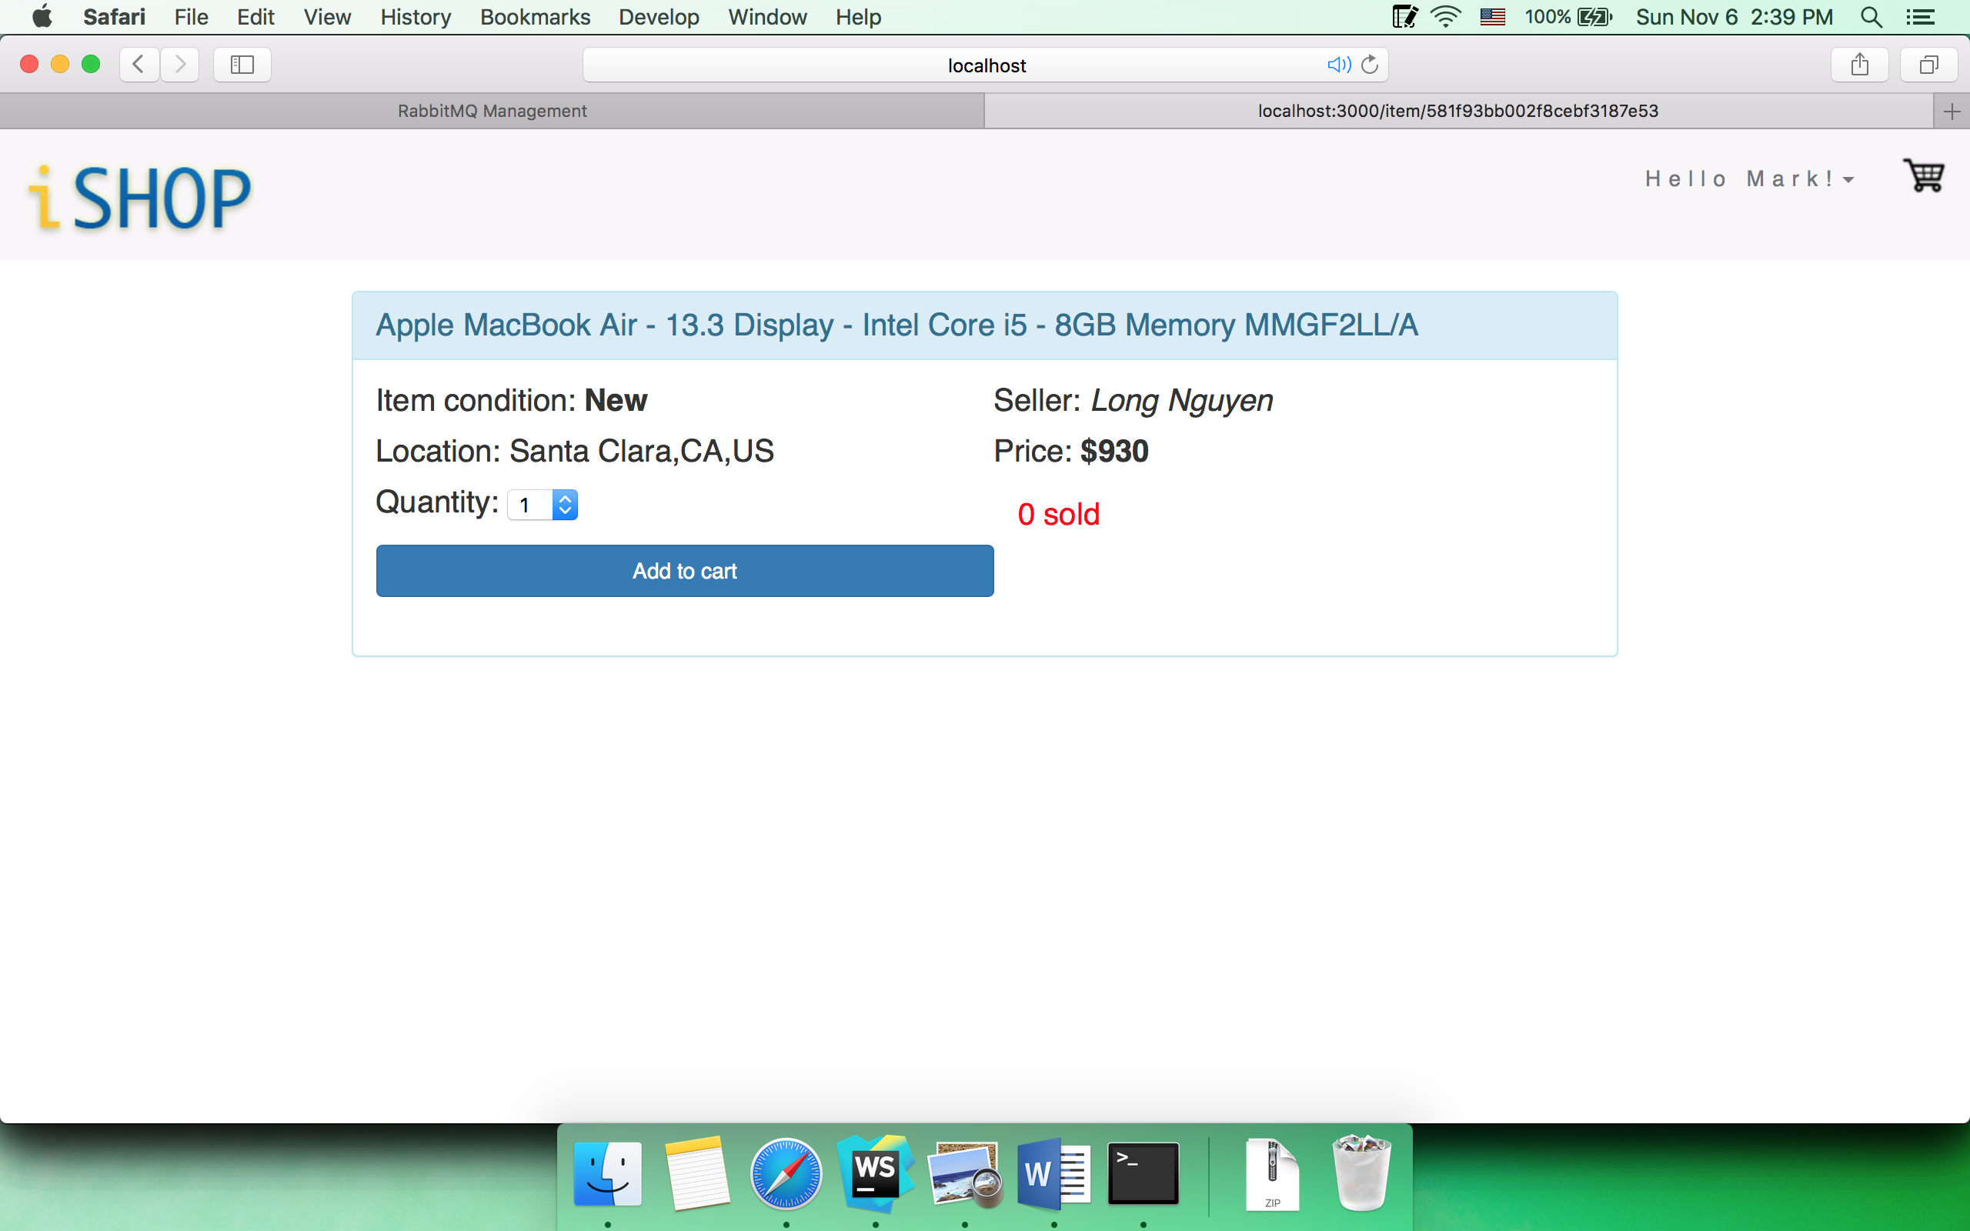

Queue

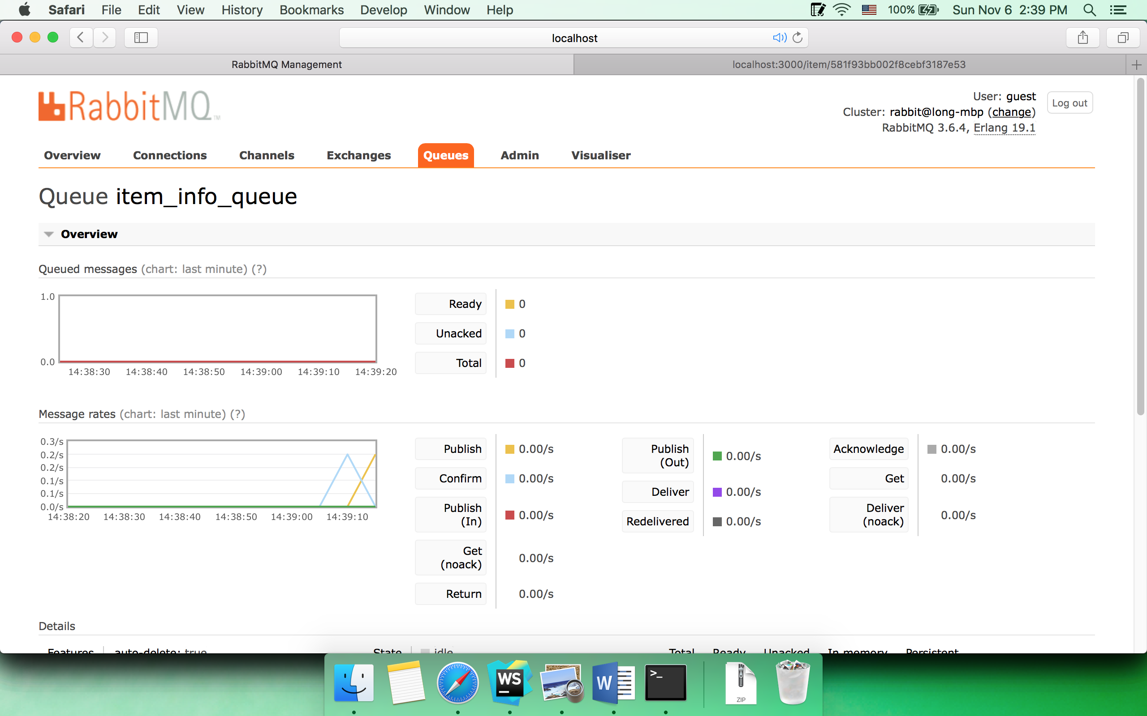

Client

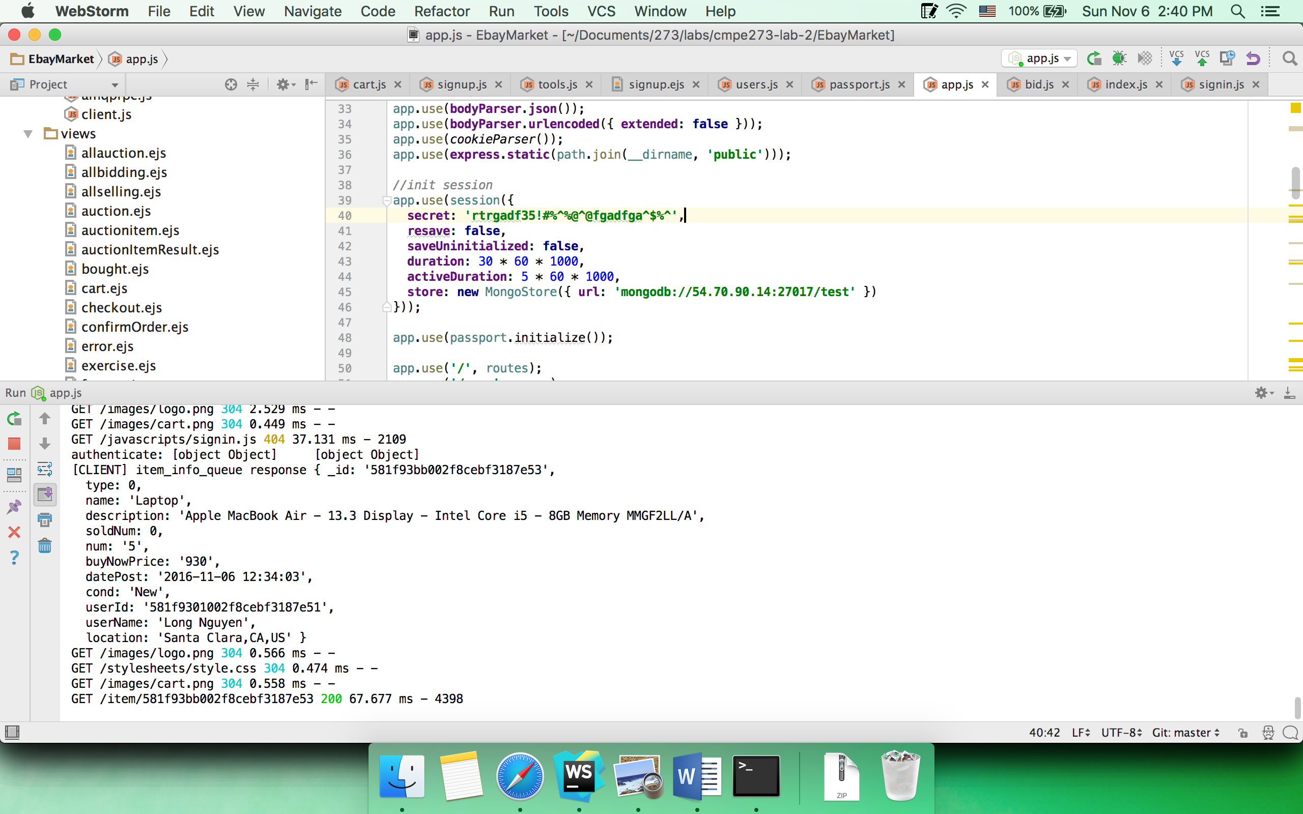

Server

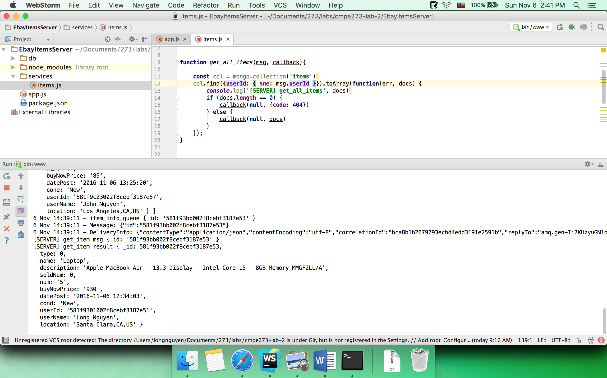

* 1. Add items to cart

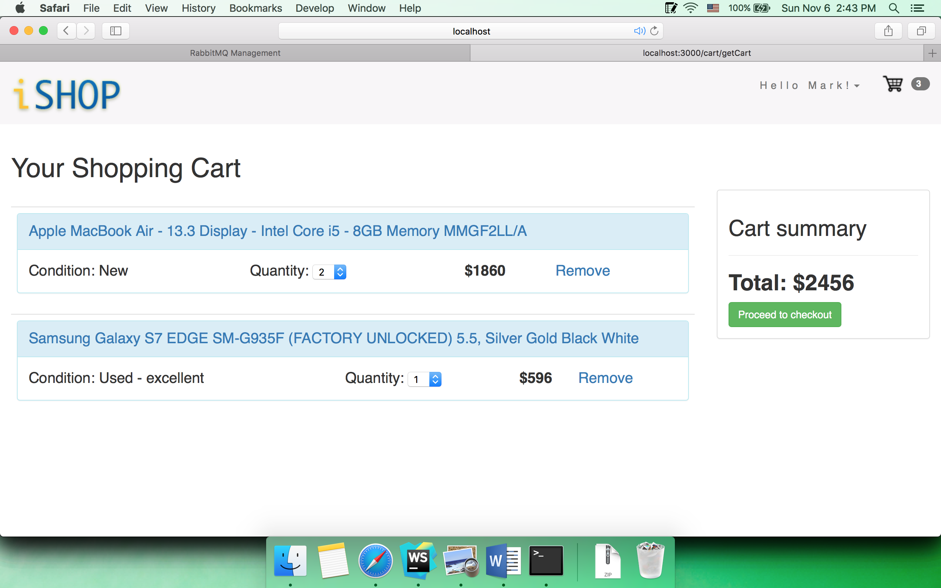

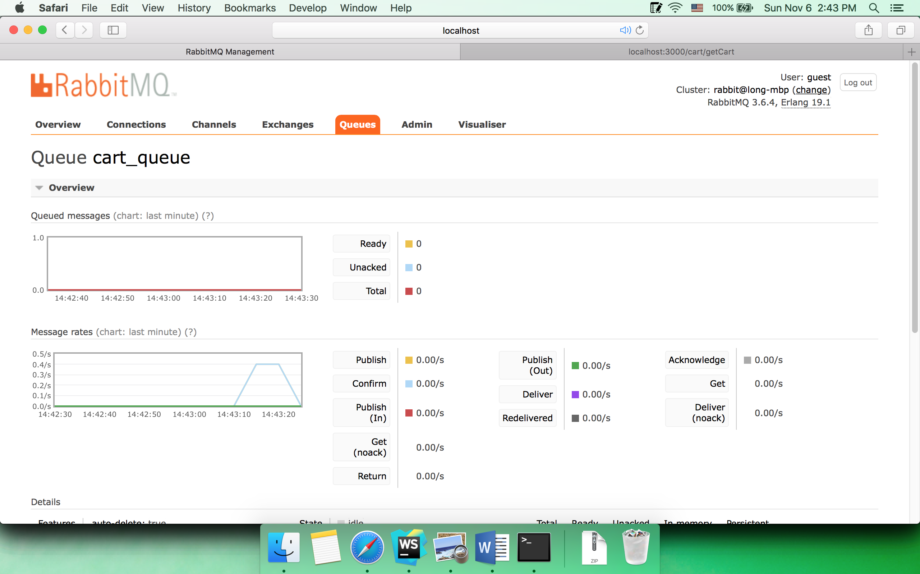

* 1. Edit number item in cart

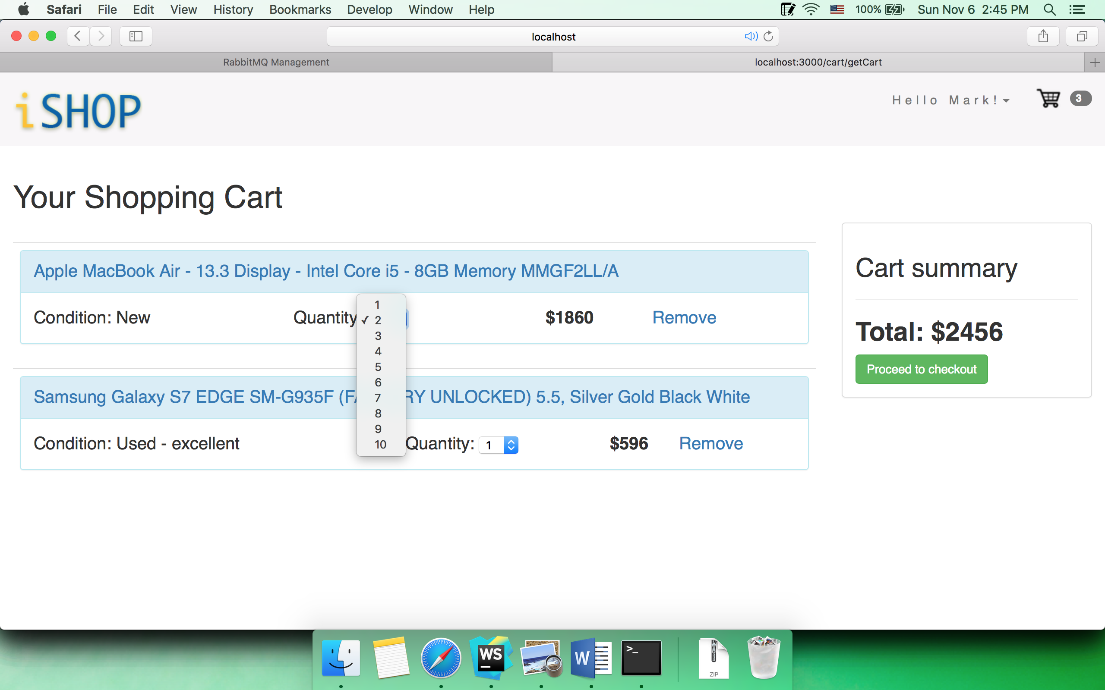

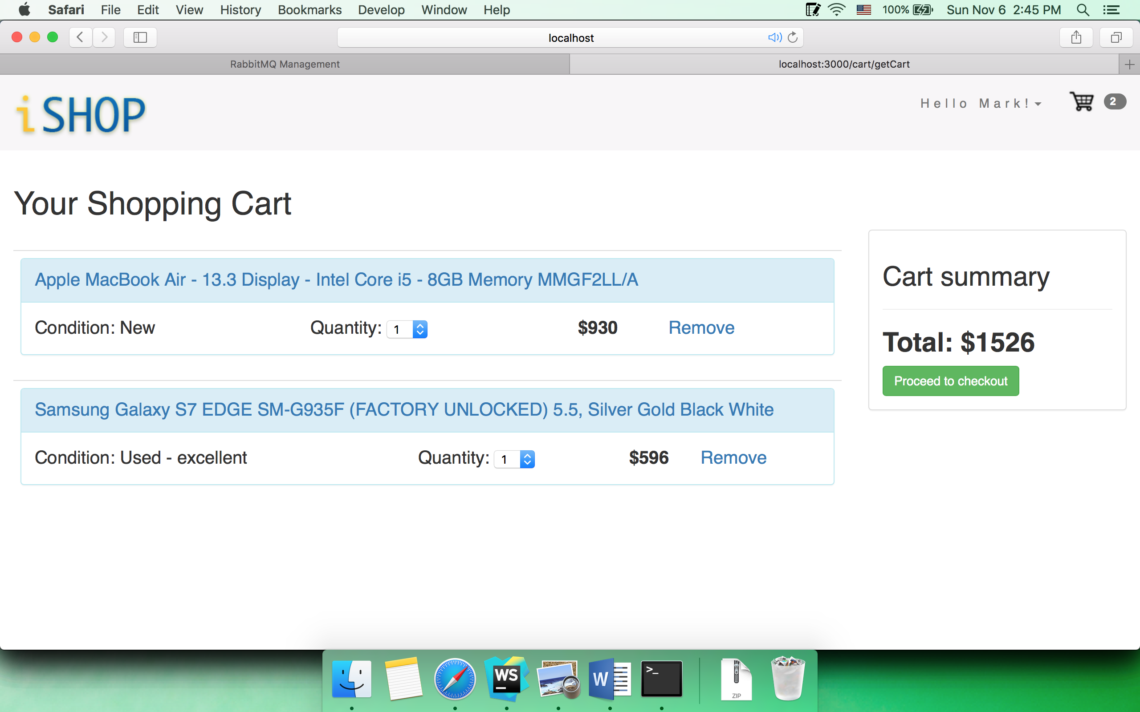

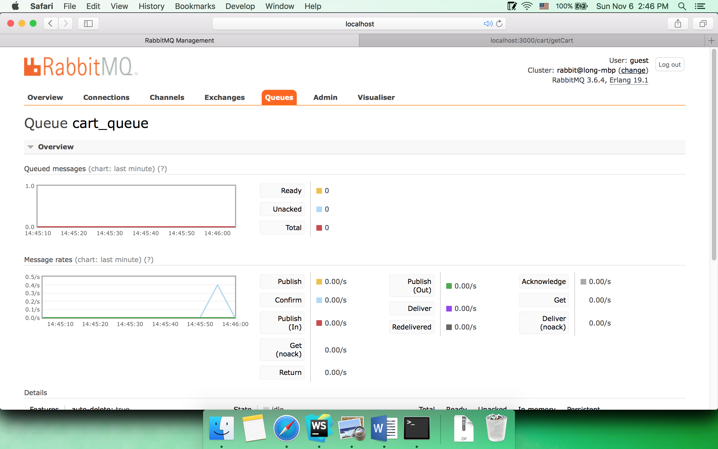

* 1. Remove item in cart

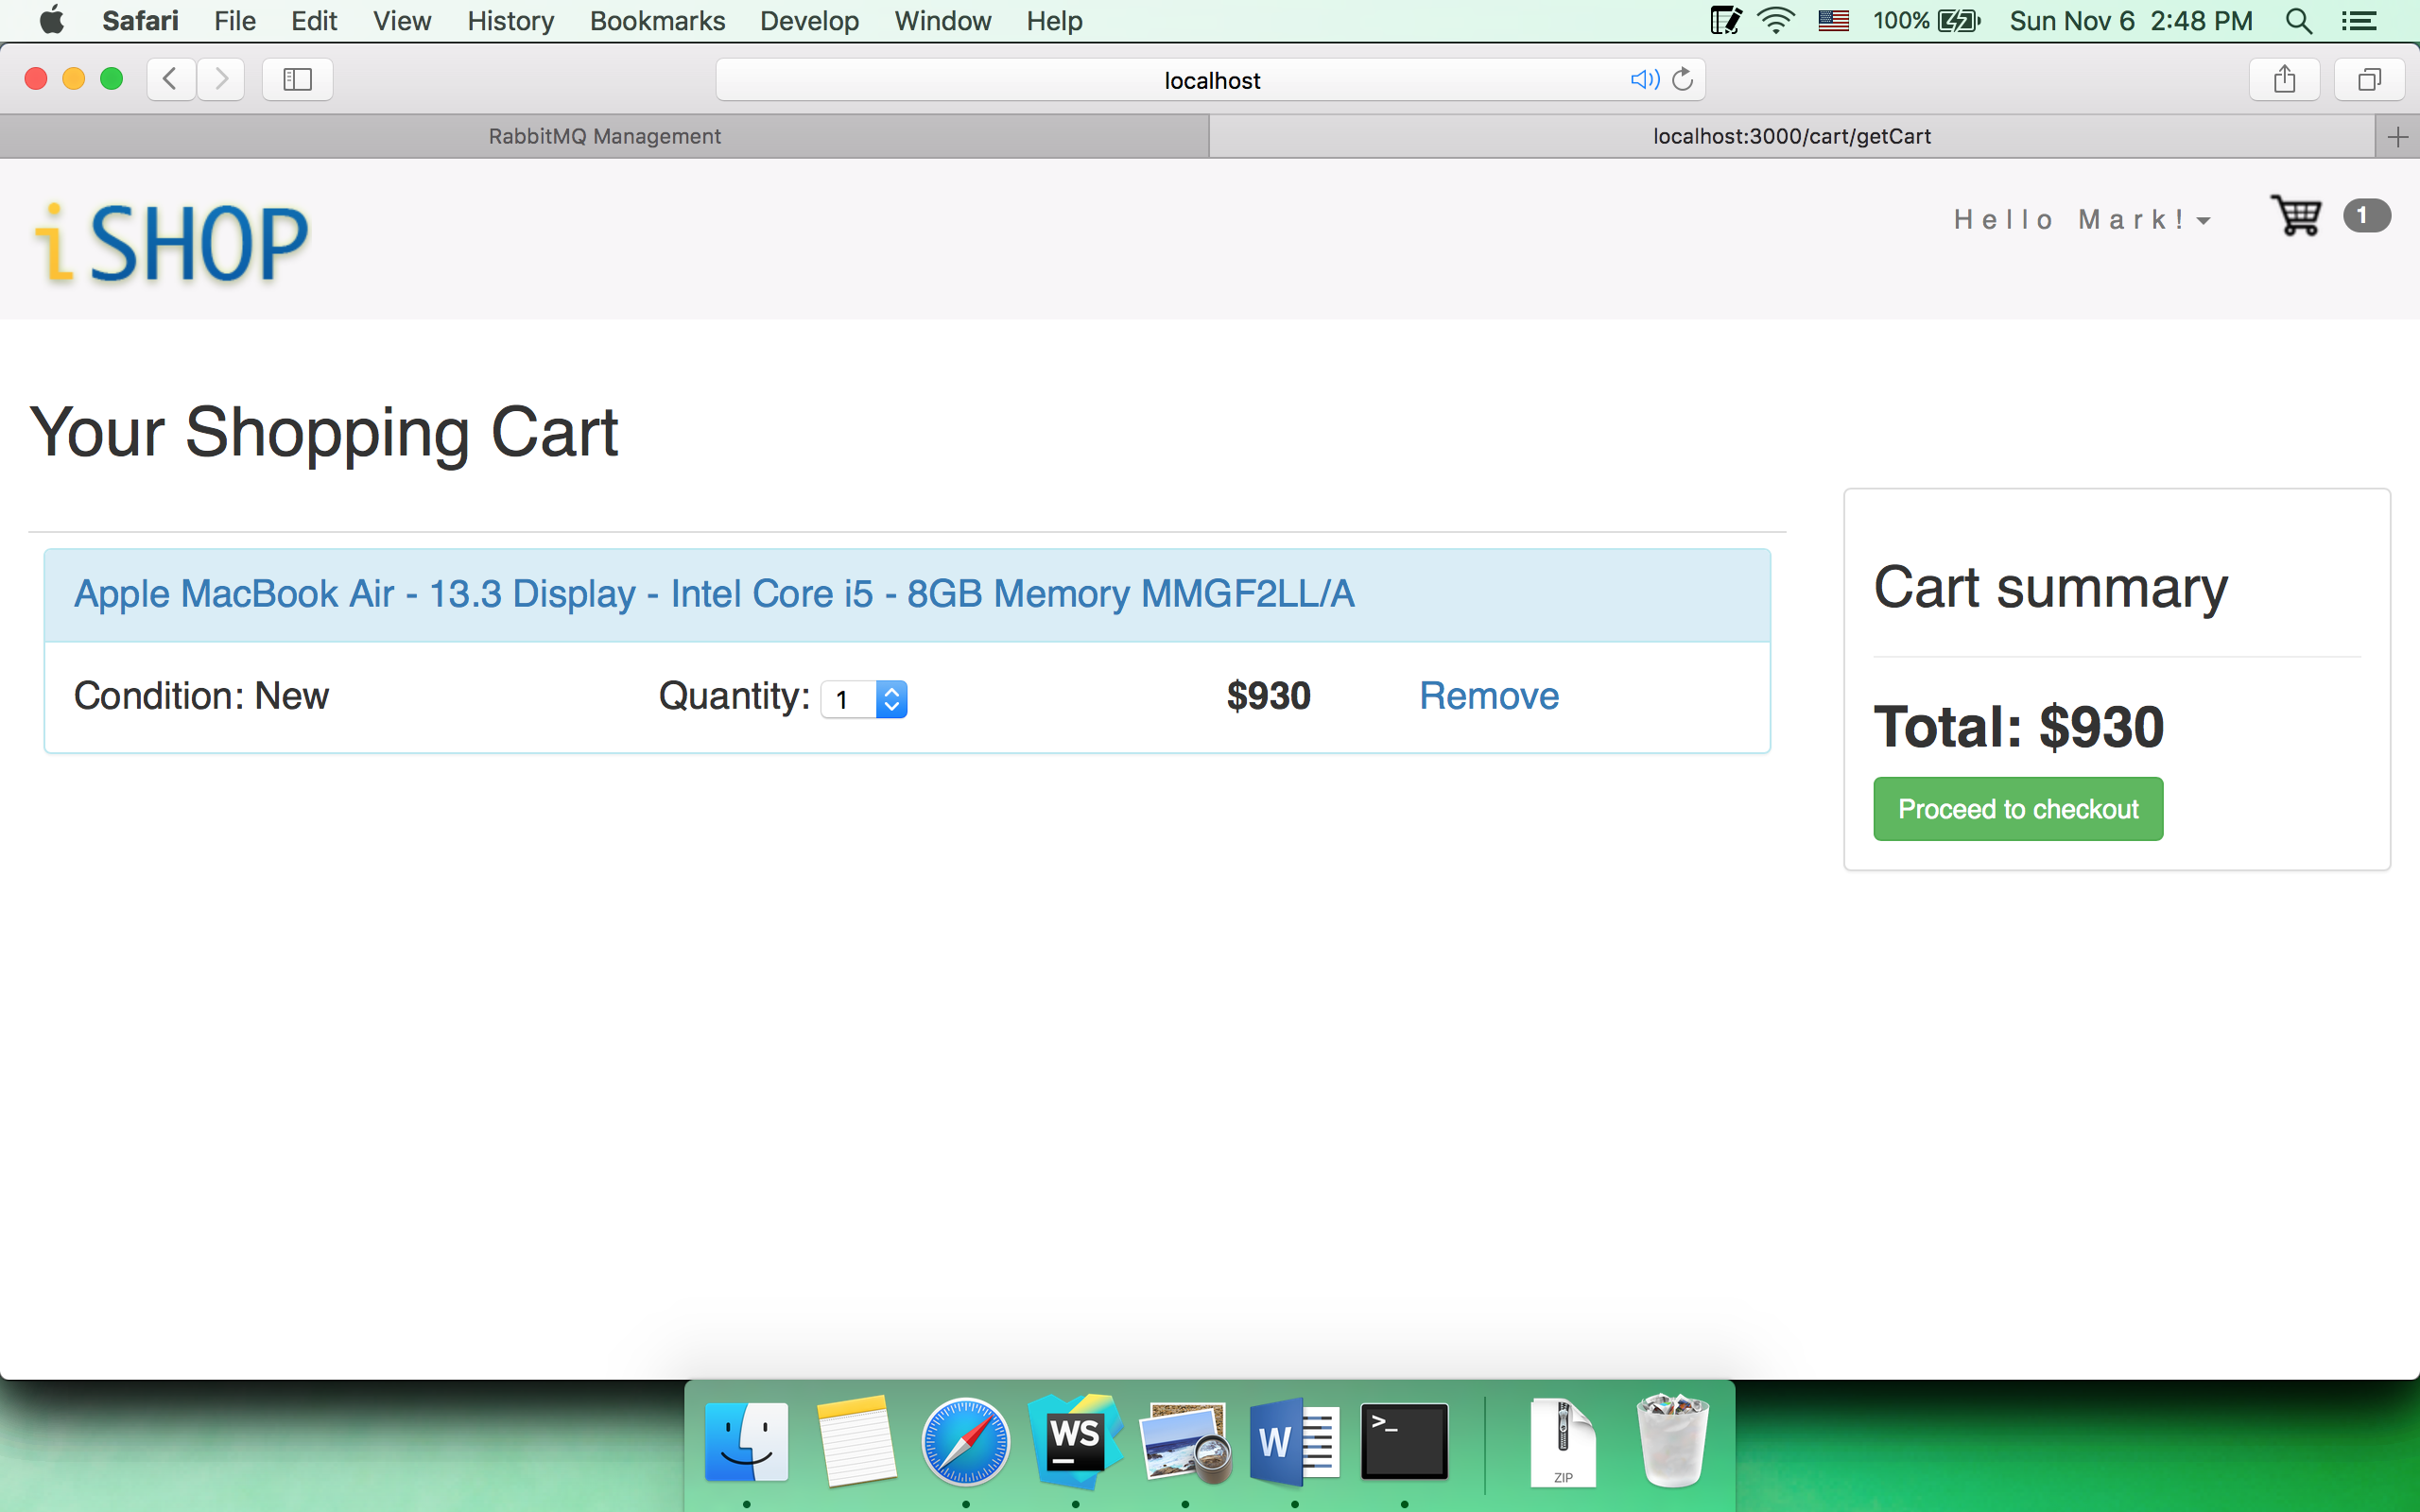

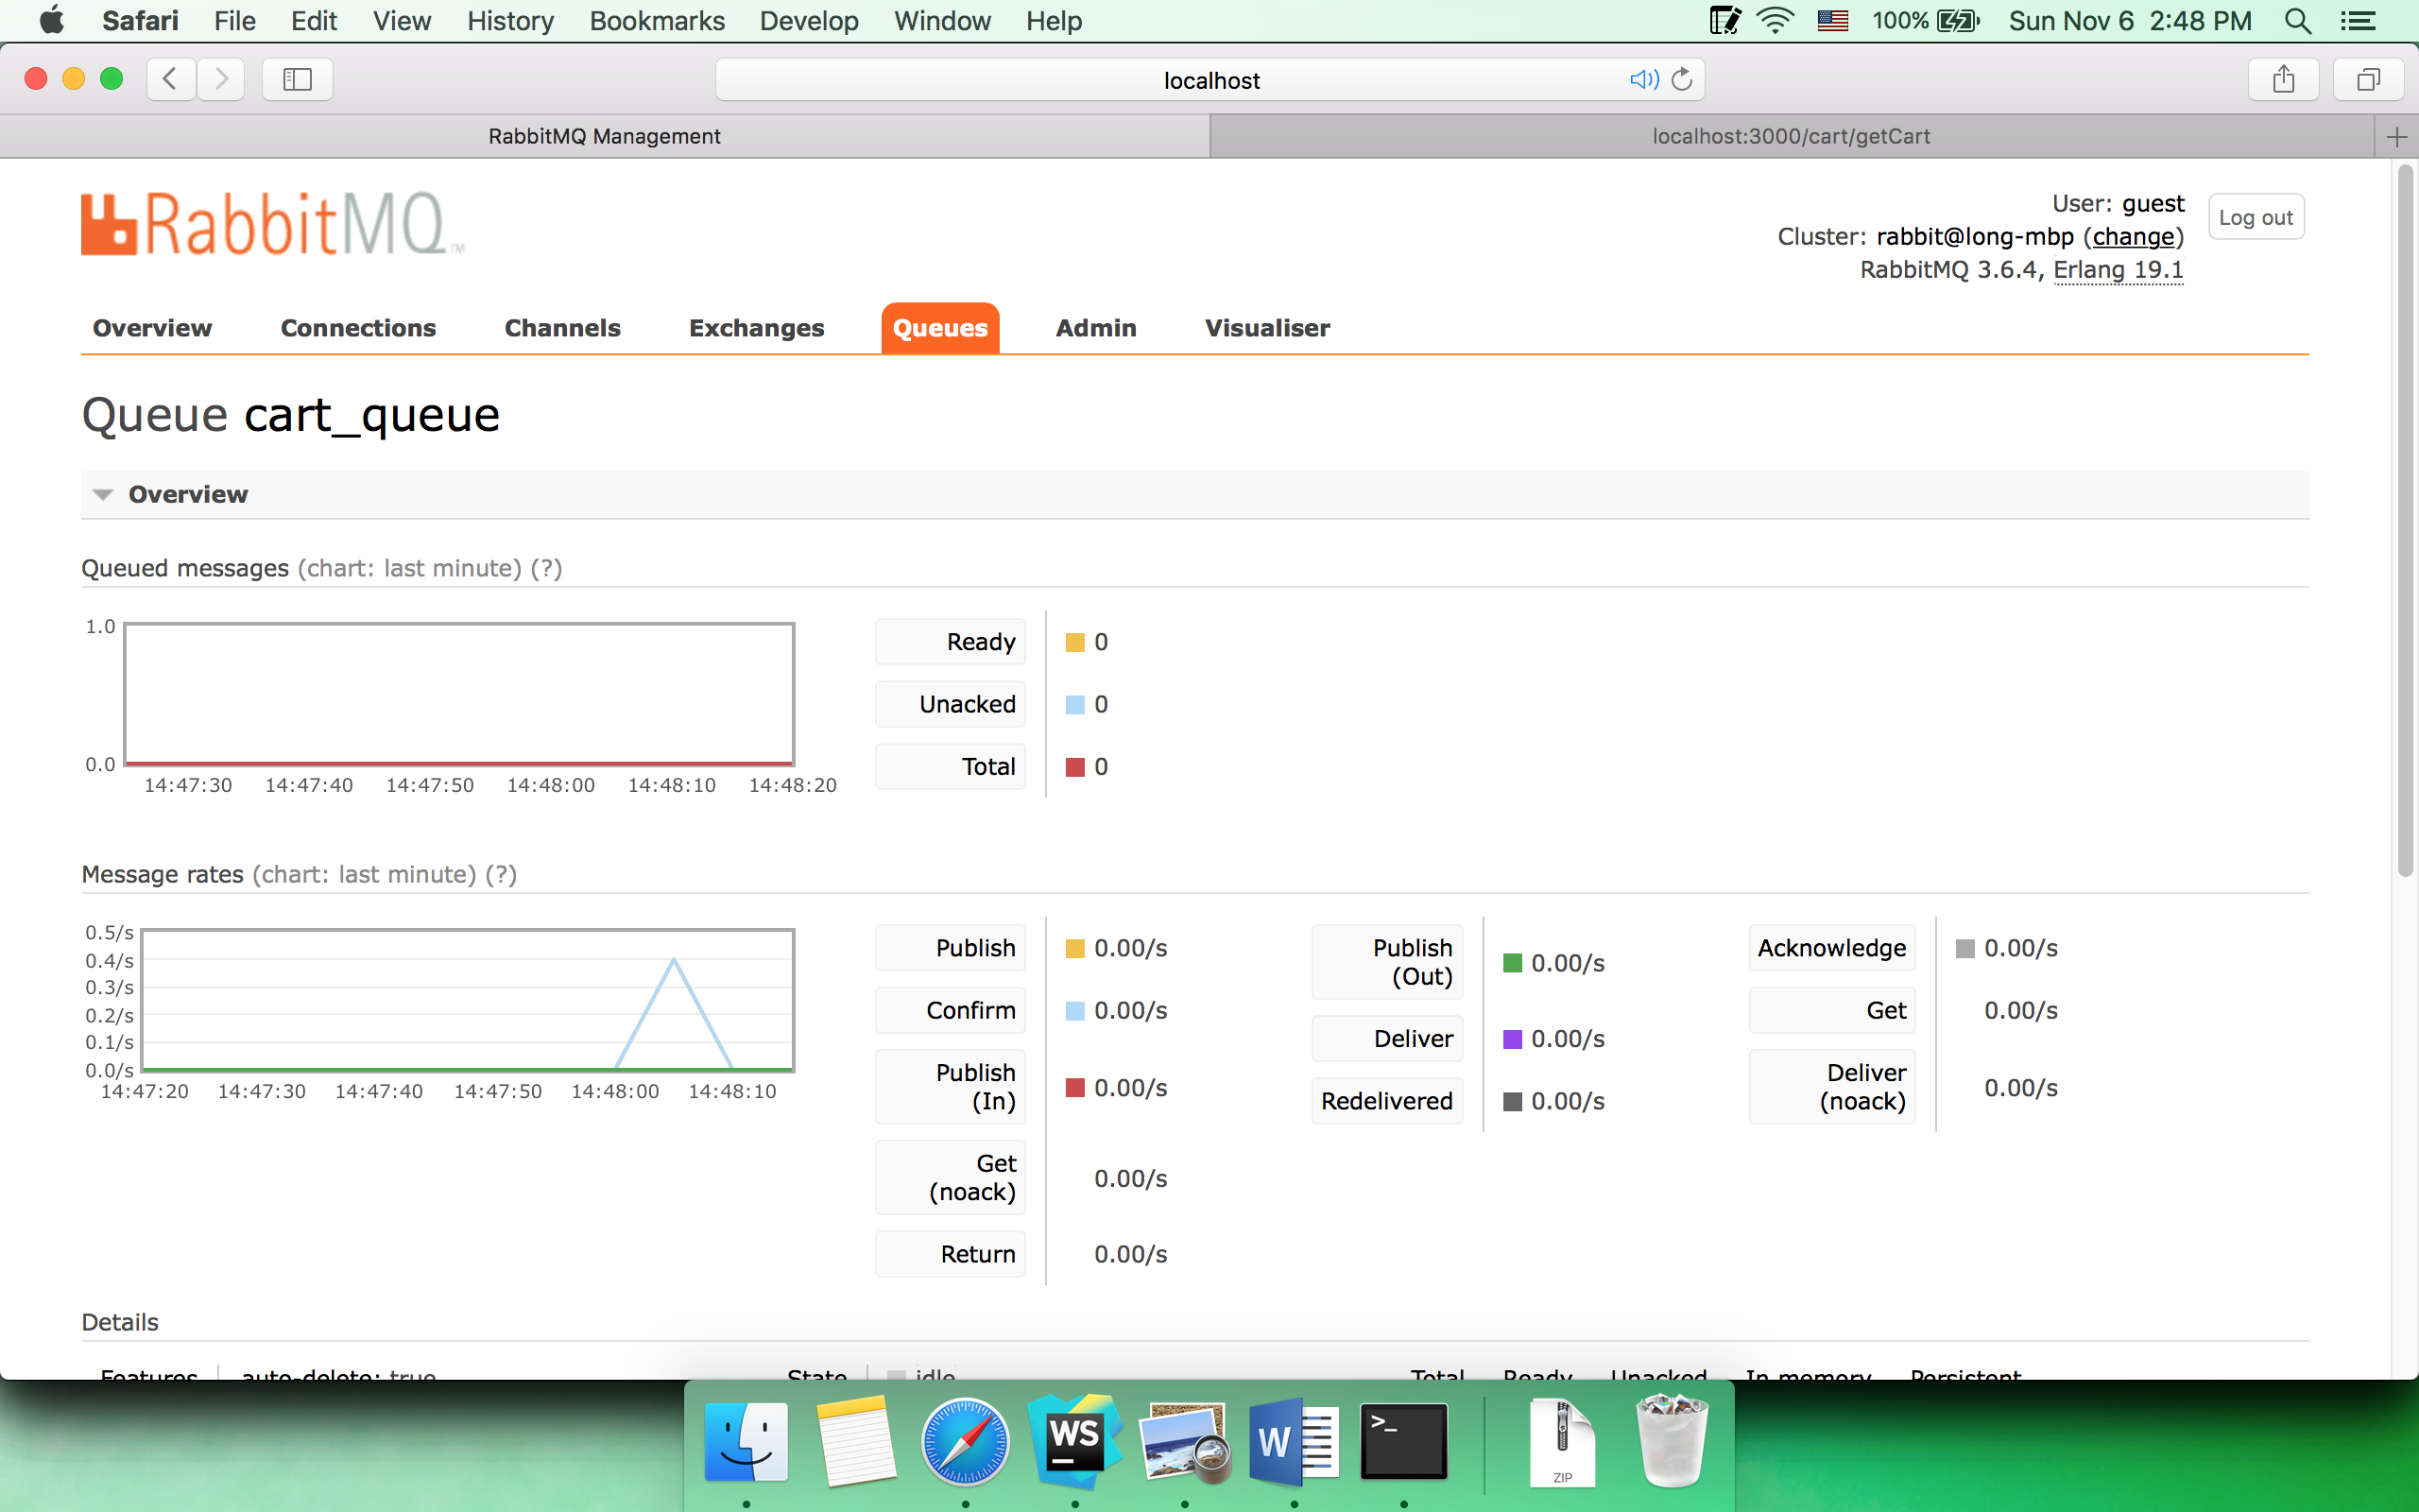

* 1. Checkout

Checkout page

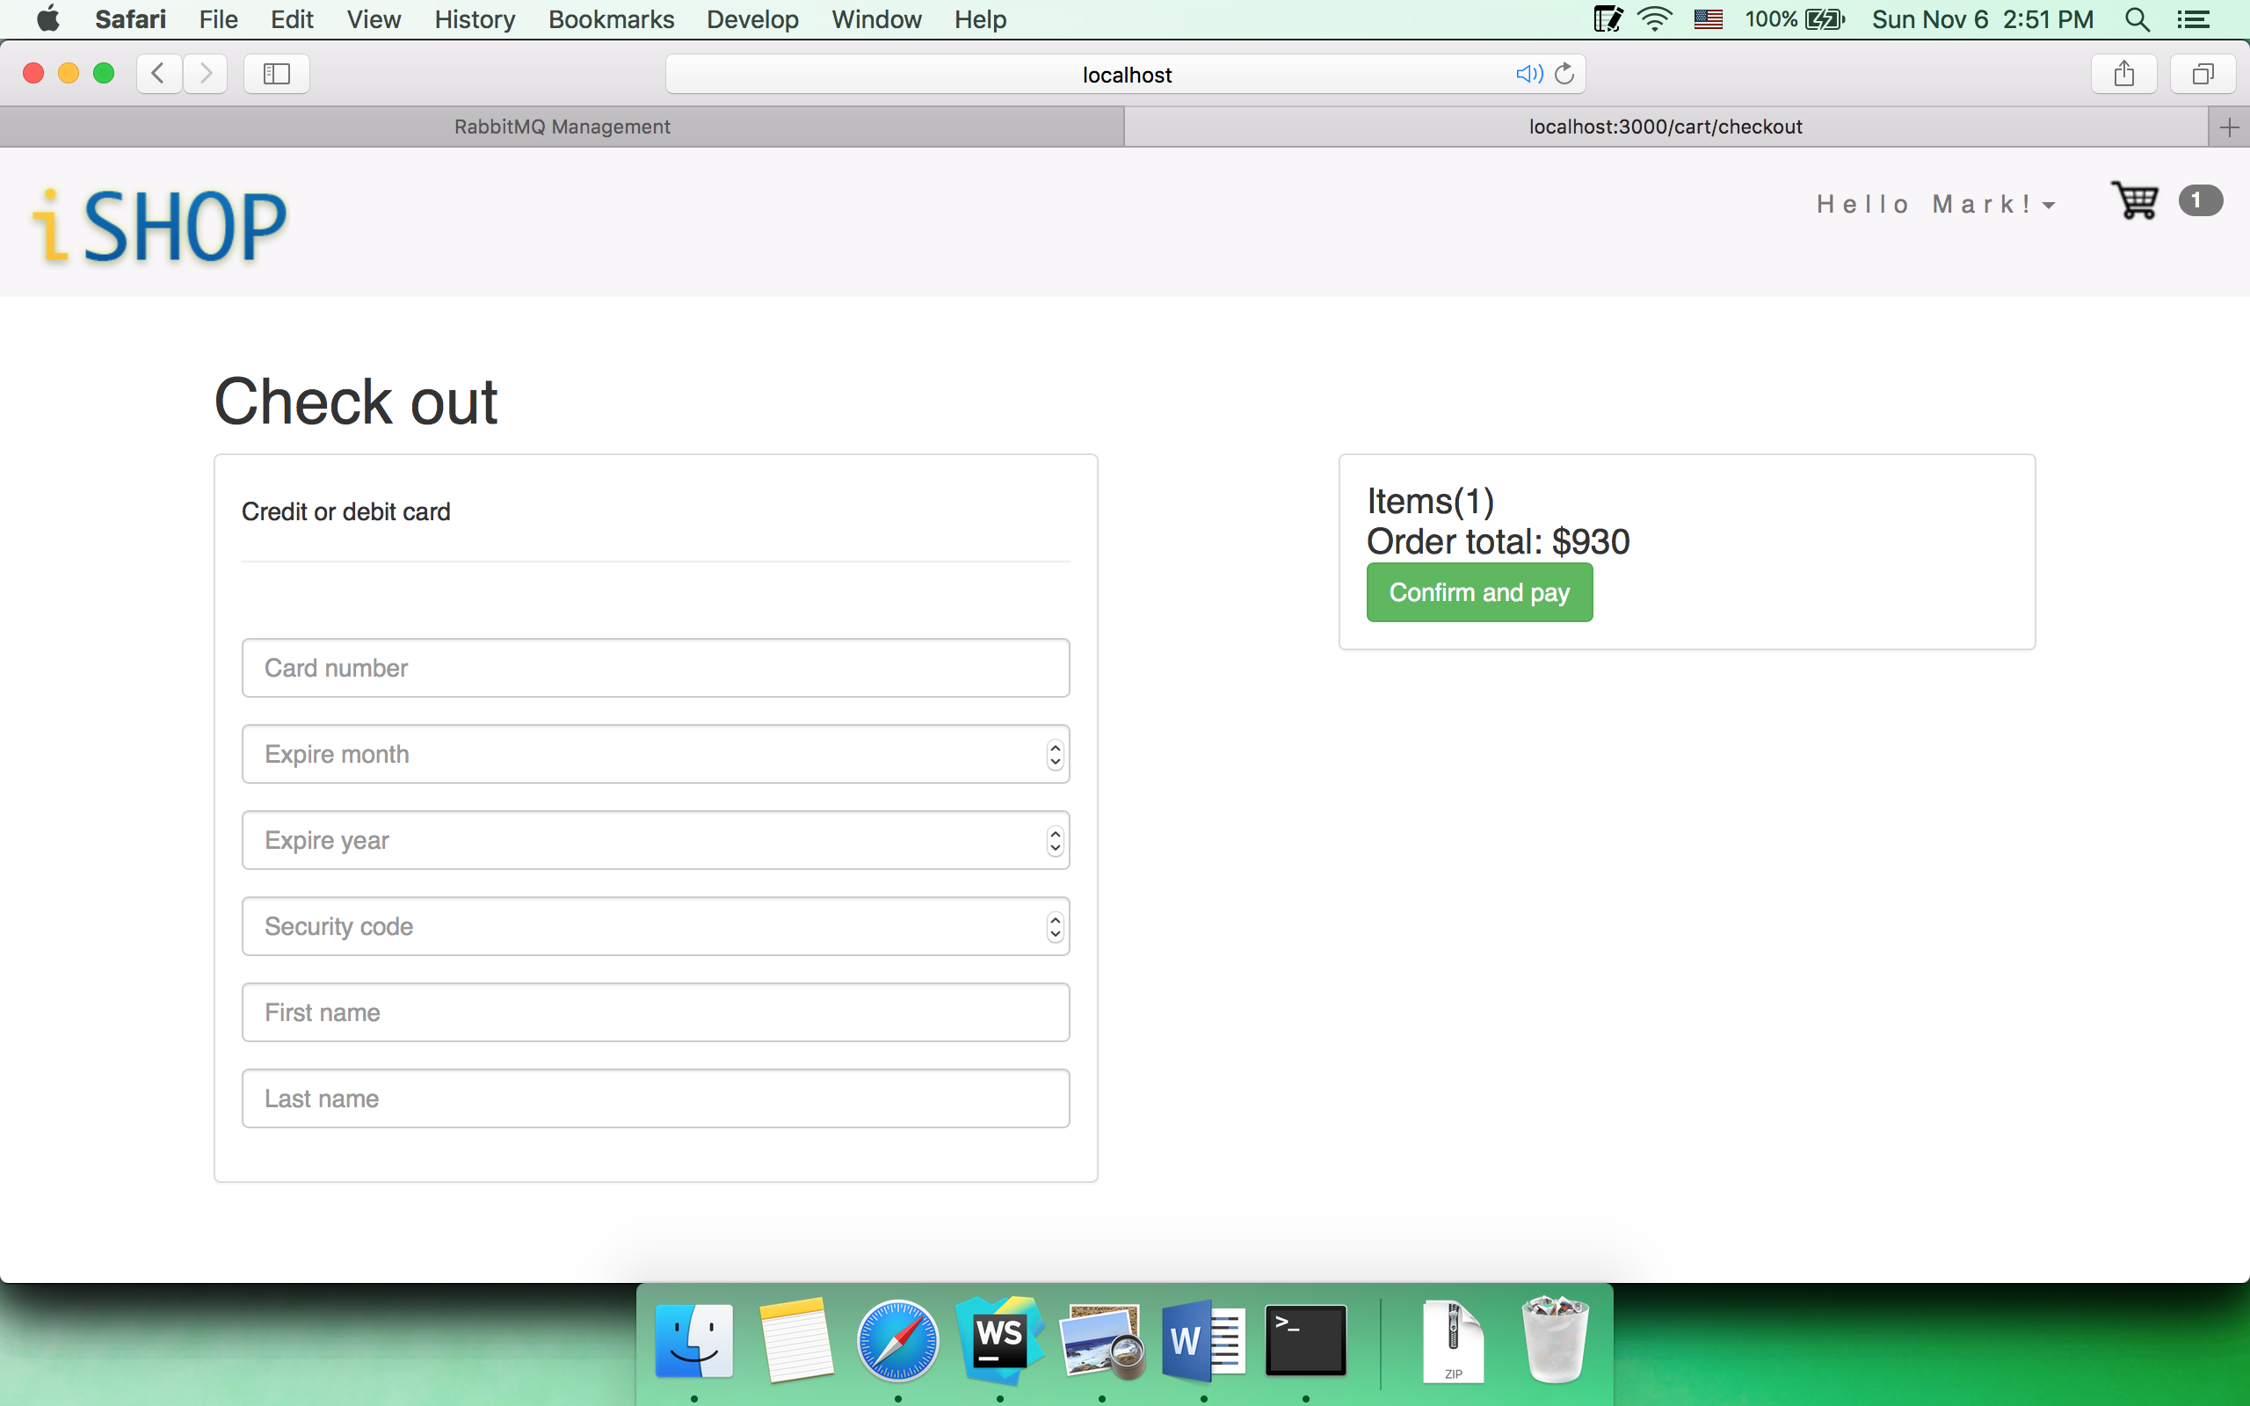

Confirm checkout with invalid card number

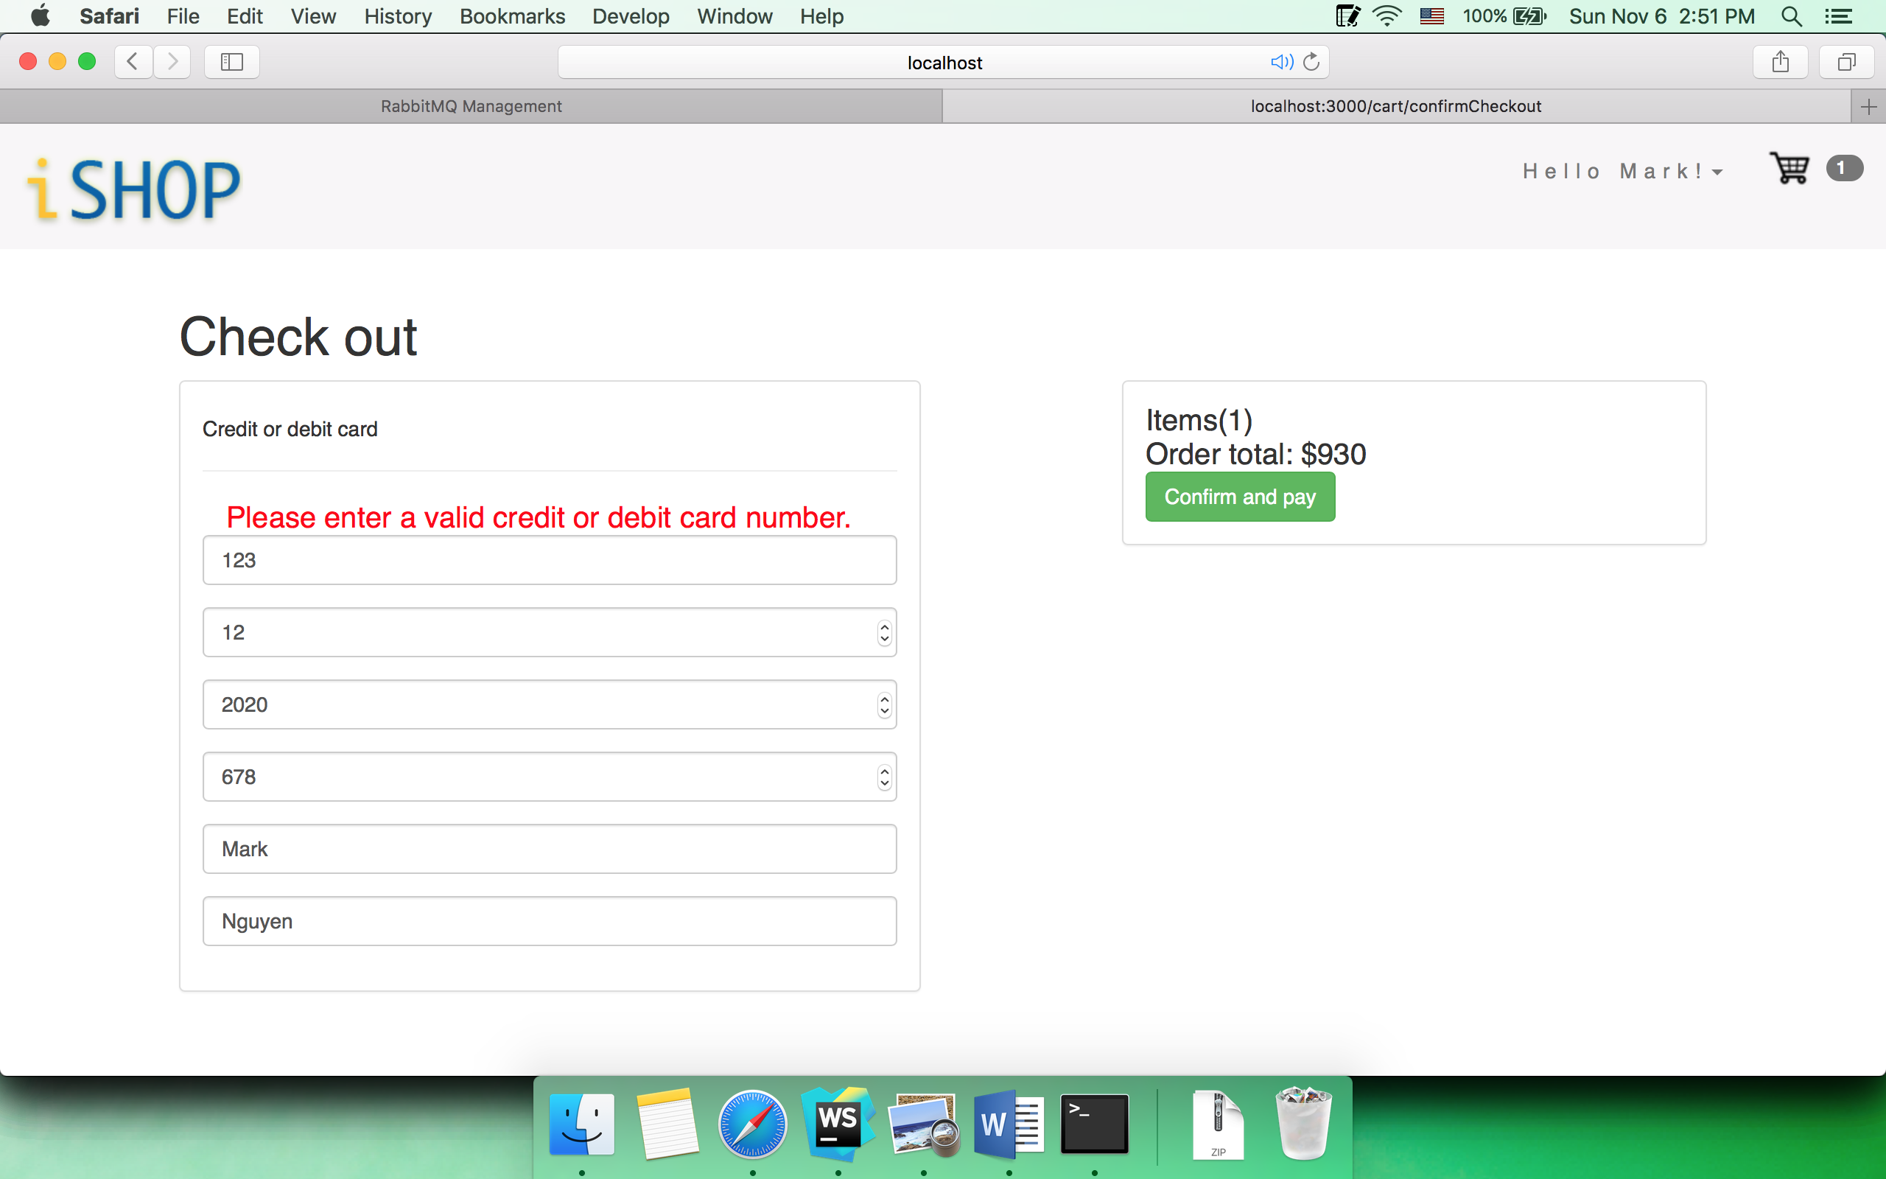

Order confirmation

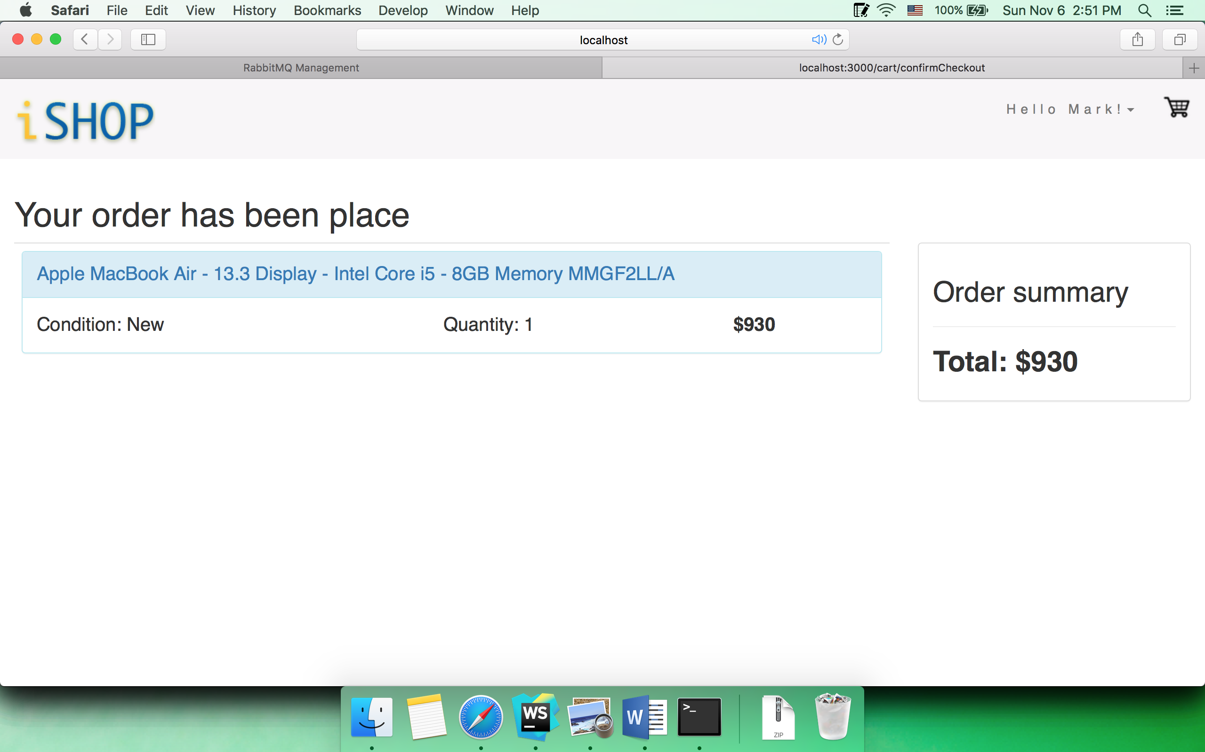

Queue

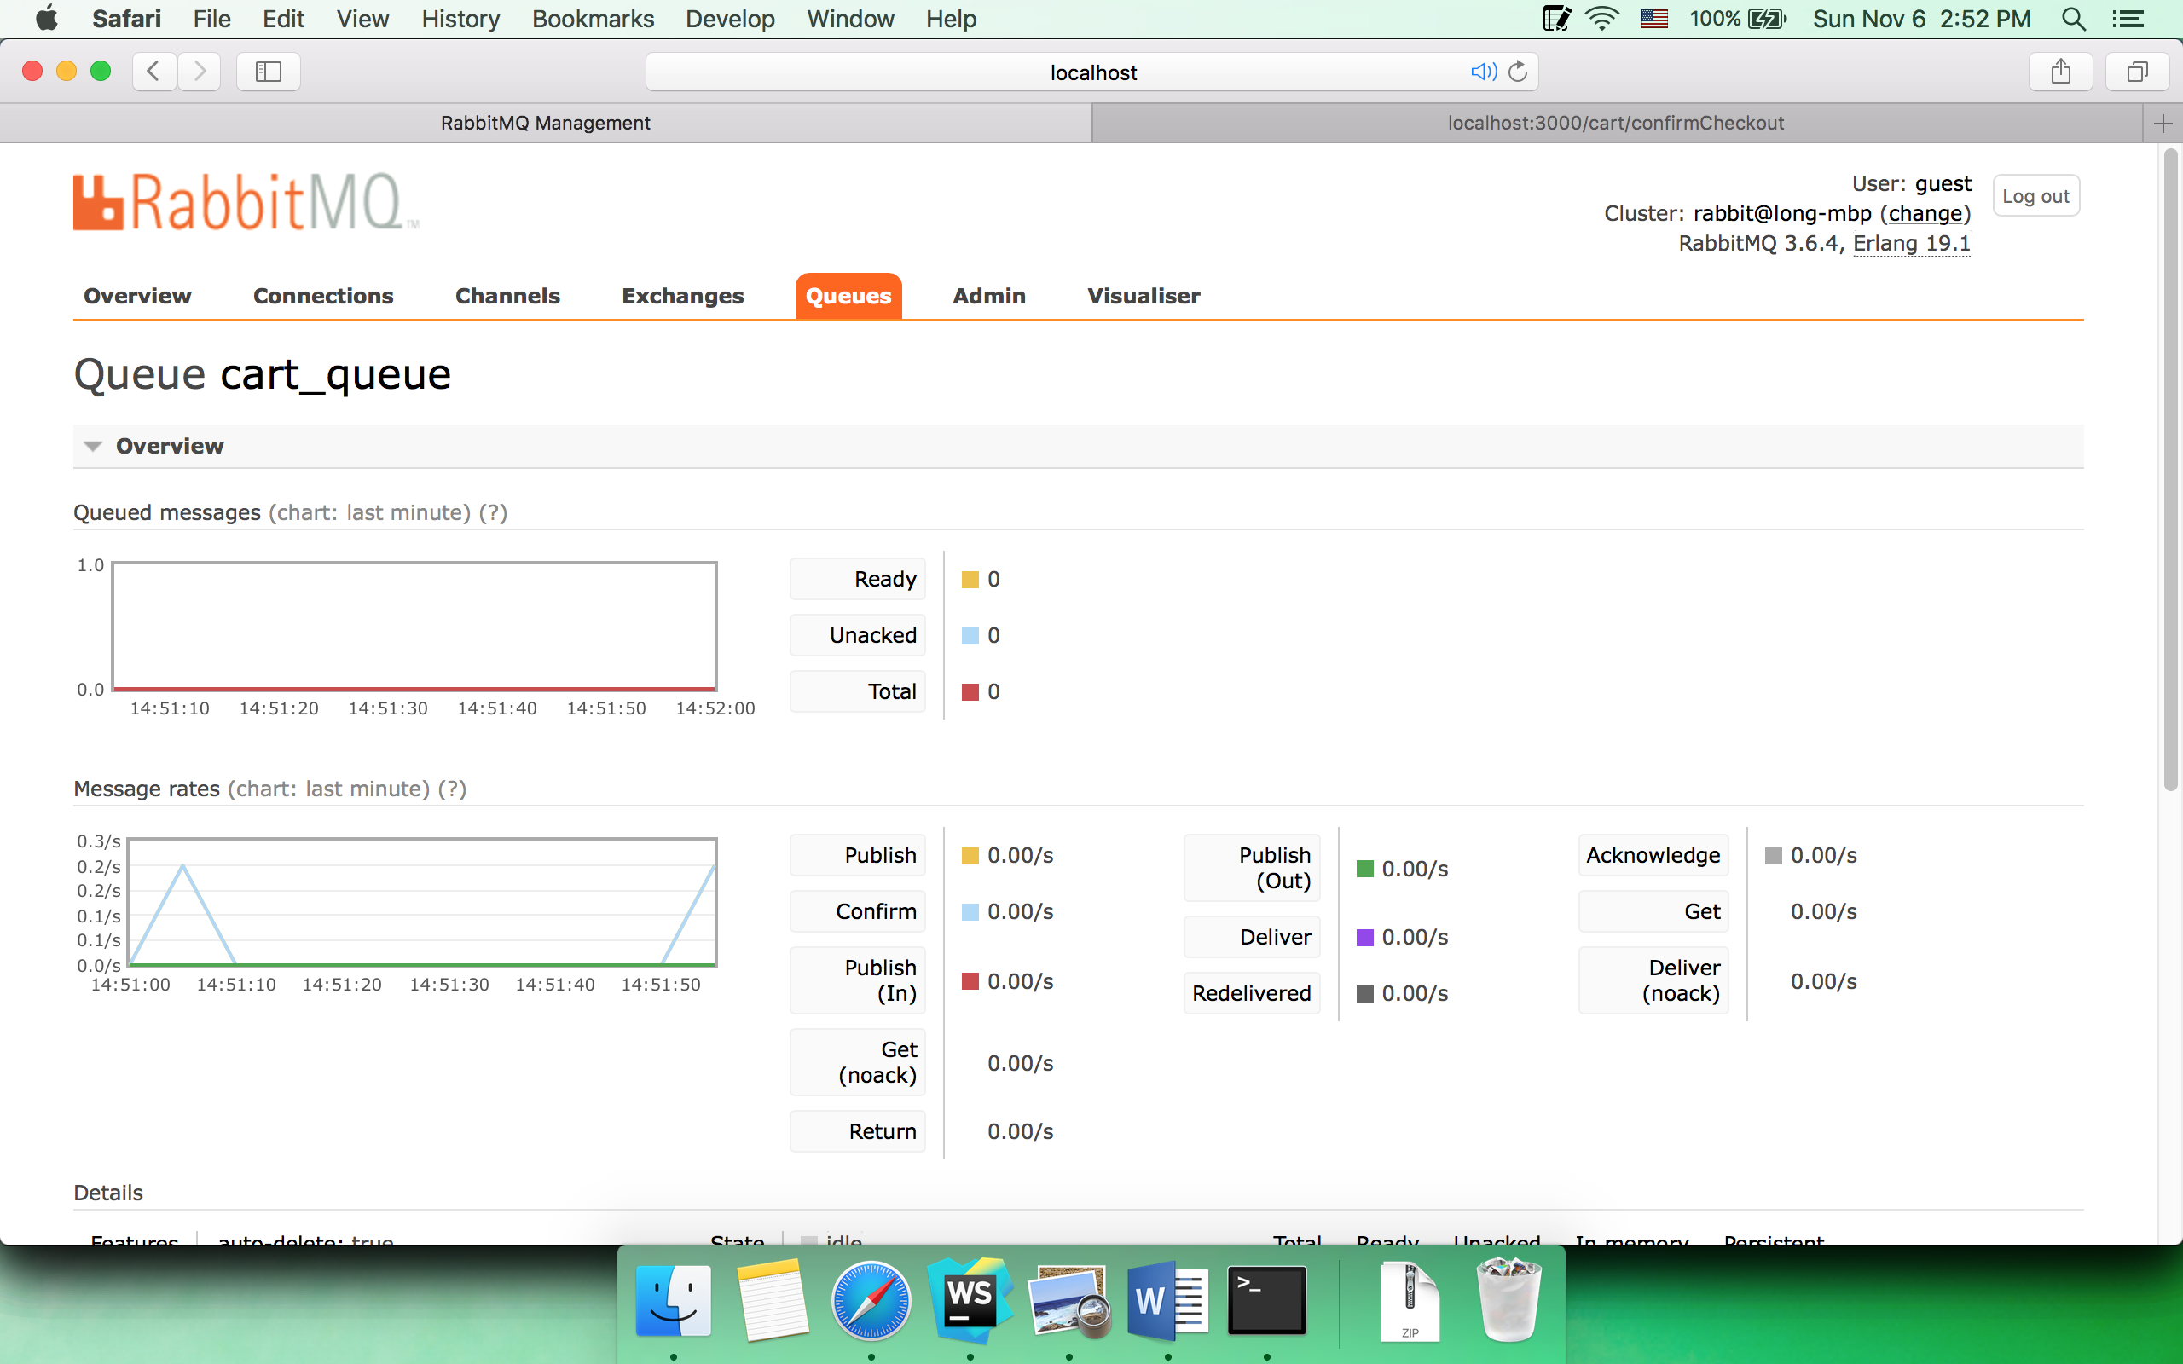

* 1. After this user check out, the sold number of the macbook air increases

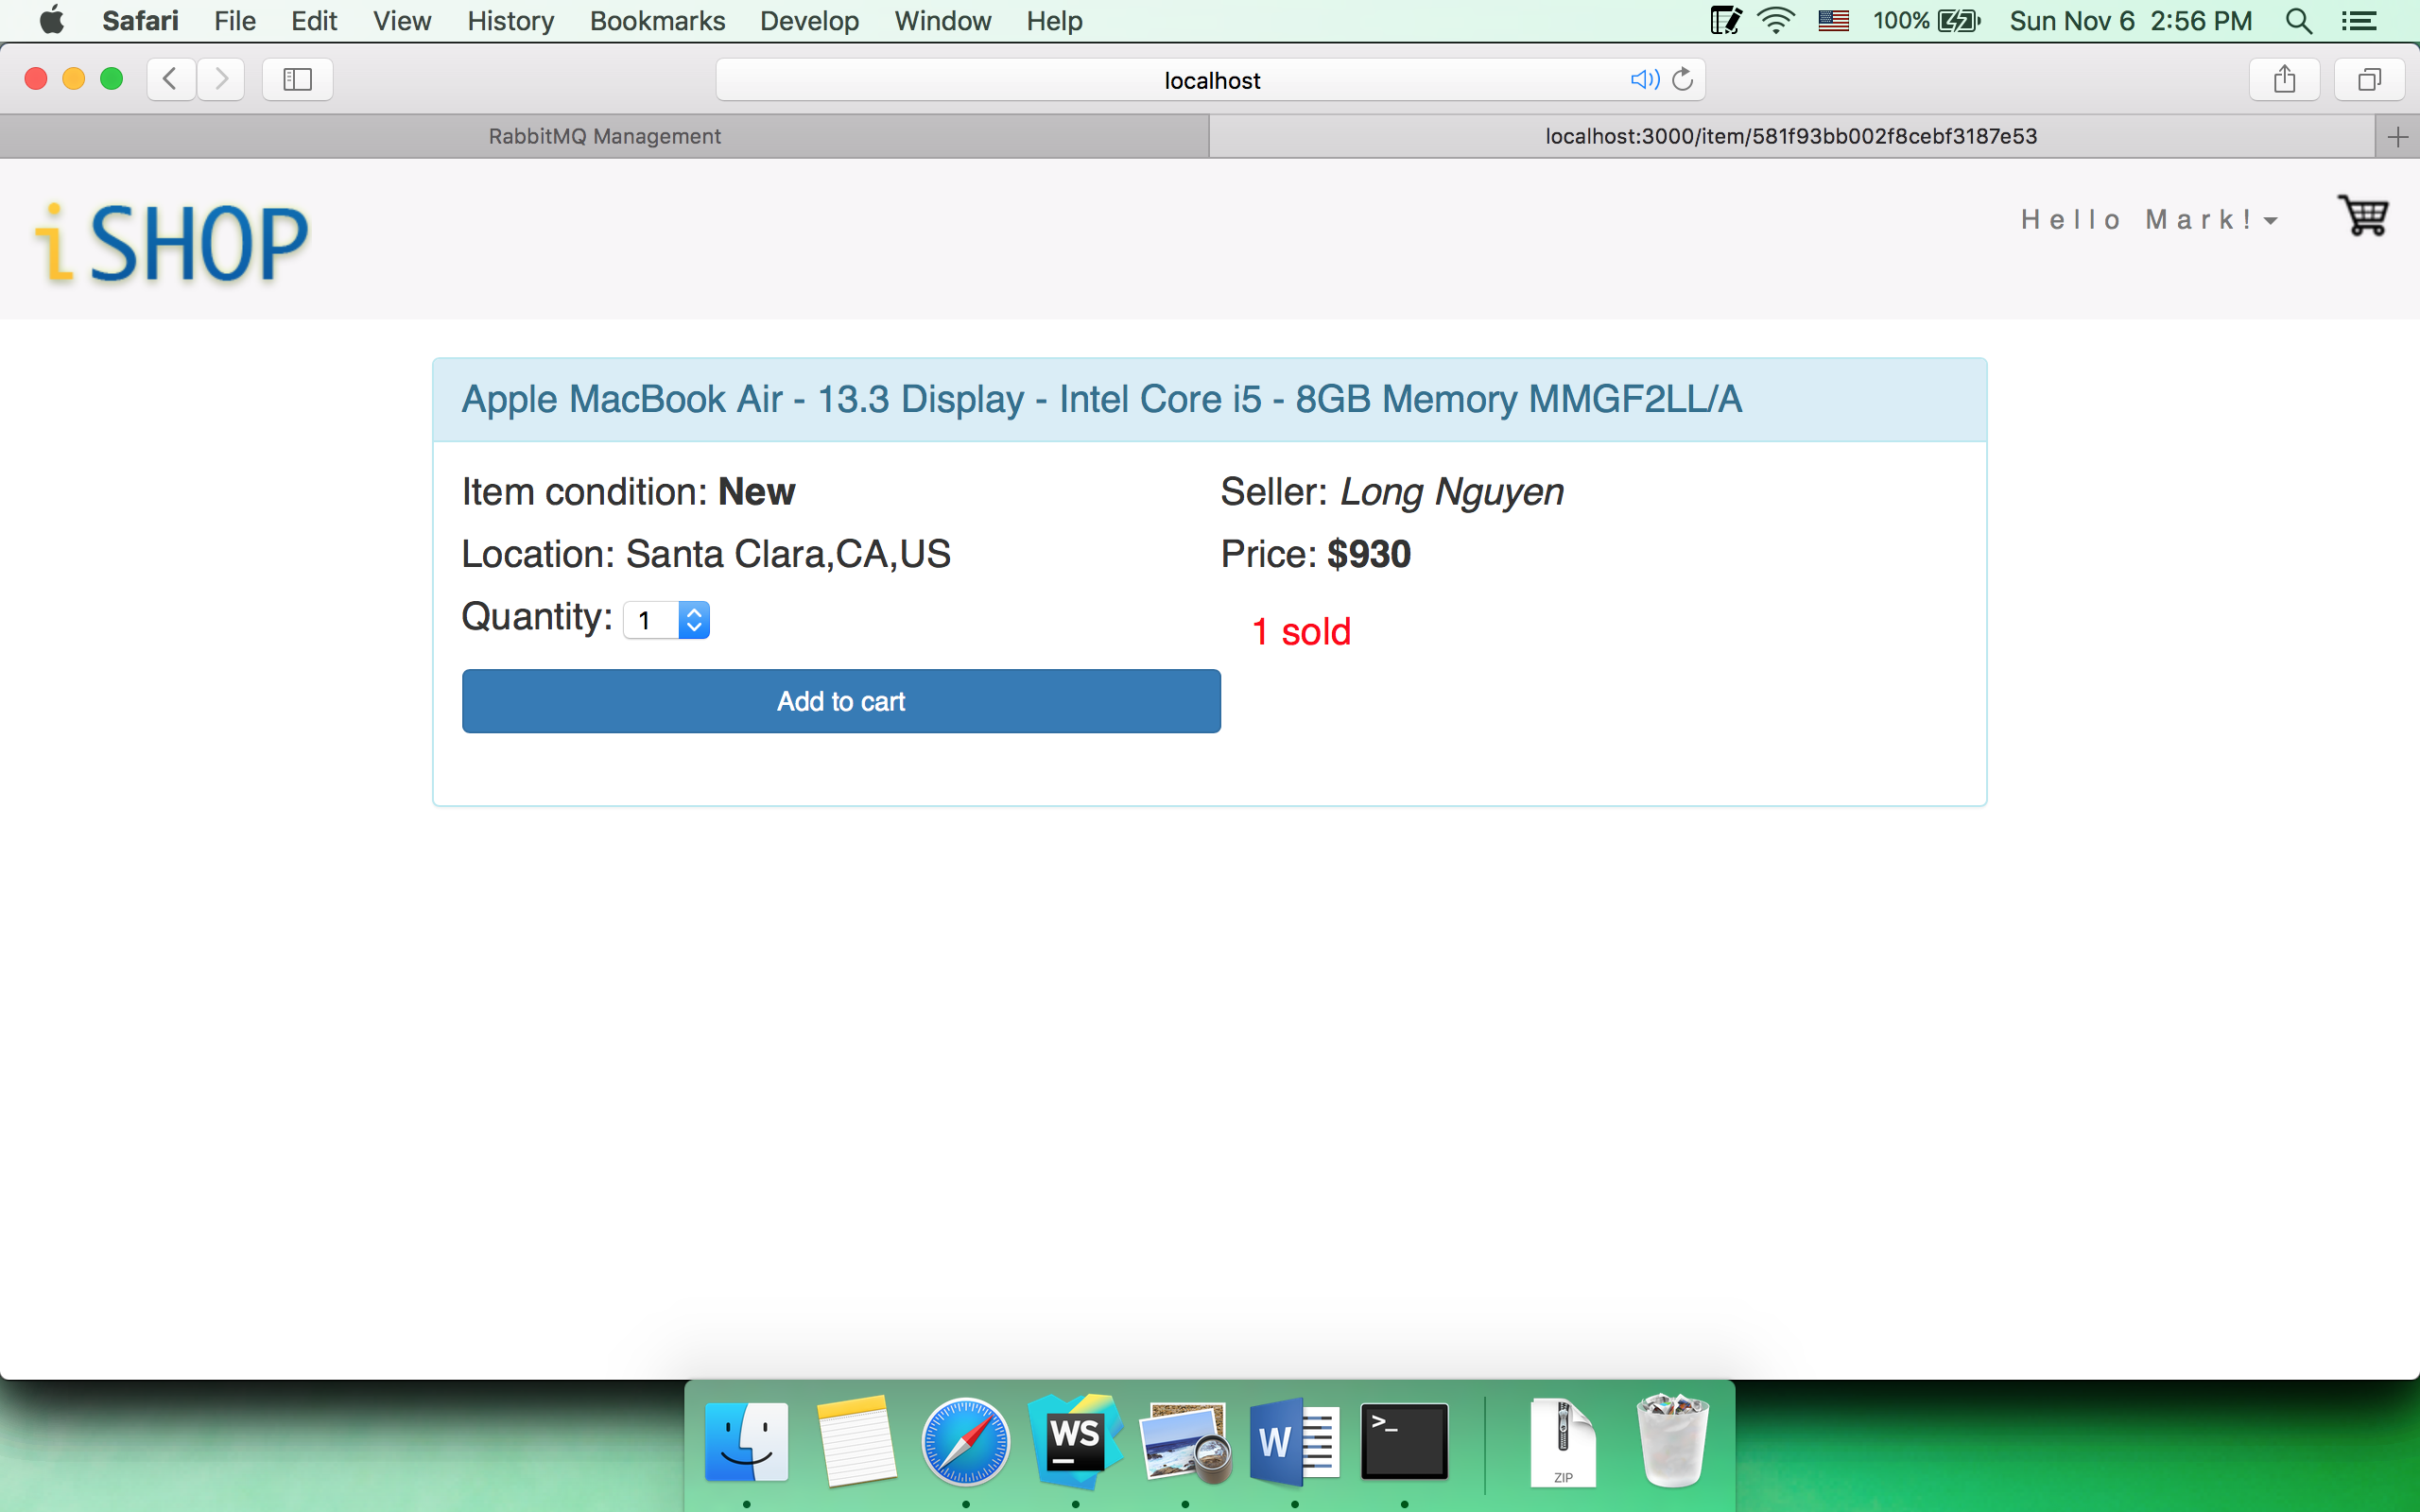

* 1. Try to add to cart with the number of items that exceeds the available

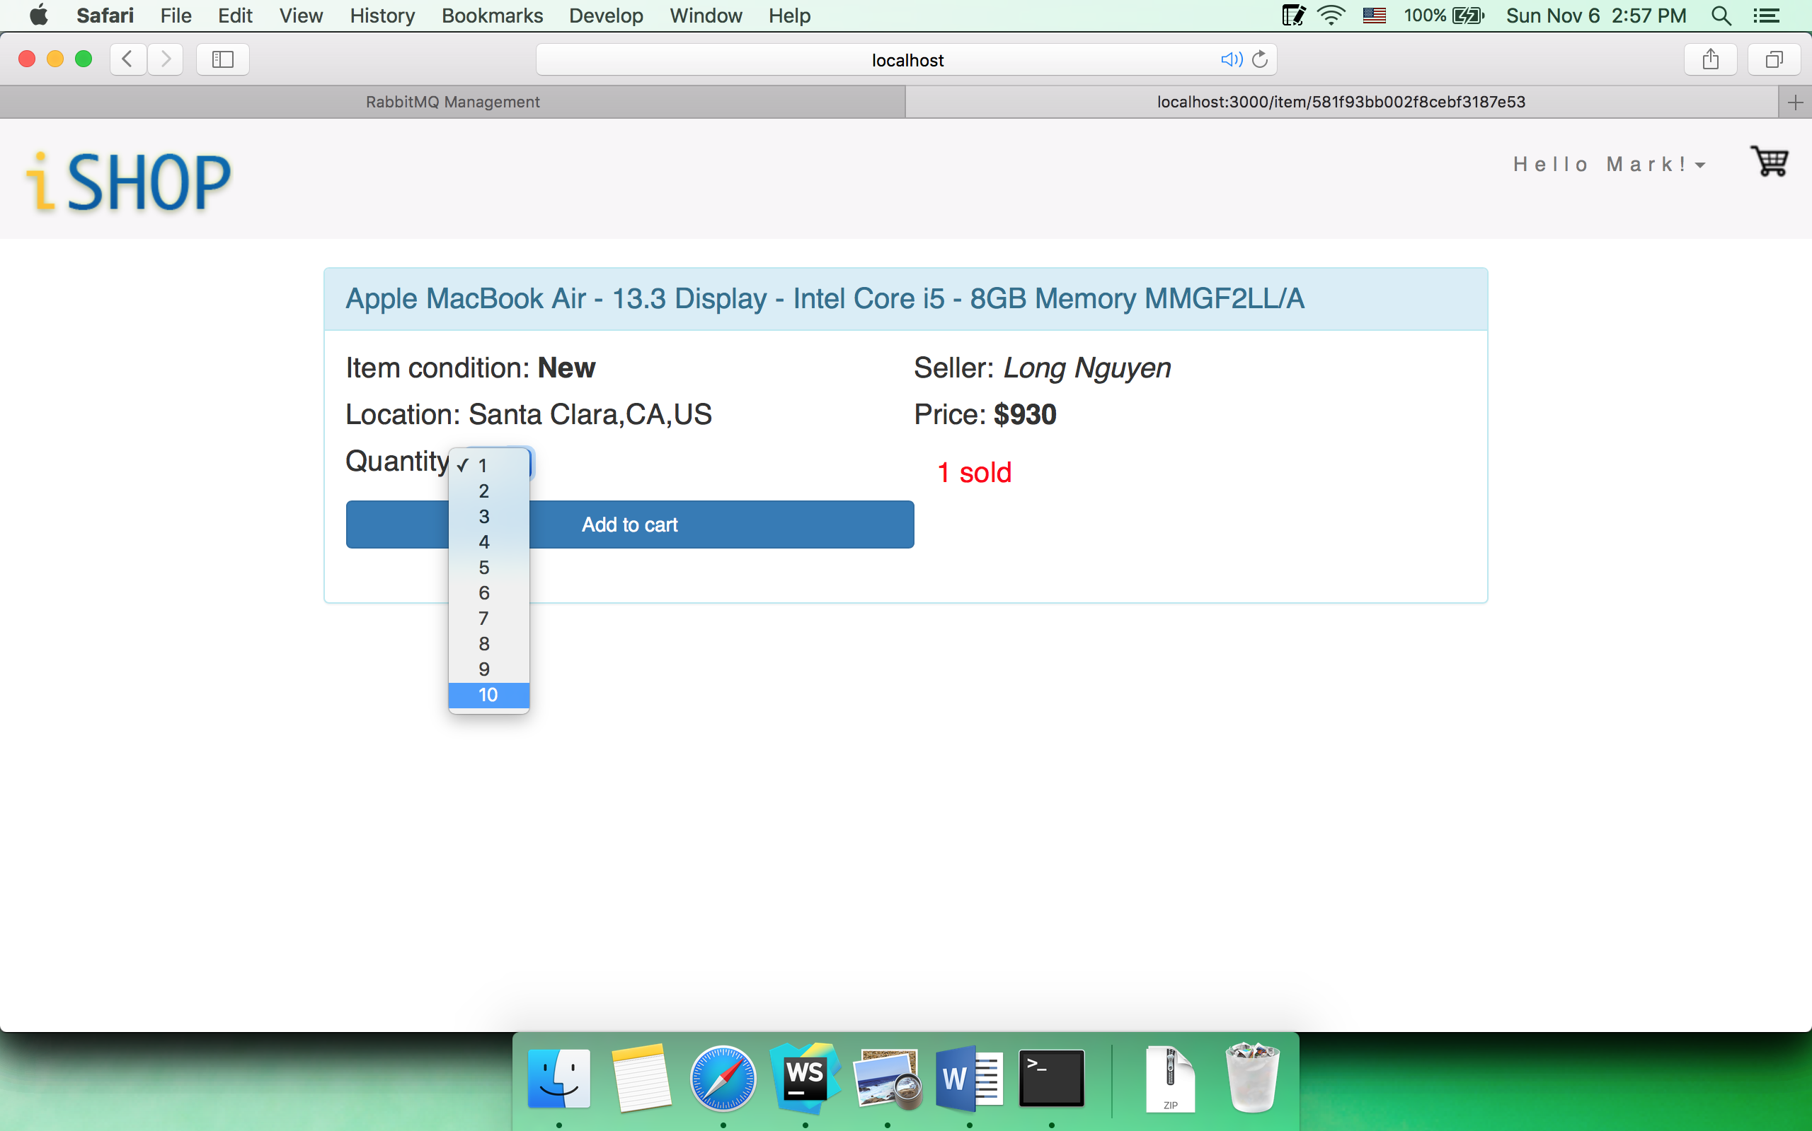

The number of items in cart will be automatically adjusted to match the available

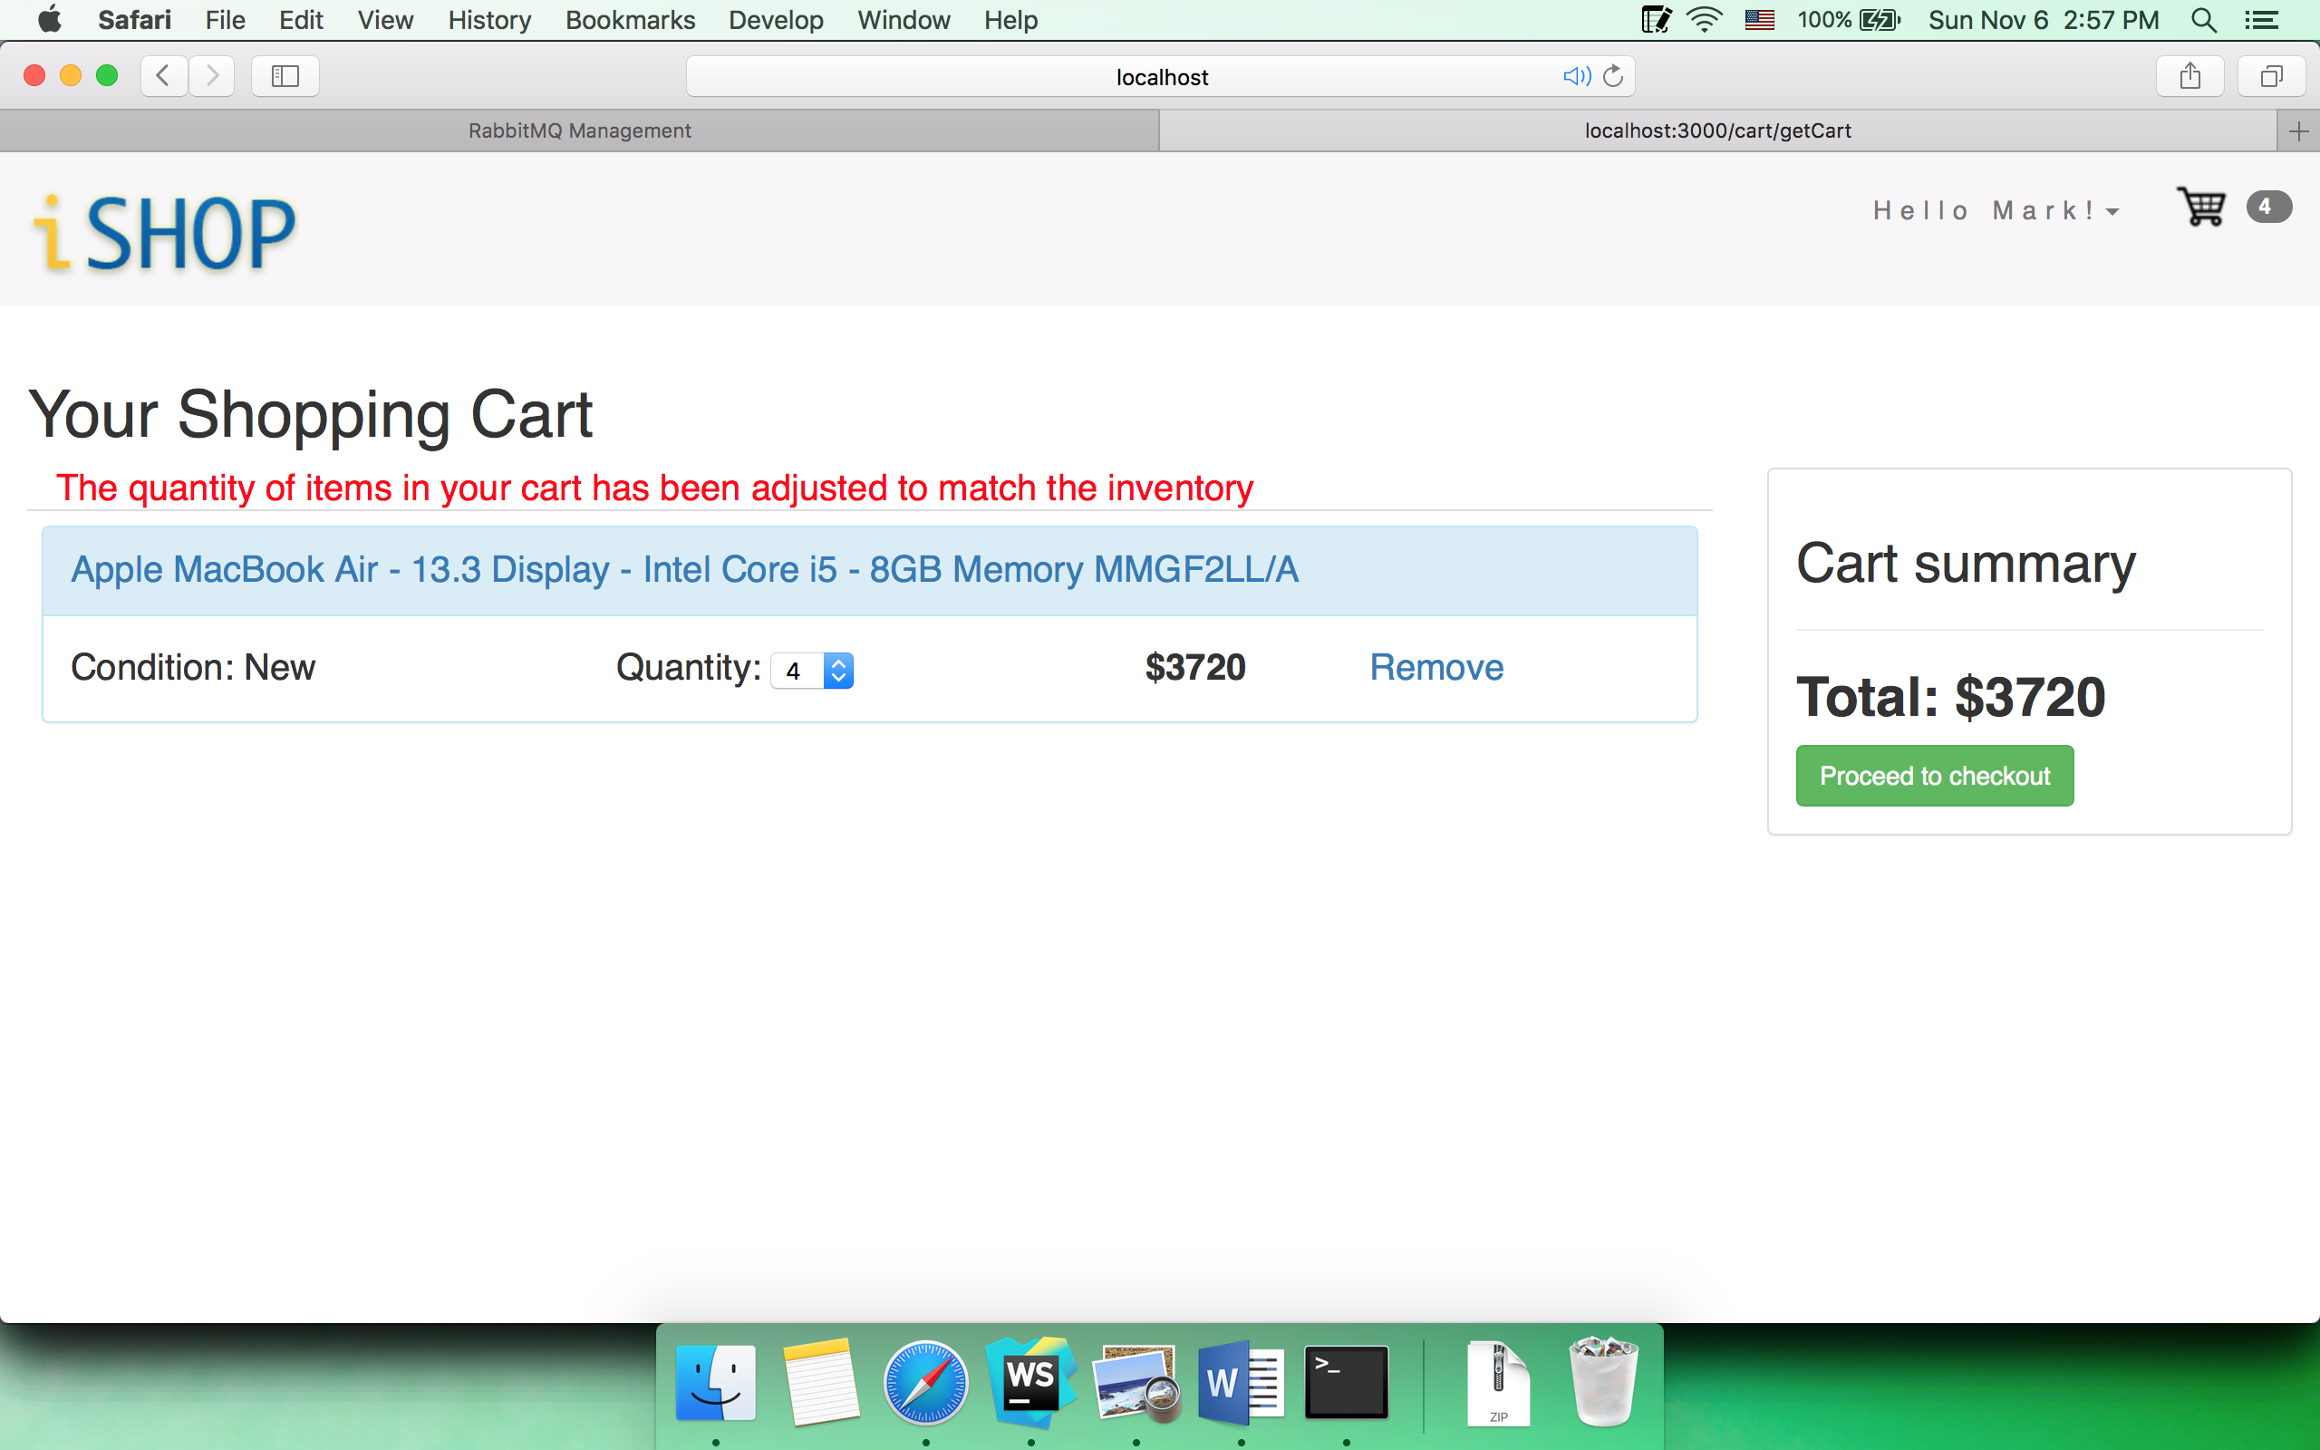

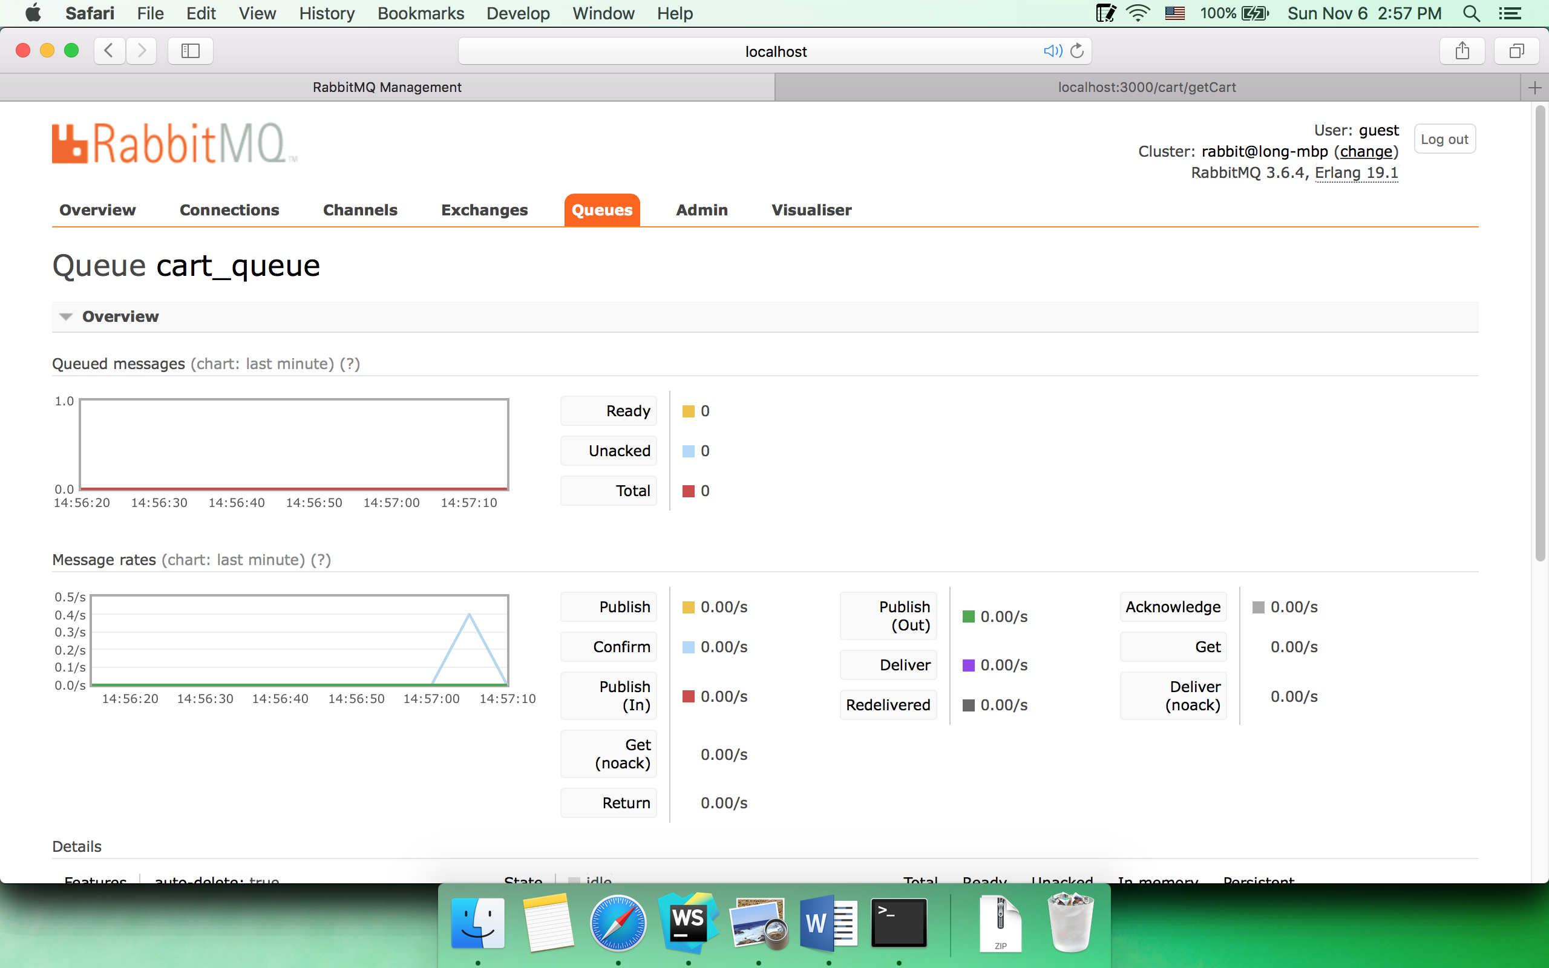

* 1. Inventory management

Suppose John buys 2 Macbook air before Mark checkouts

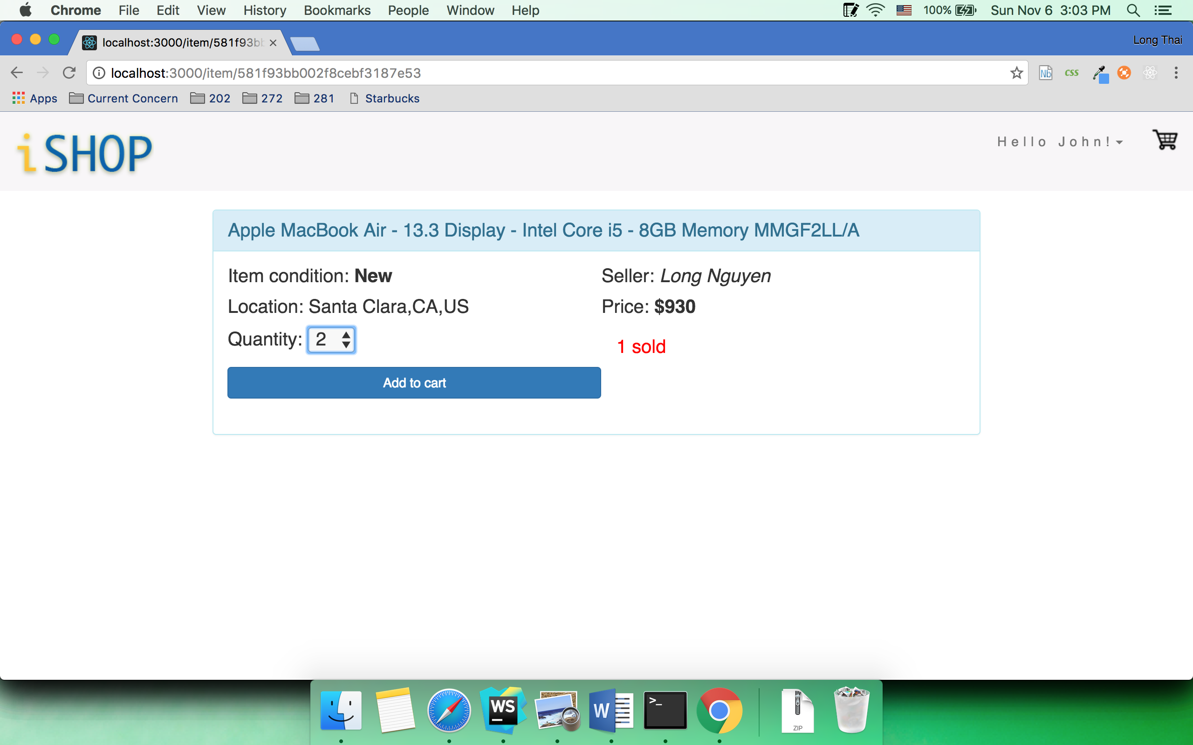

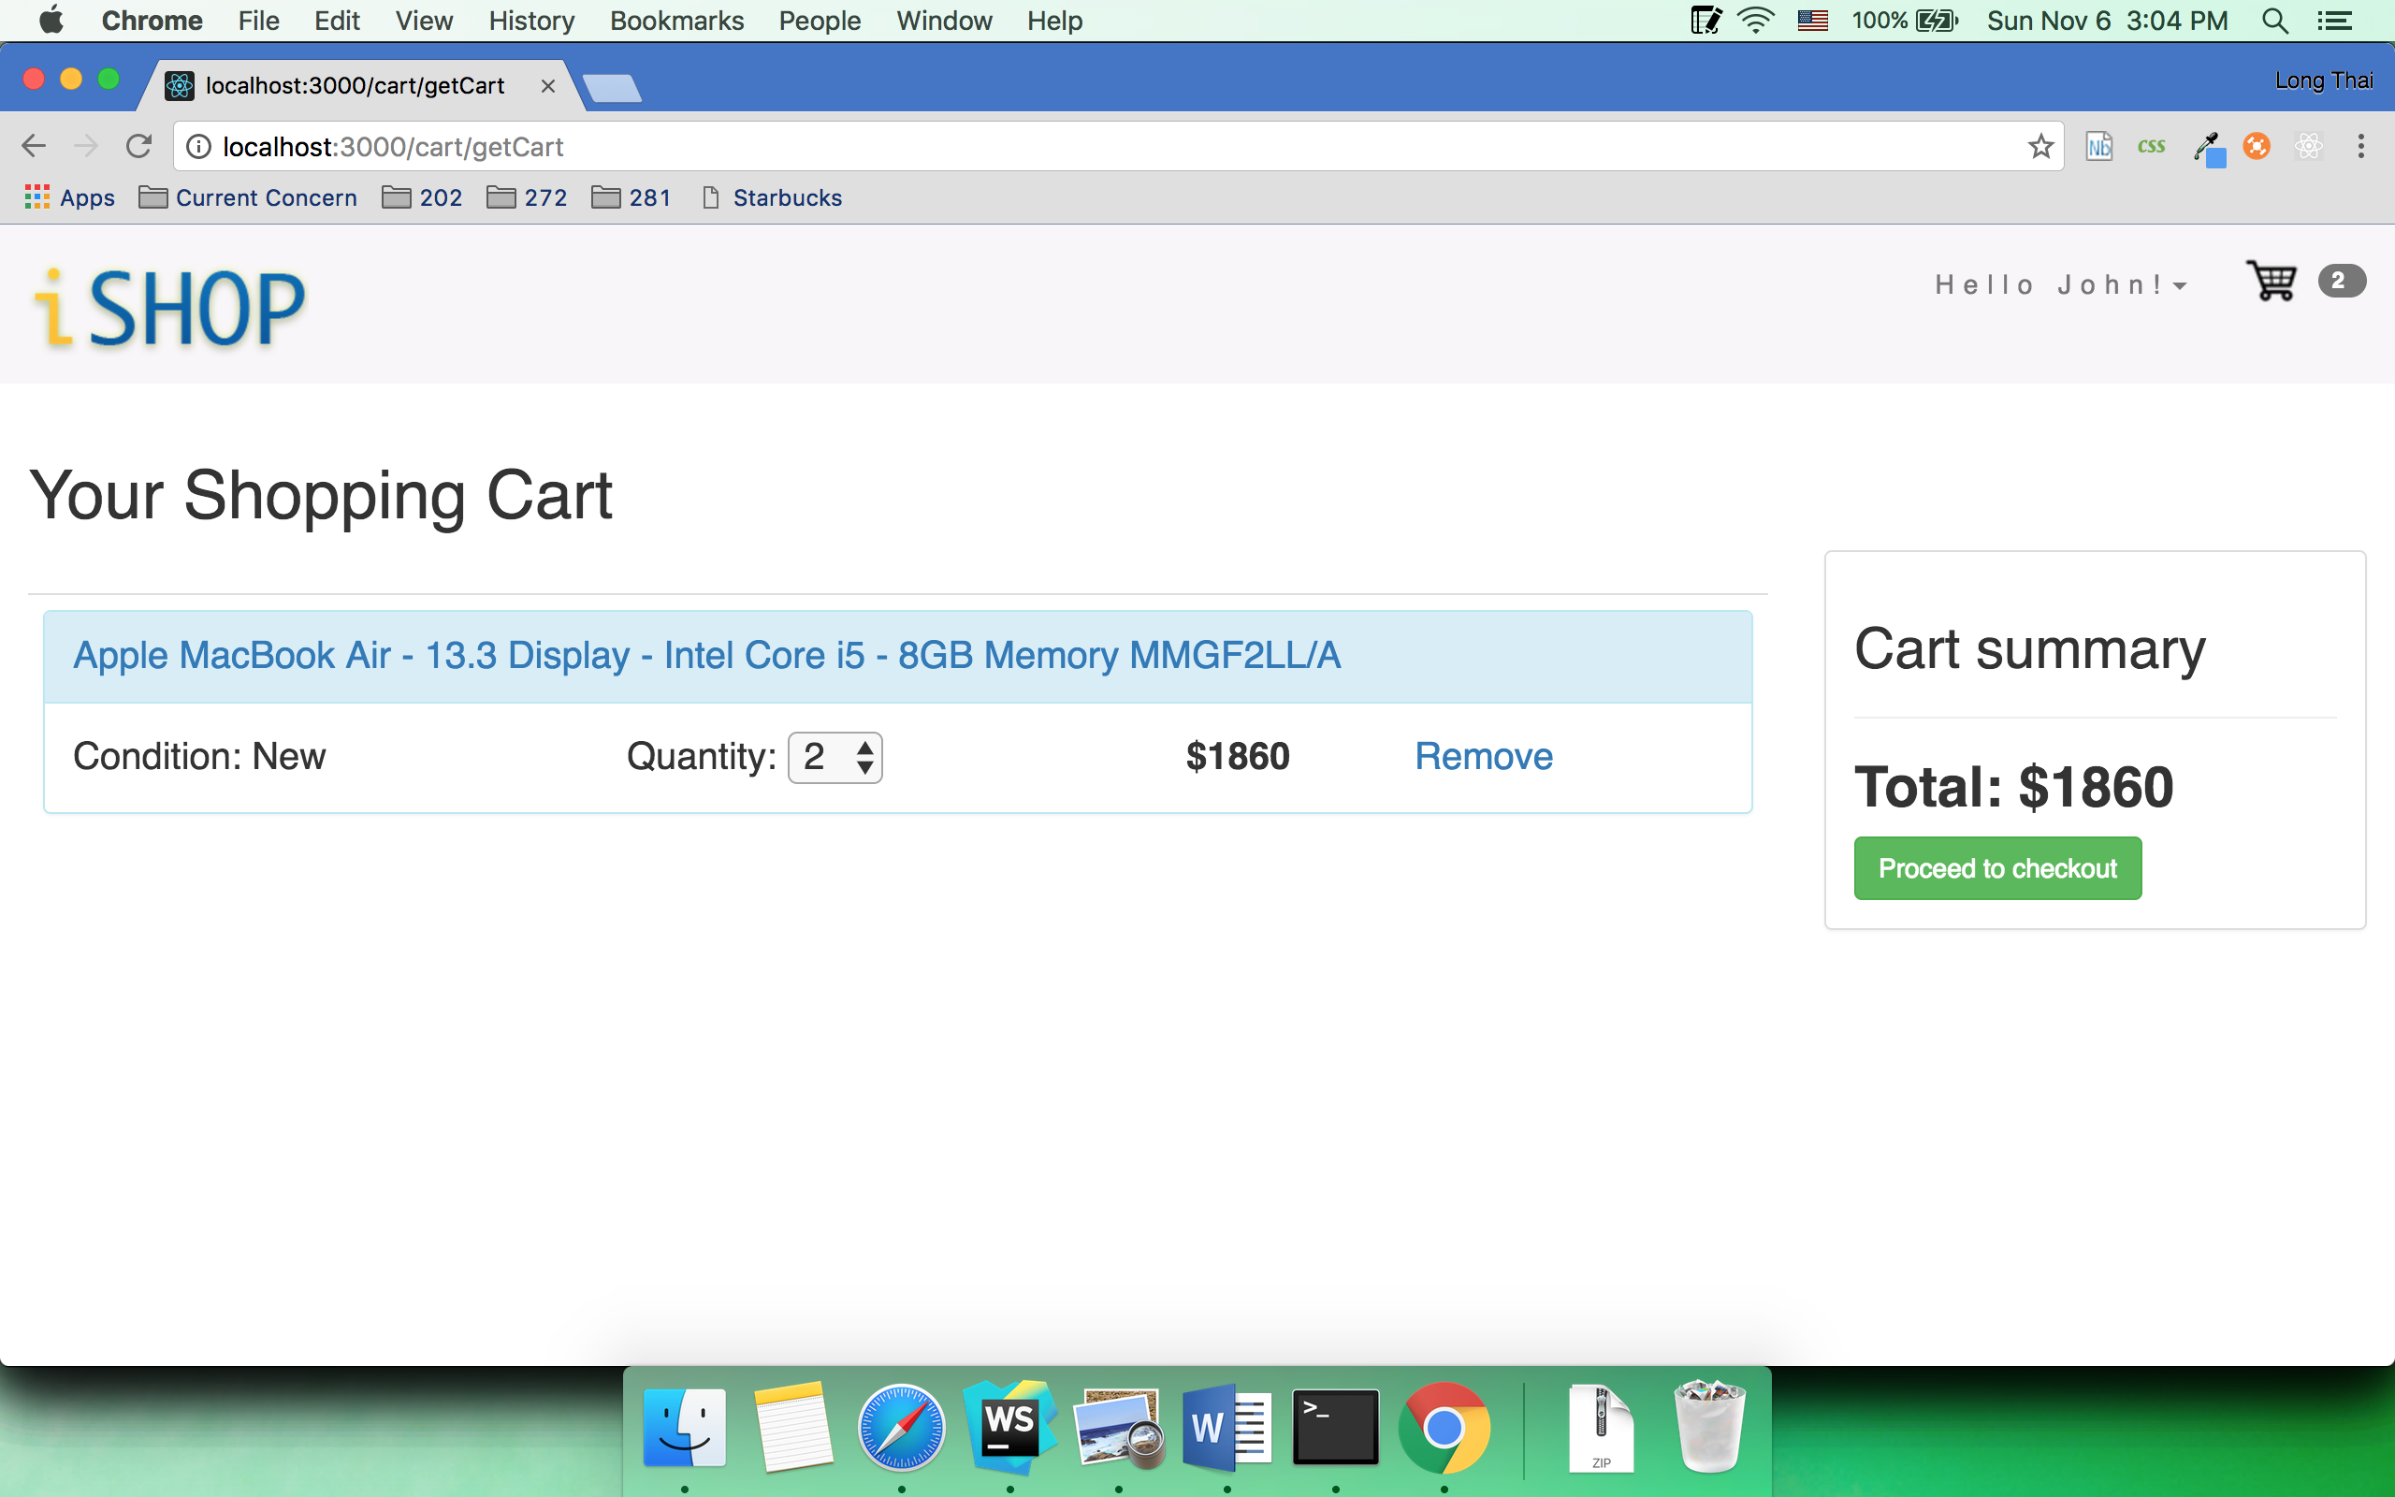

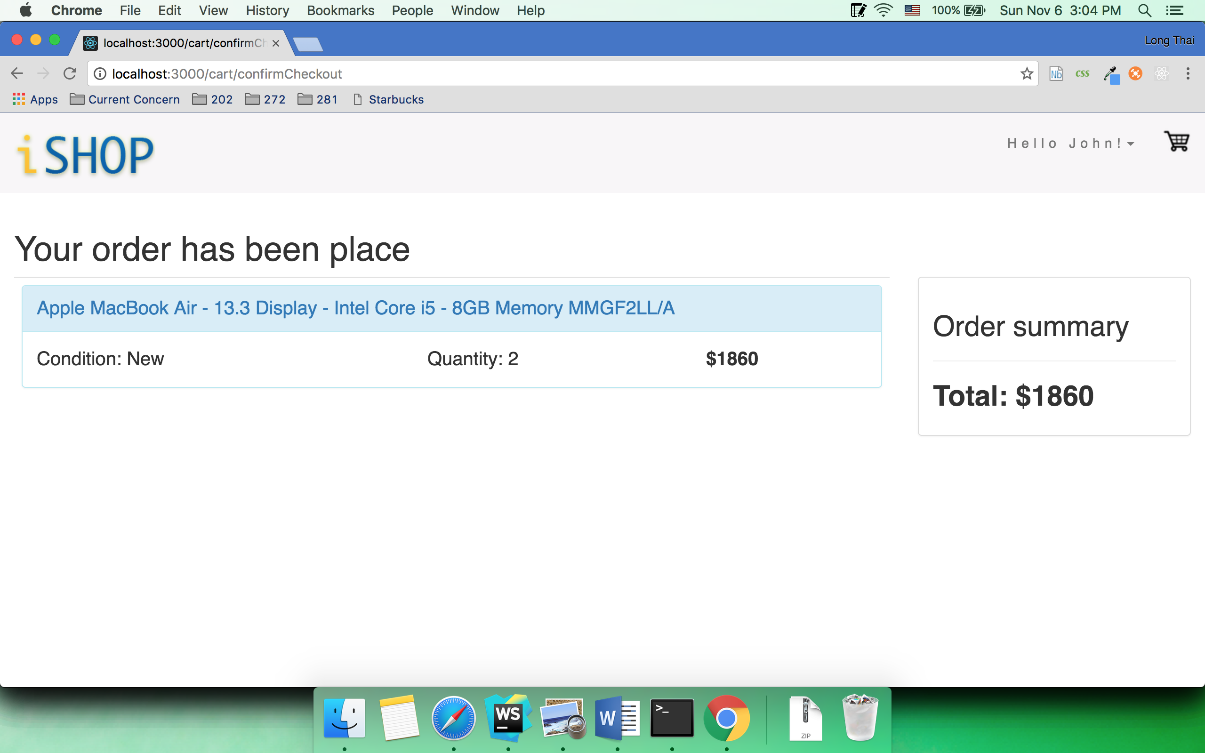

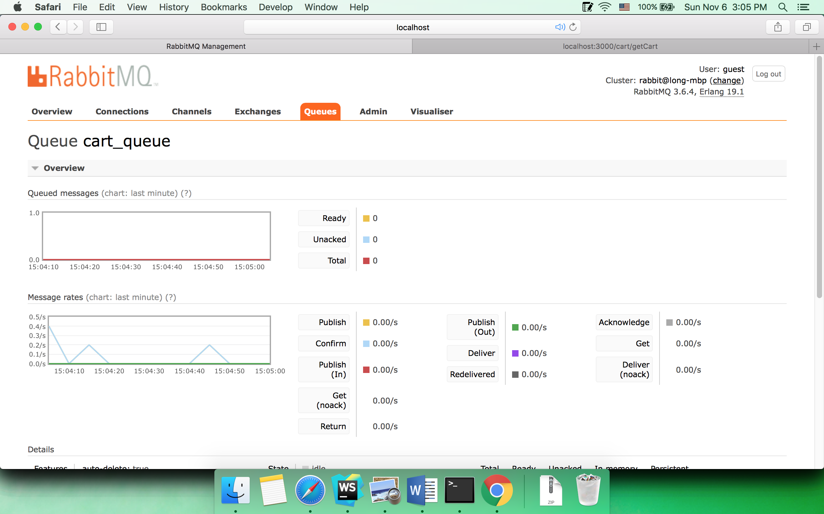

When Mark clicks Procced checkout, he will be informed to inventory changed to 2

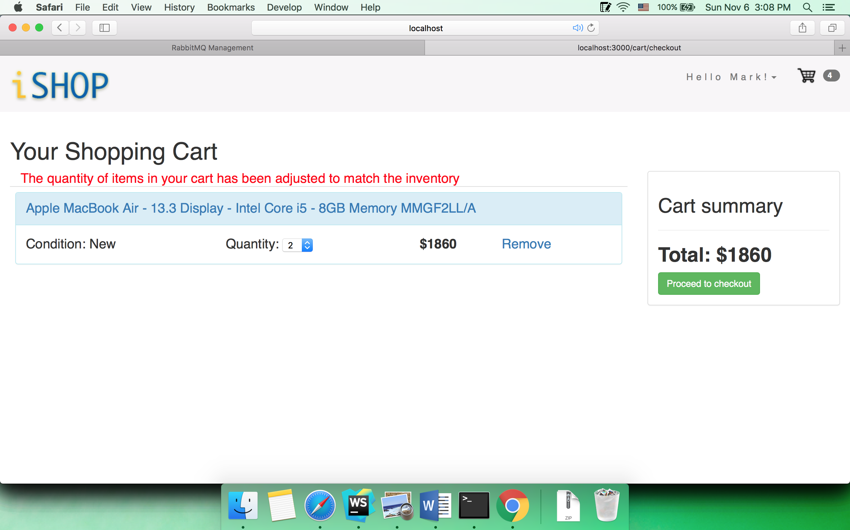

while Mark considers if he should buy 2 Macbook Airs or not, John continues to buy the 2 remain macbook airs.

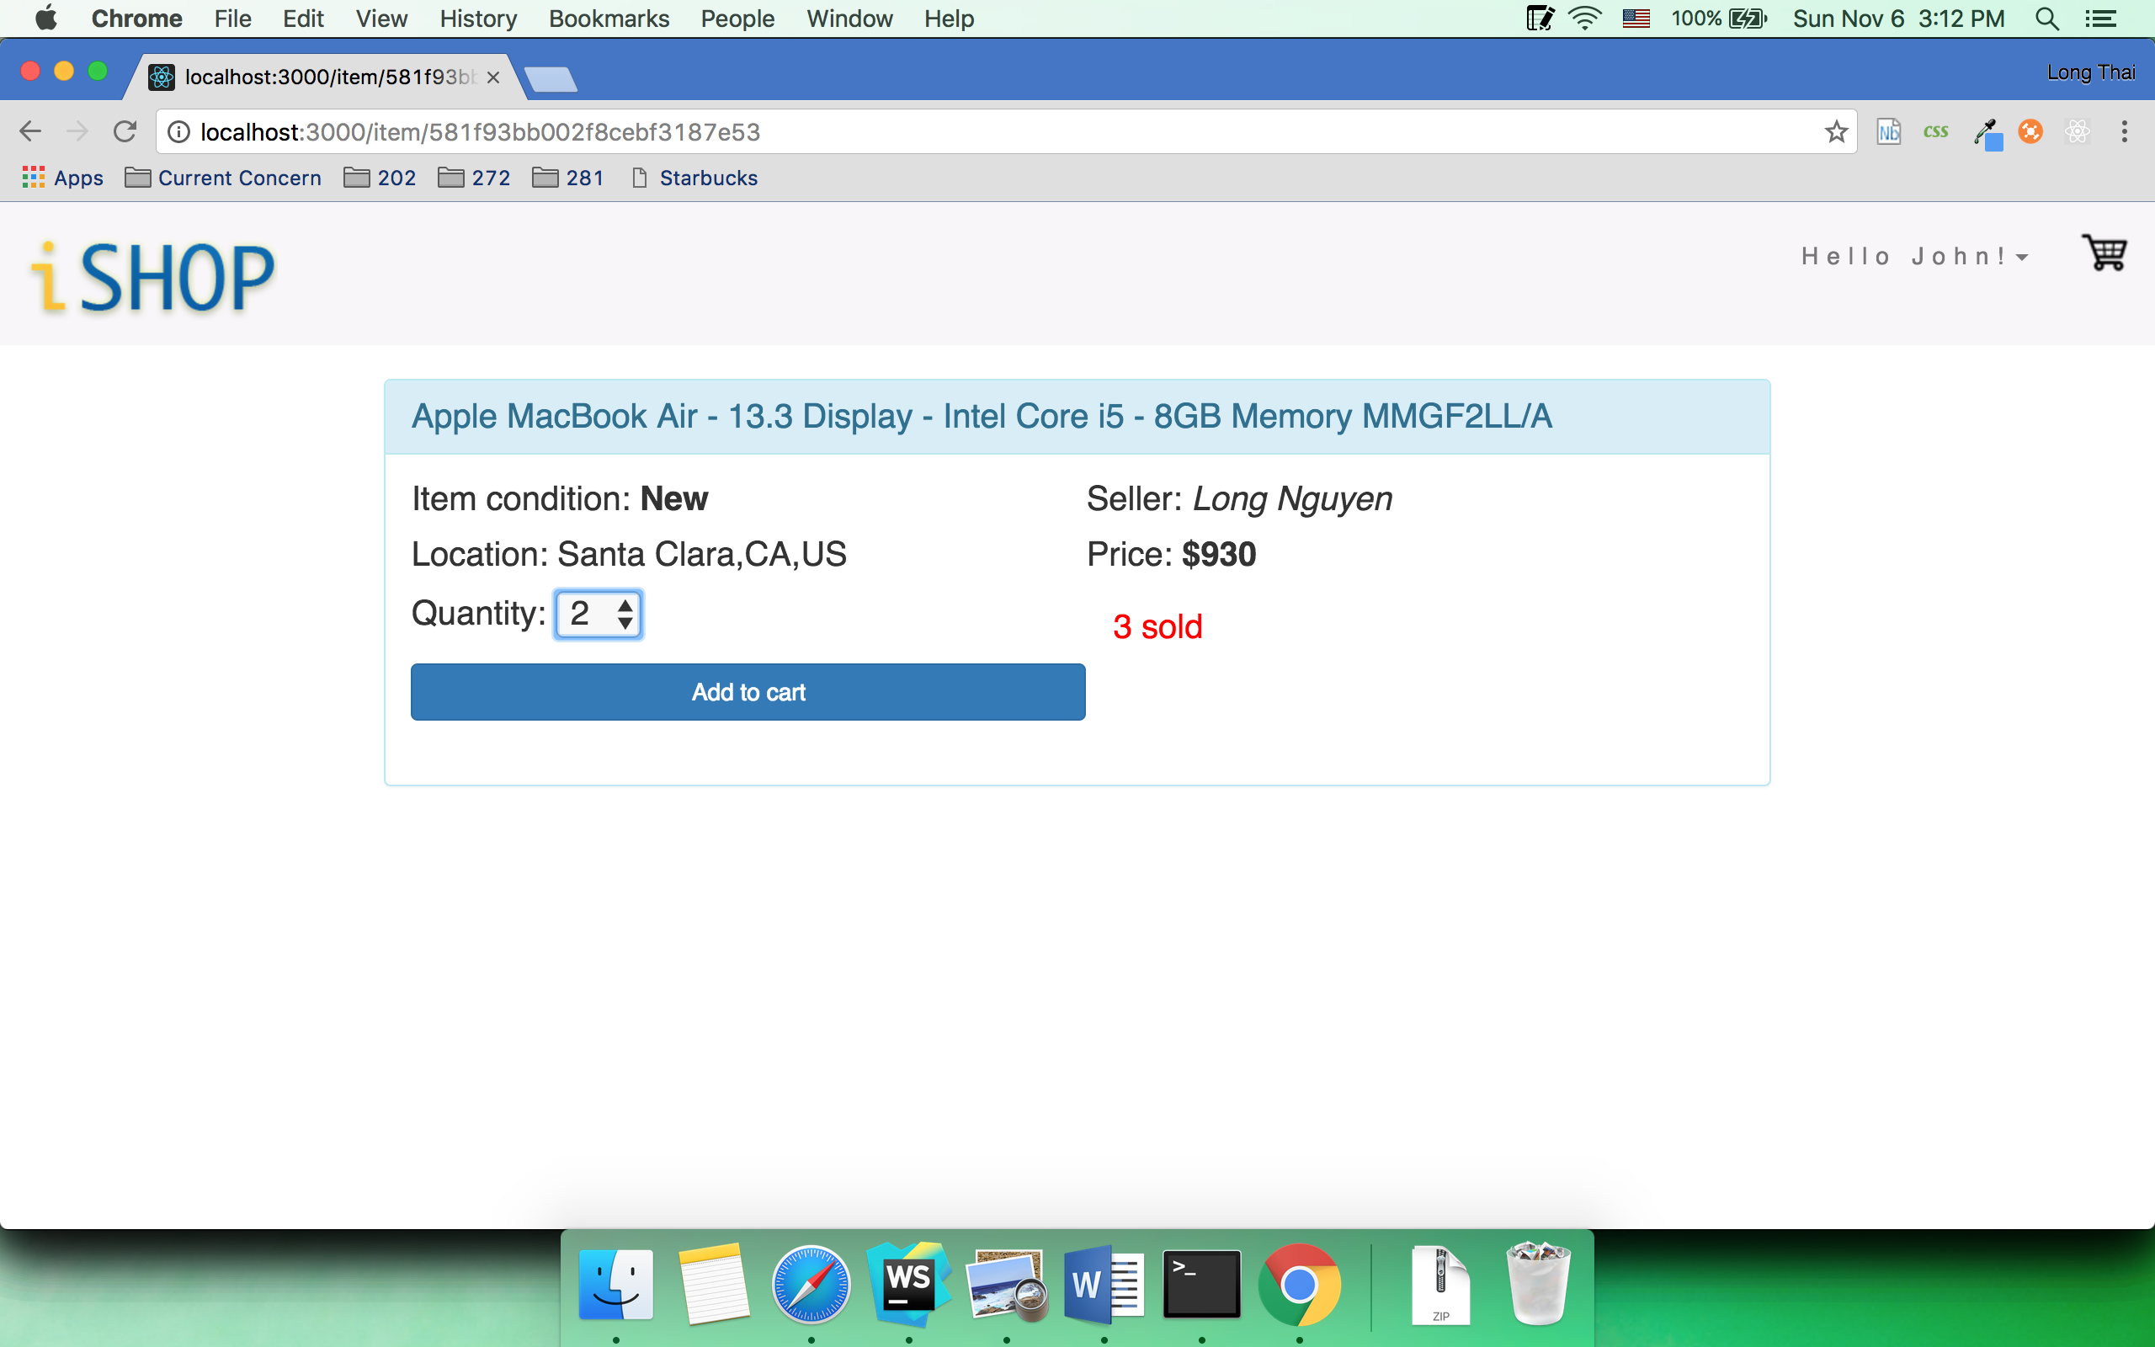

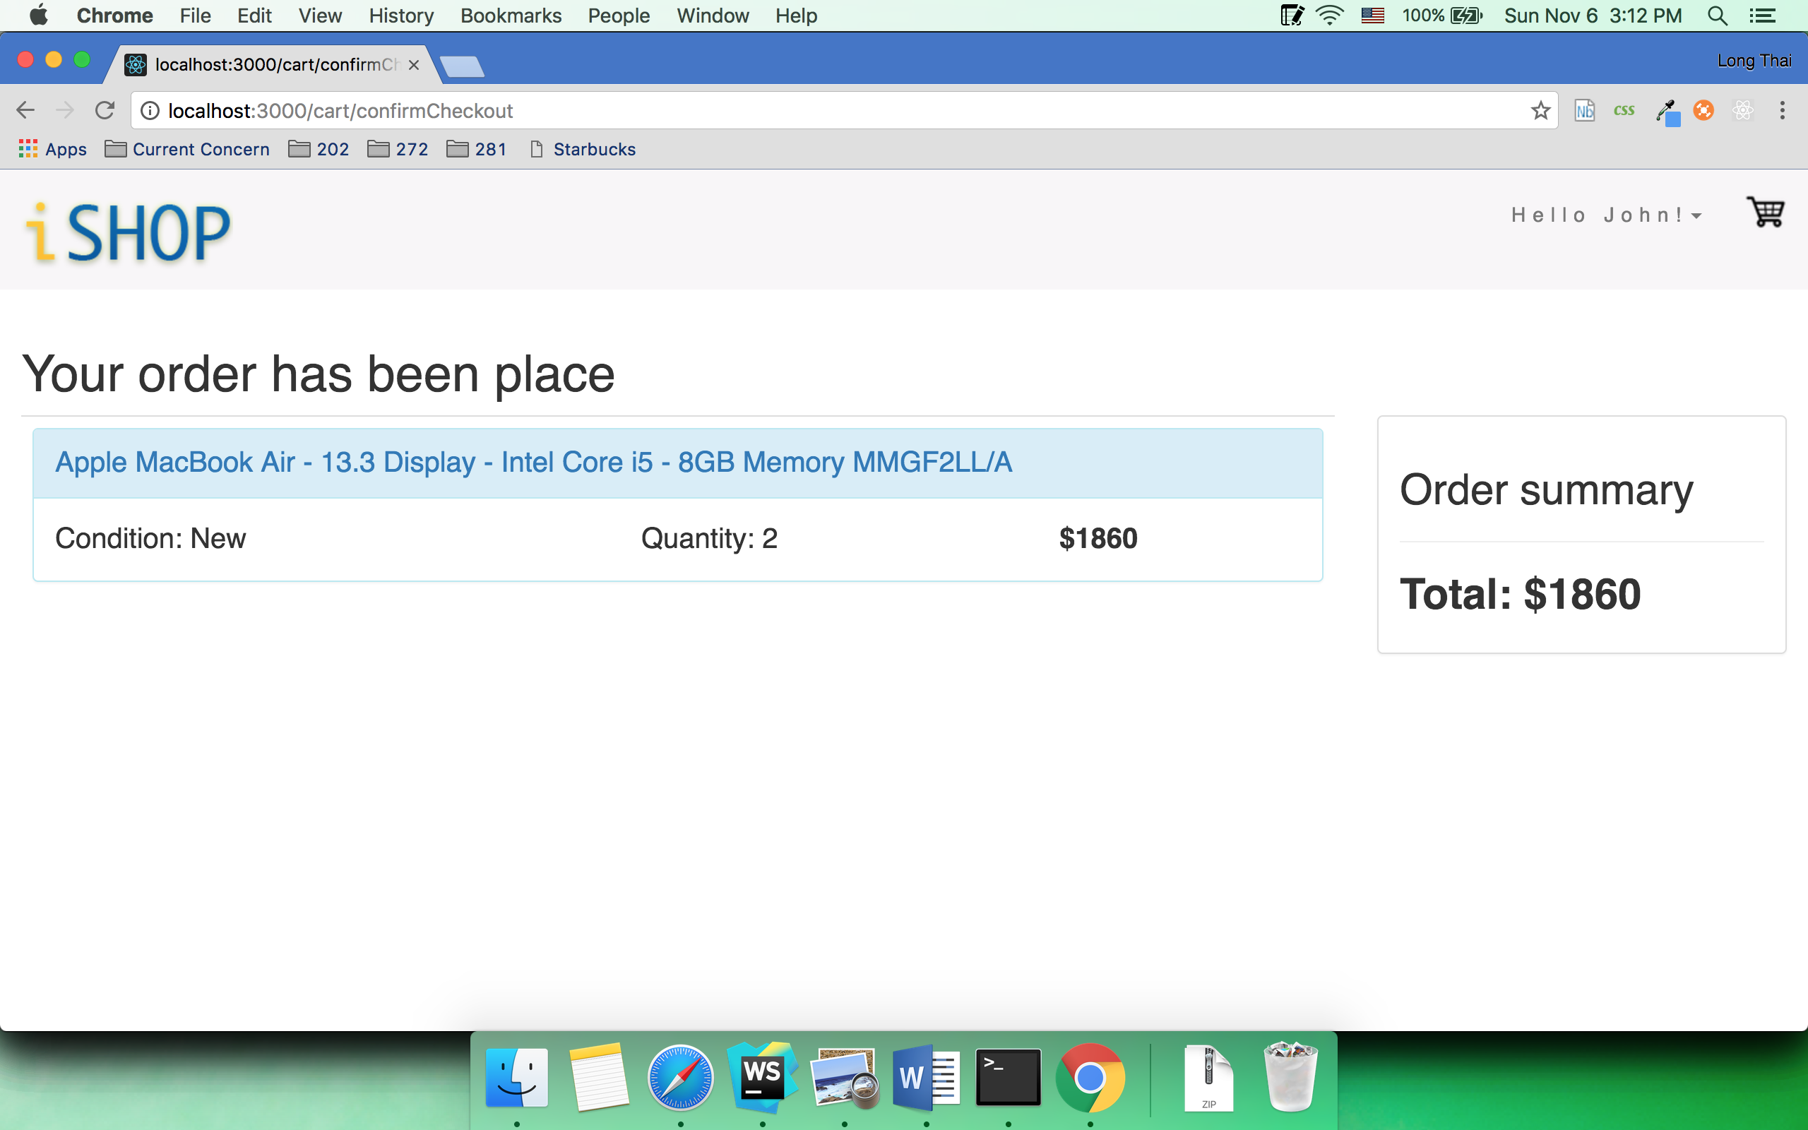

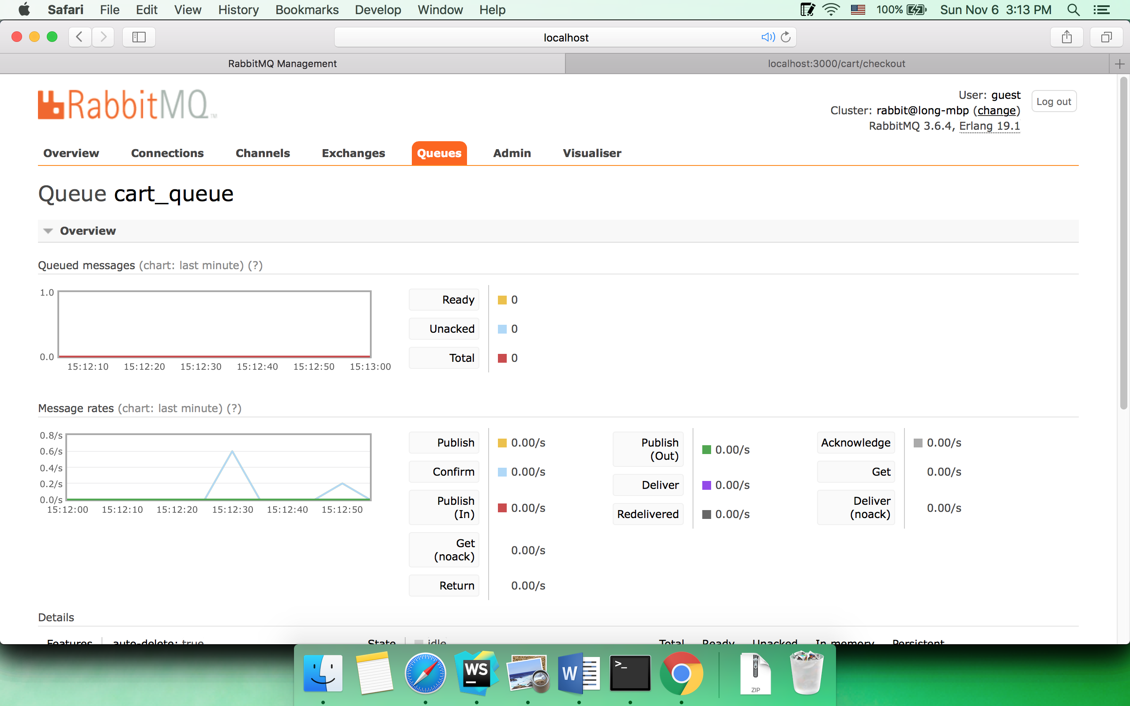

Finally, Mark decide to buy 2 macbook airs in his cart, but it is too late…

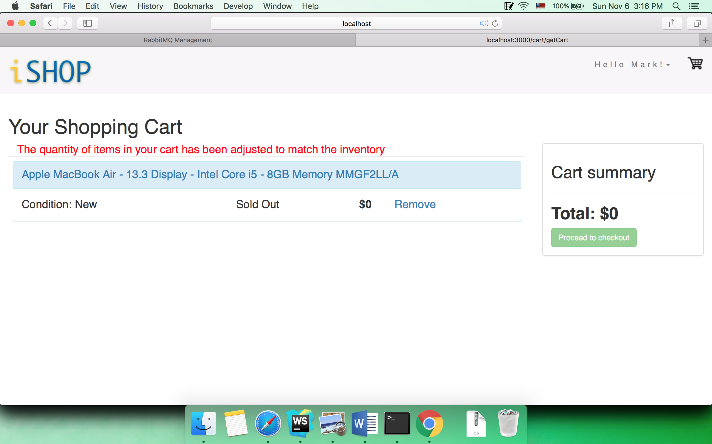

* 1. Profile

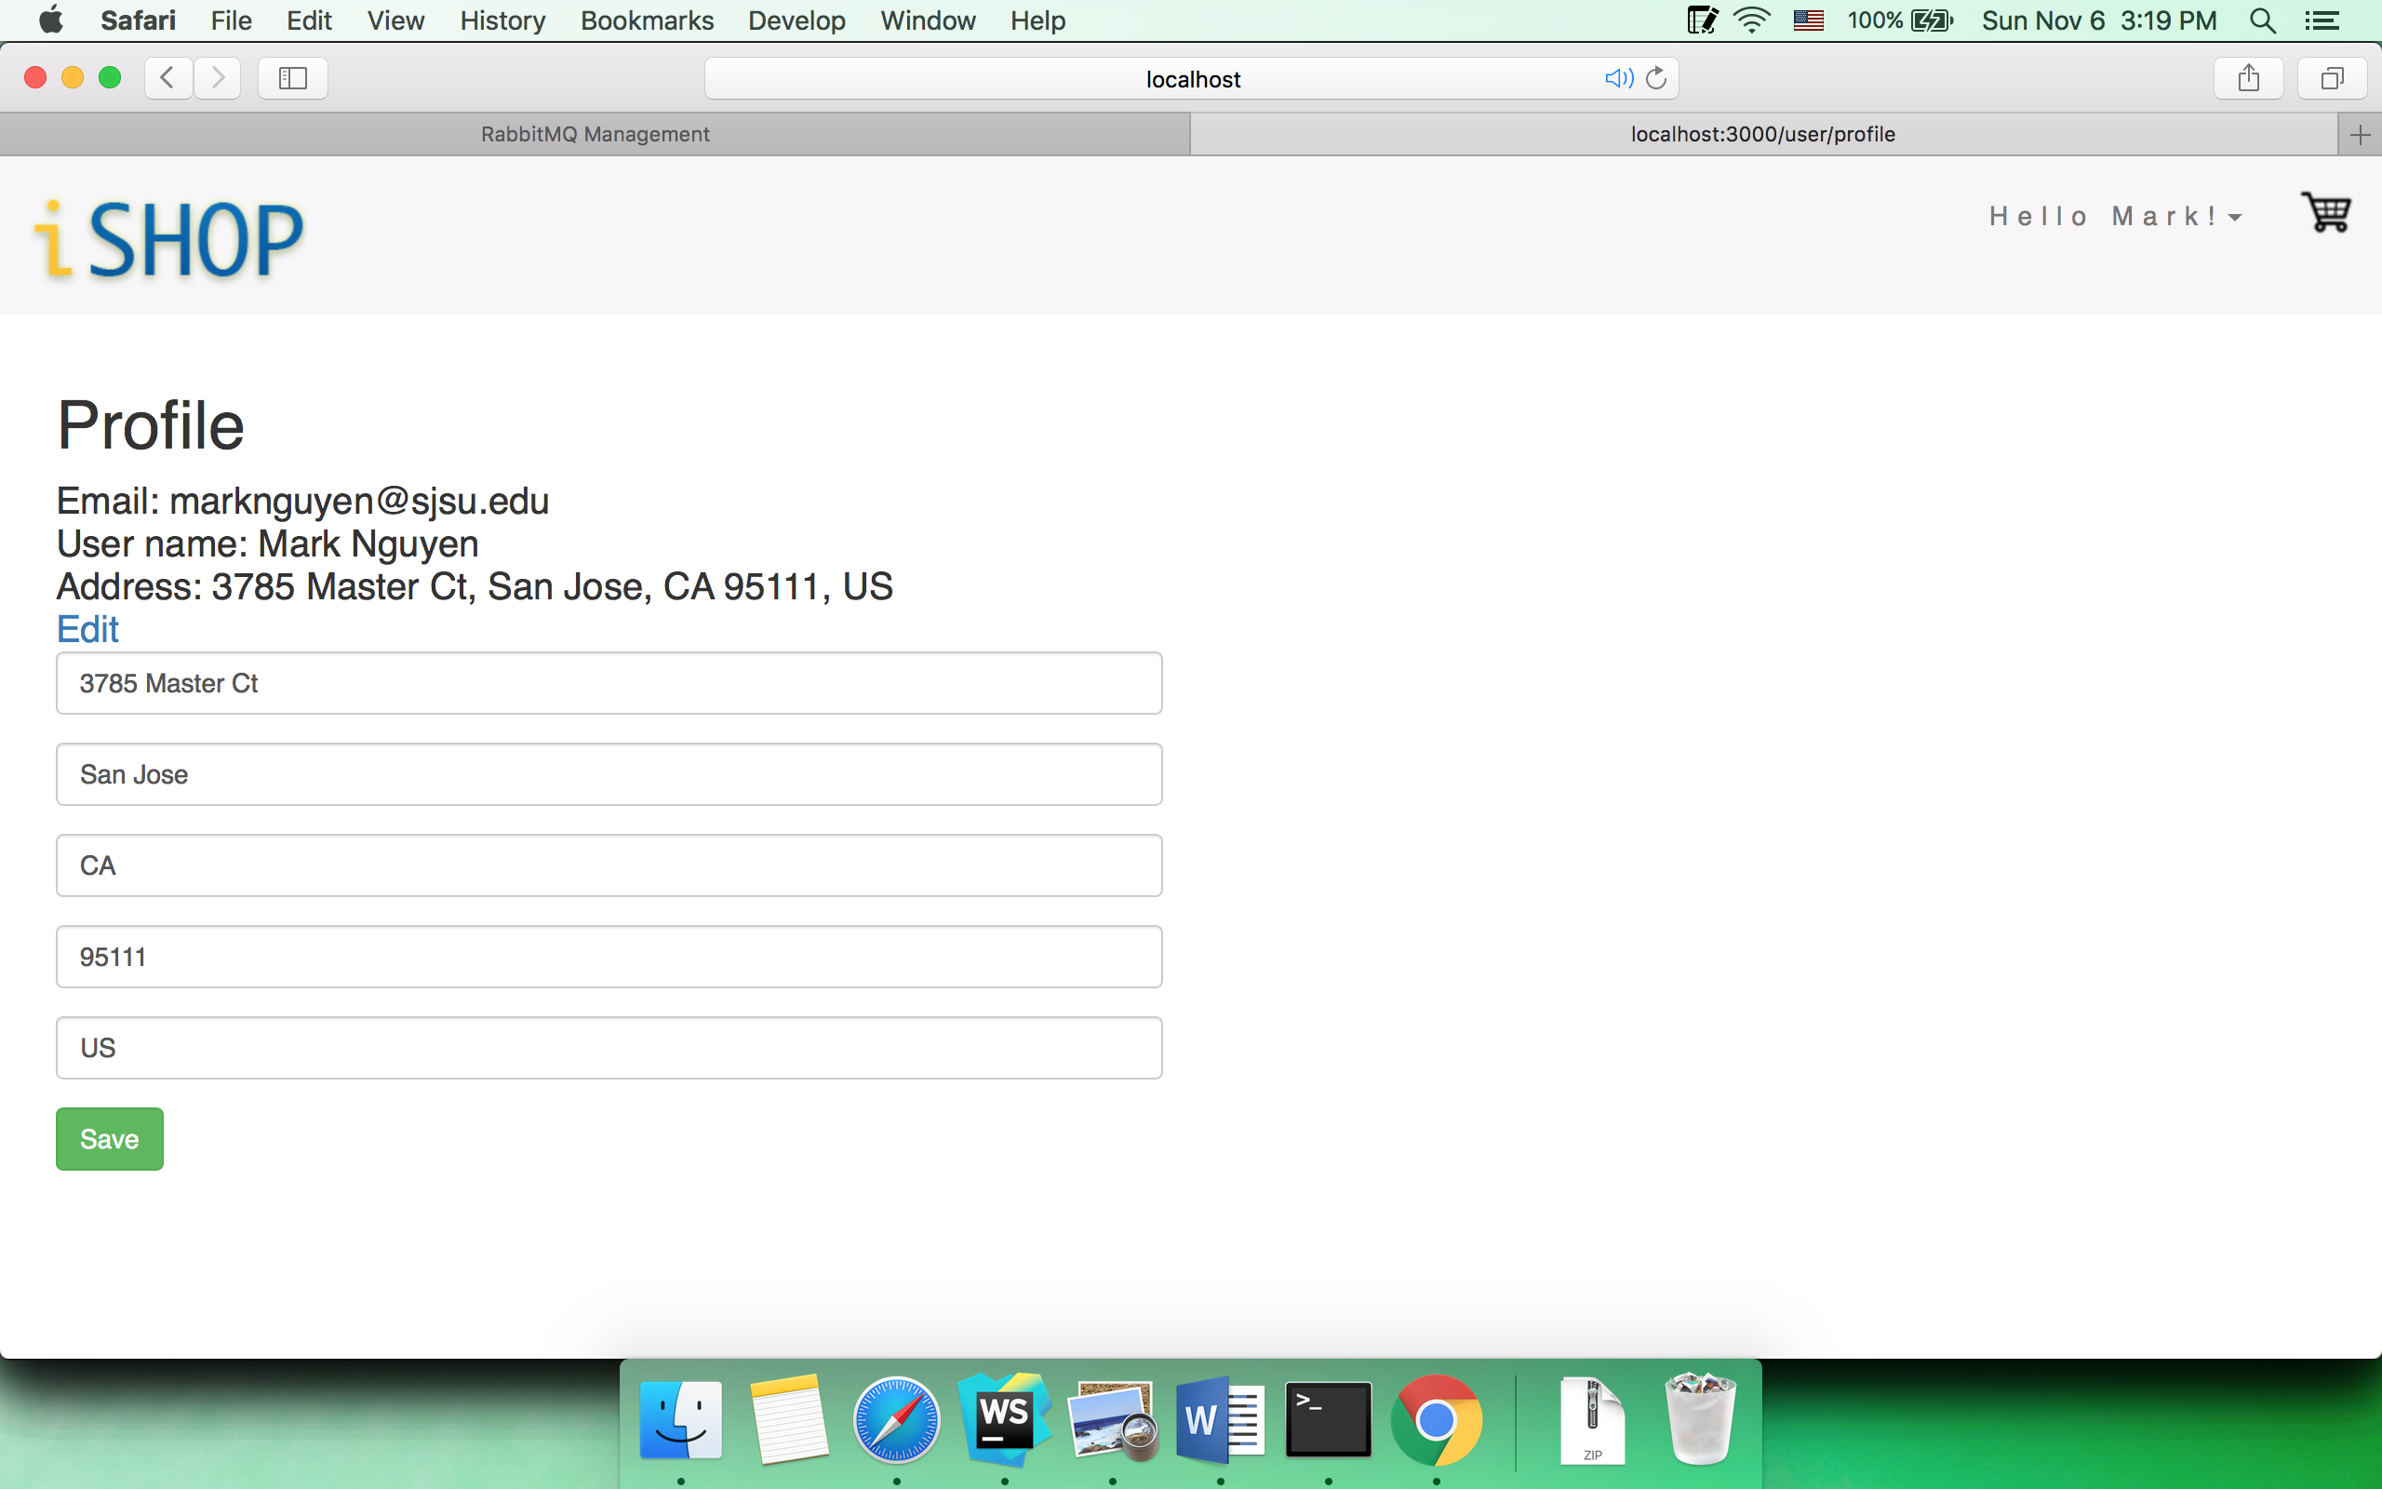

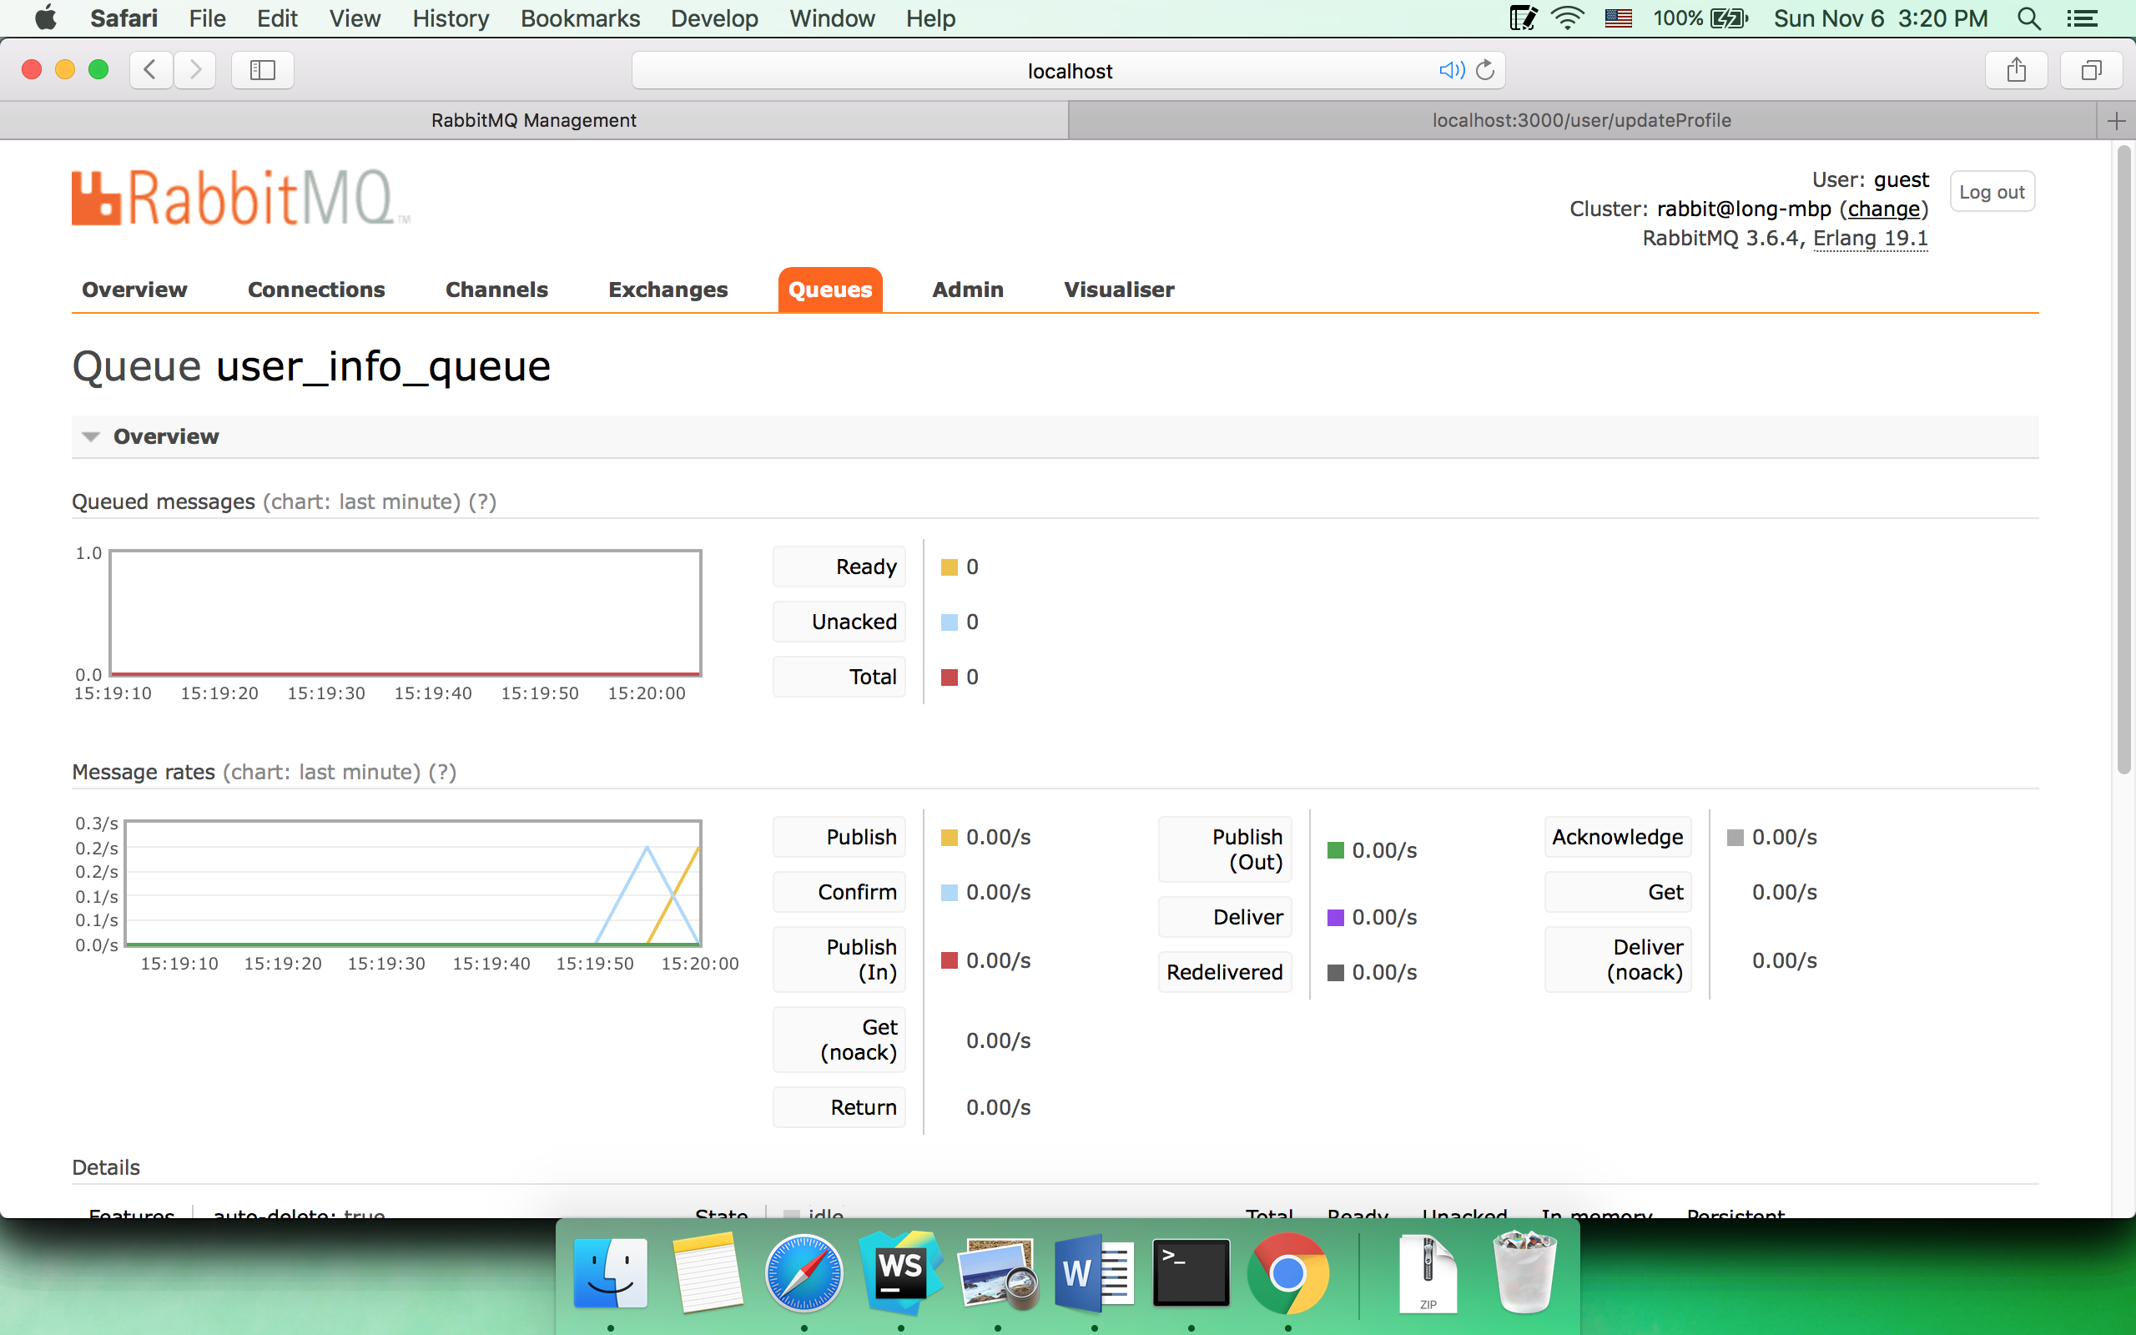

* 1. All selling

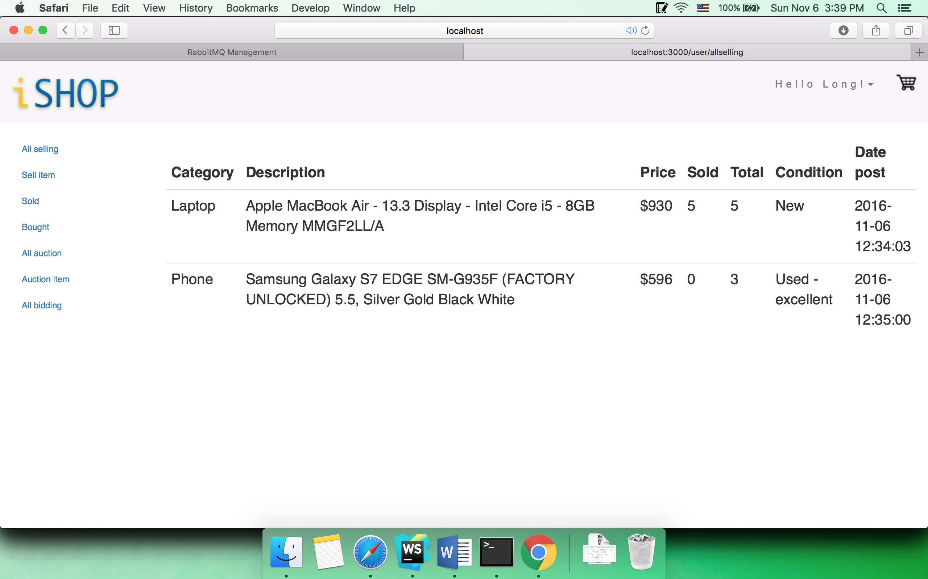

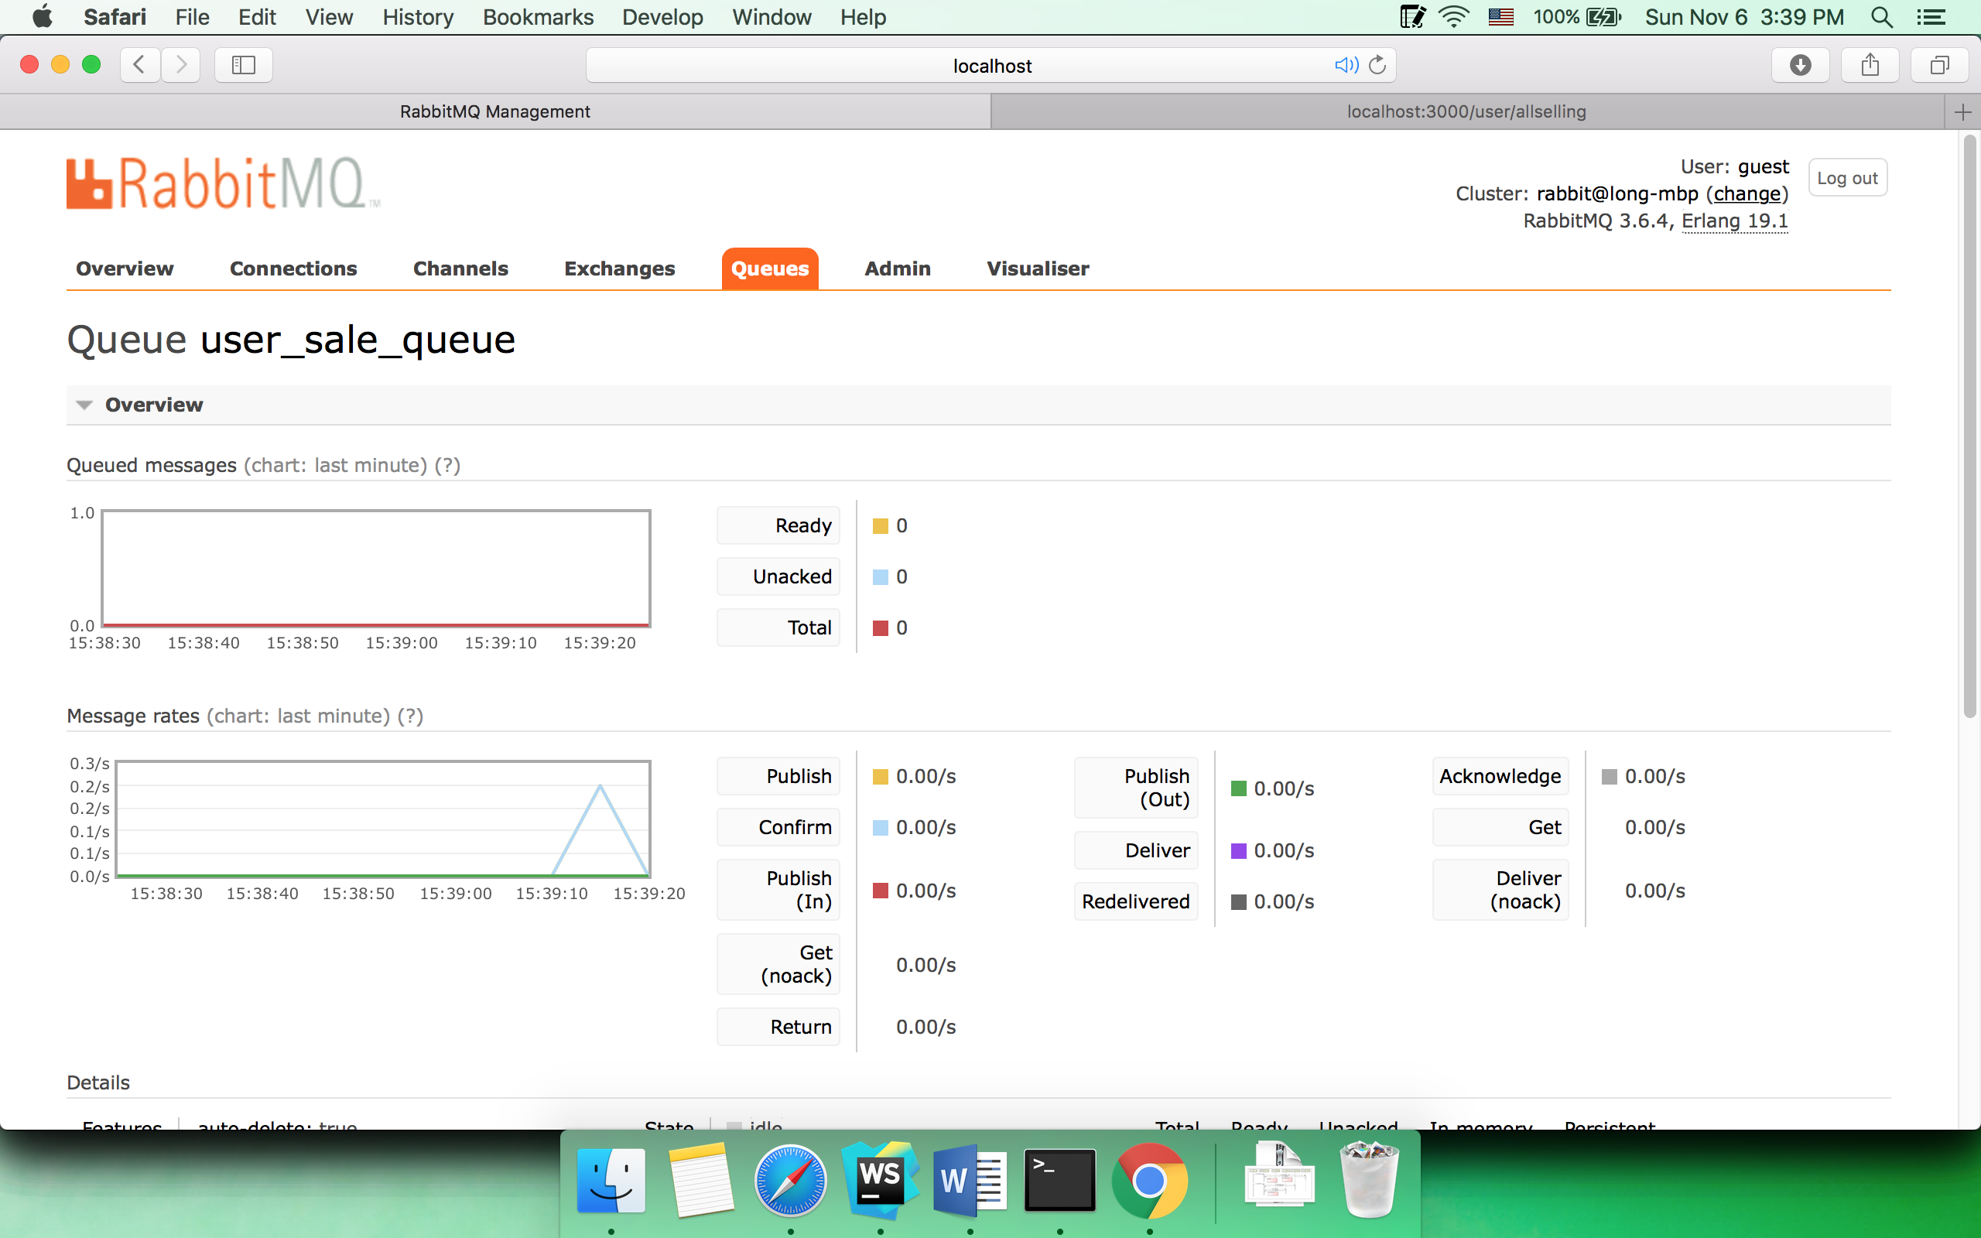

* 1. Sell item

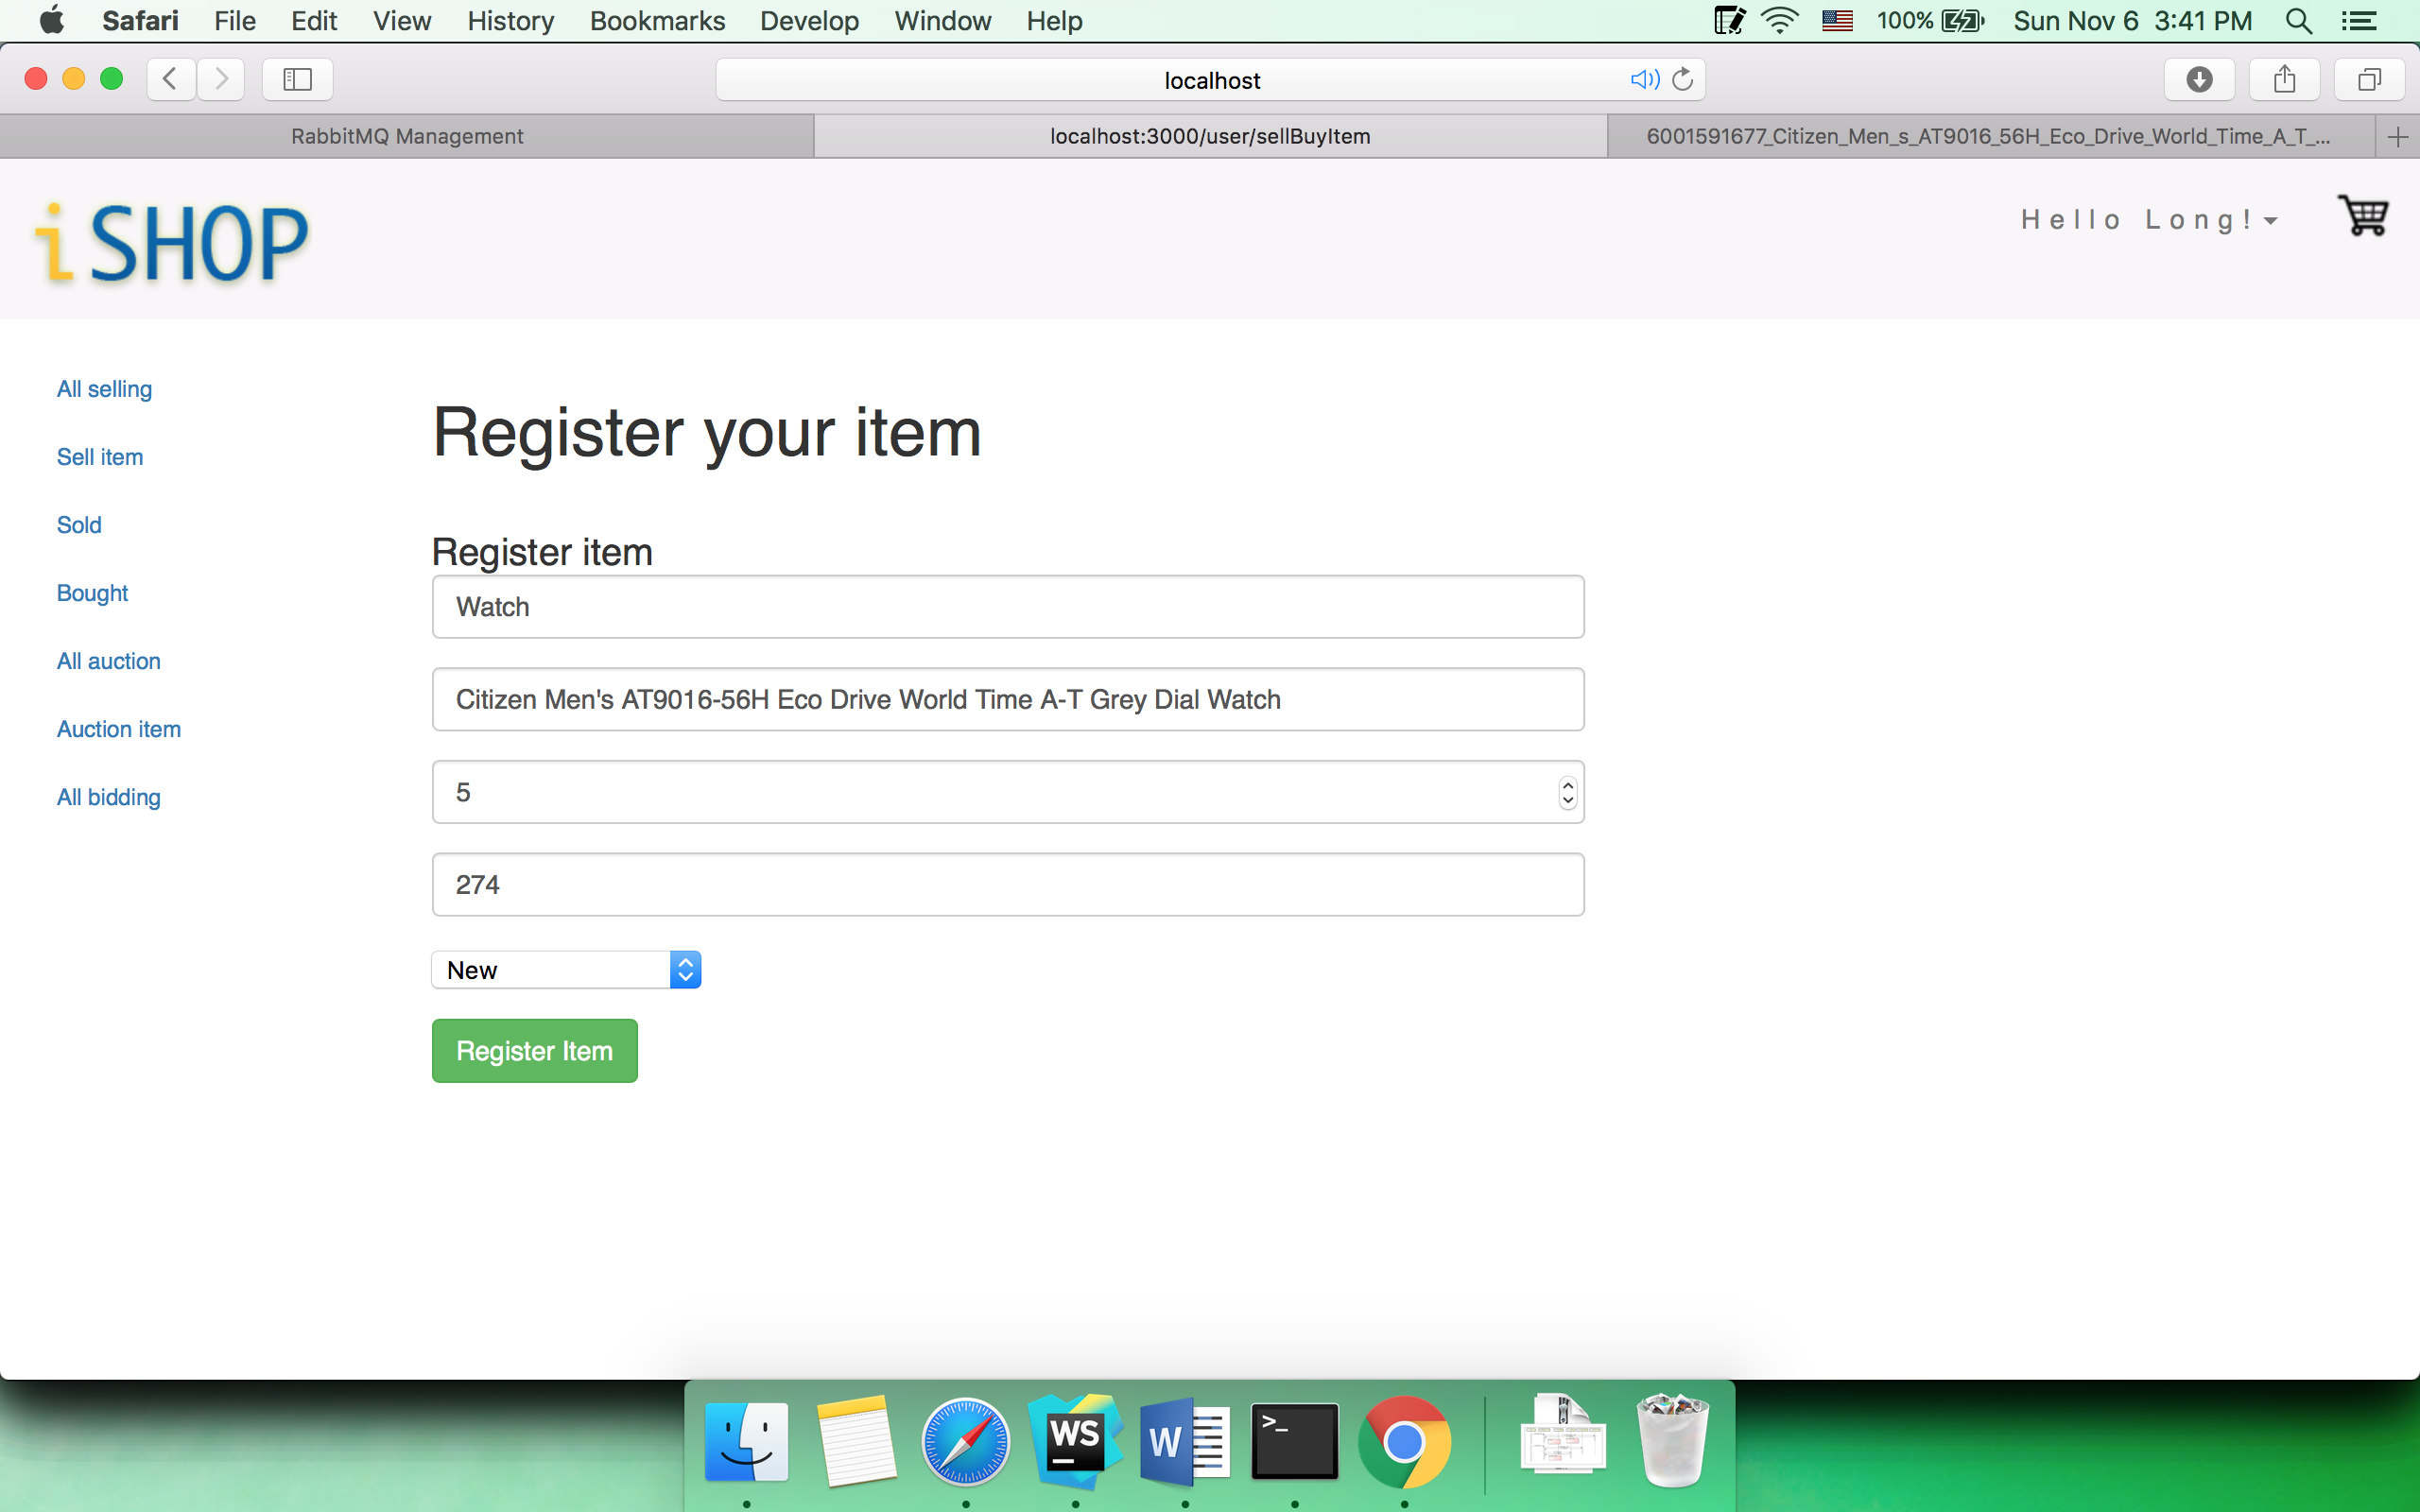

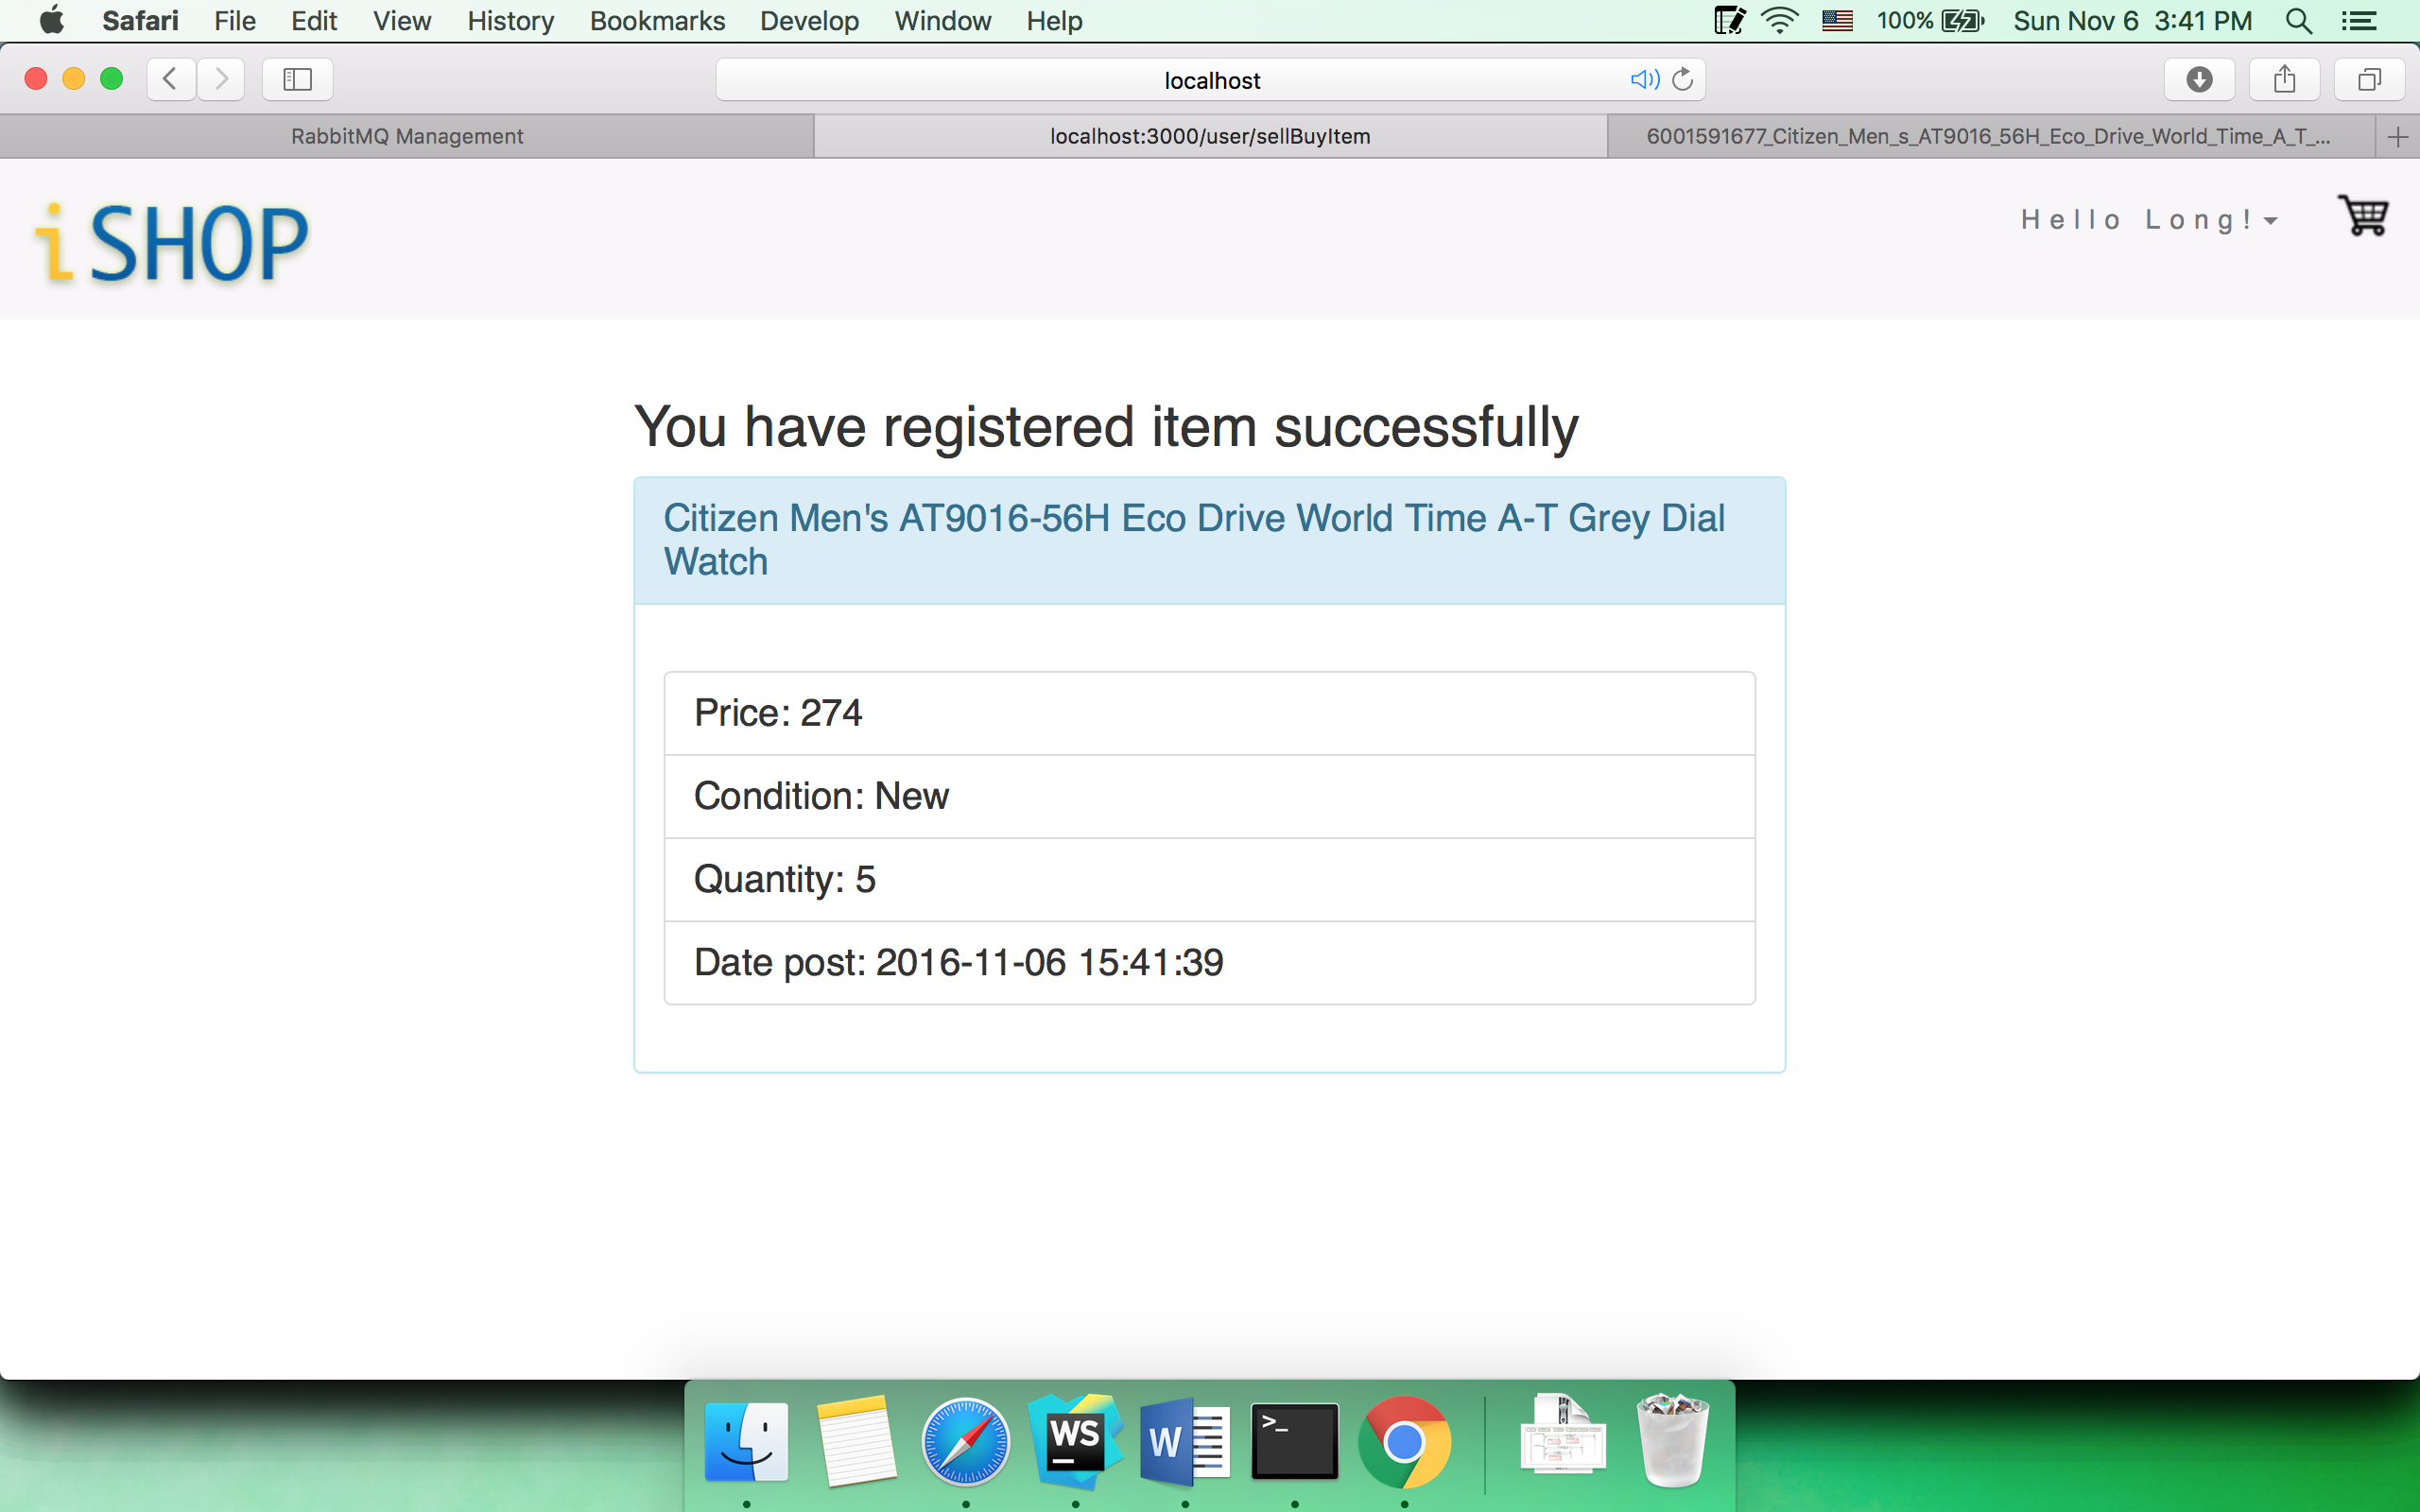

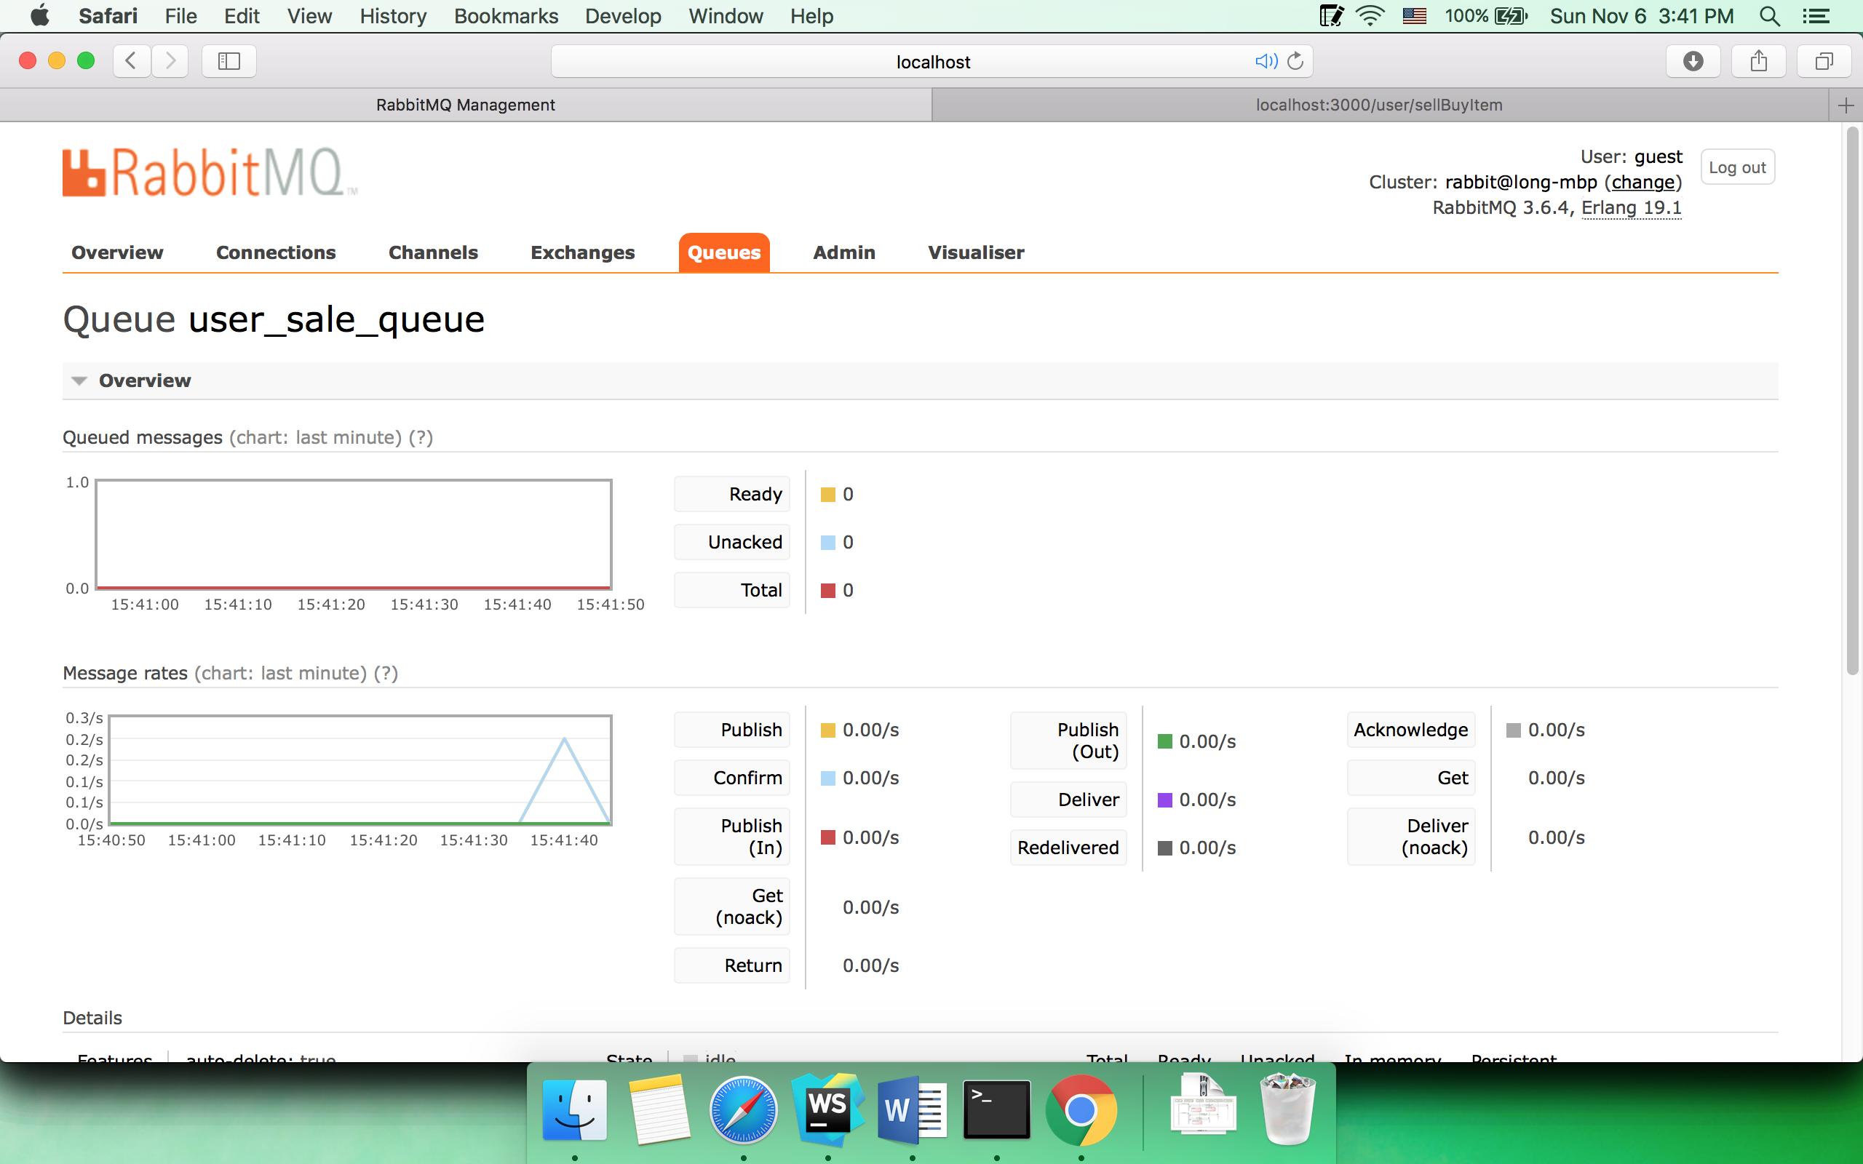

* 1. All sold

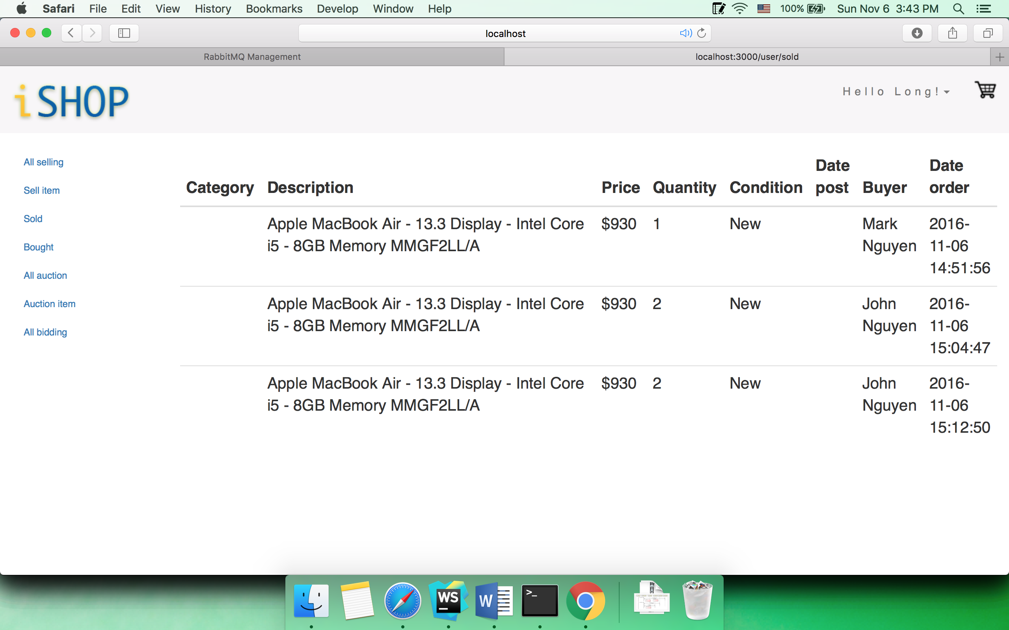

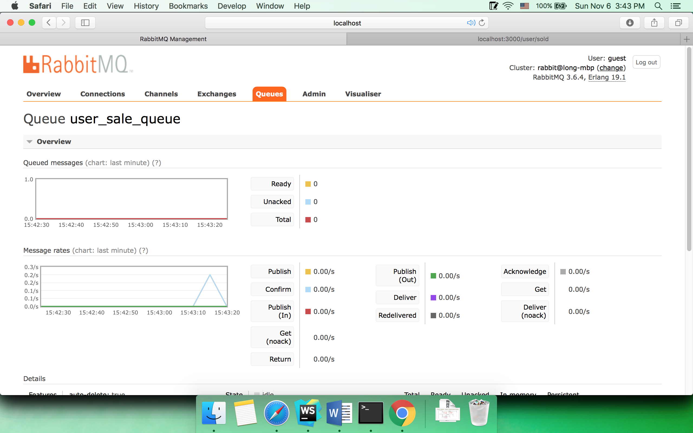

* 1. All bought

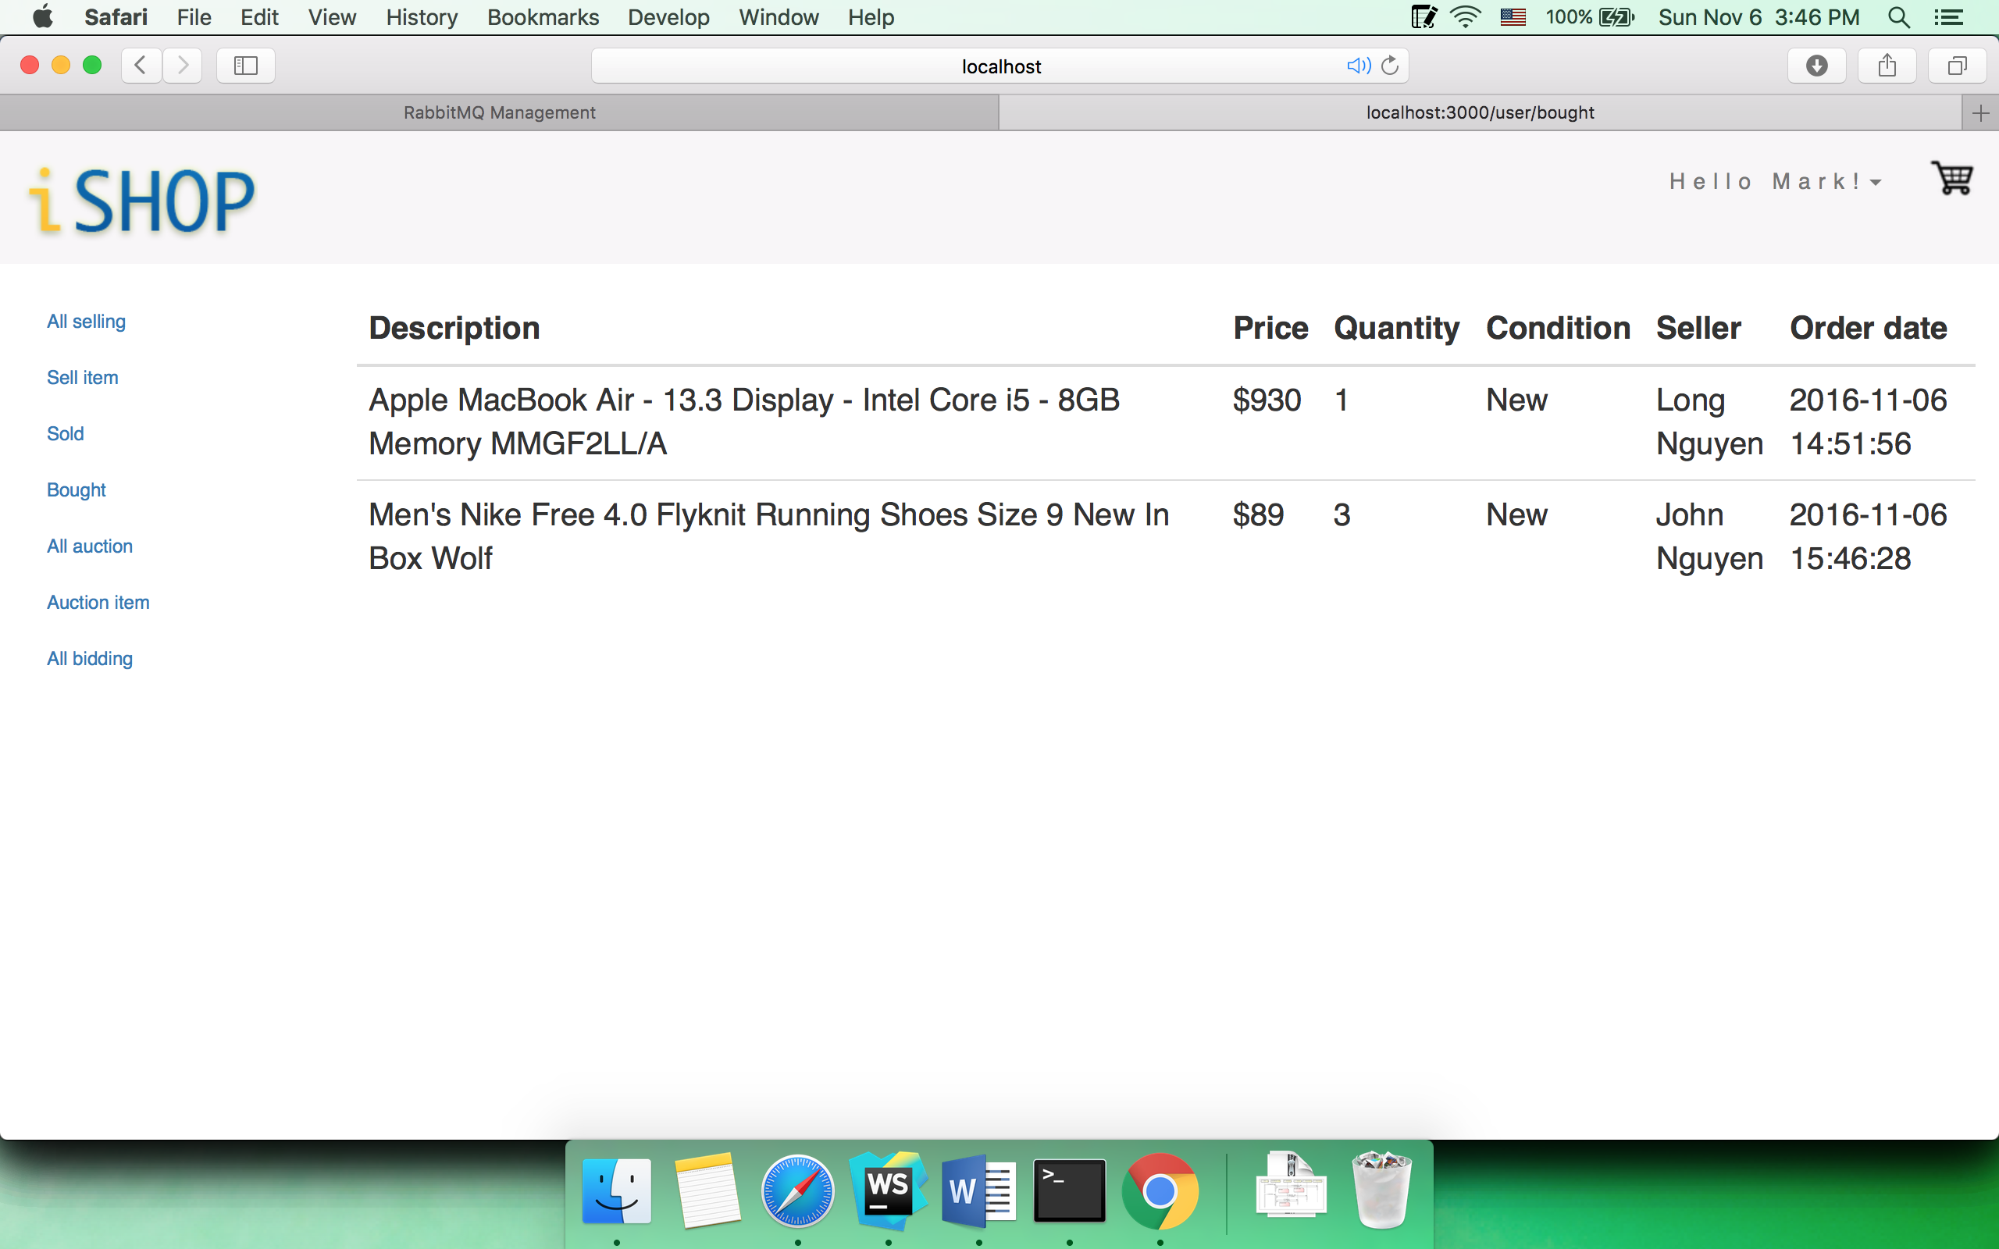

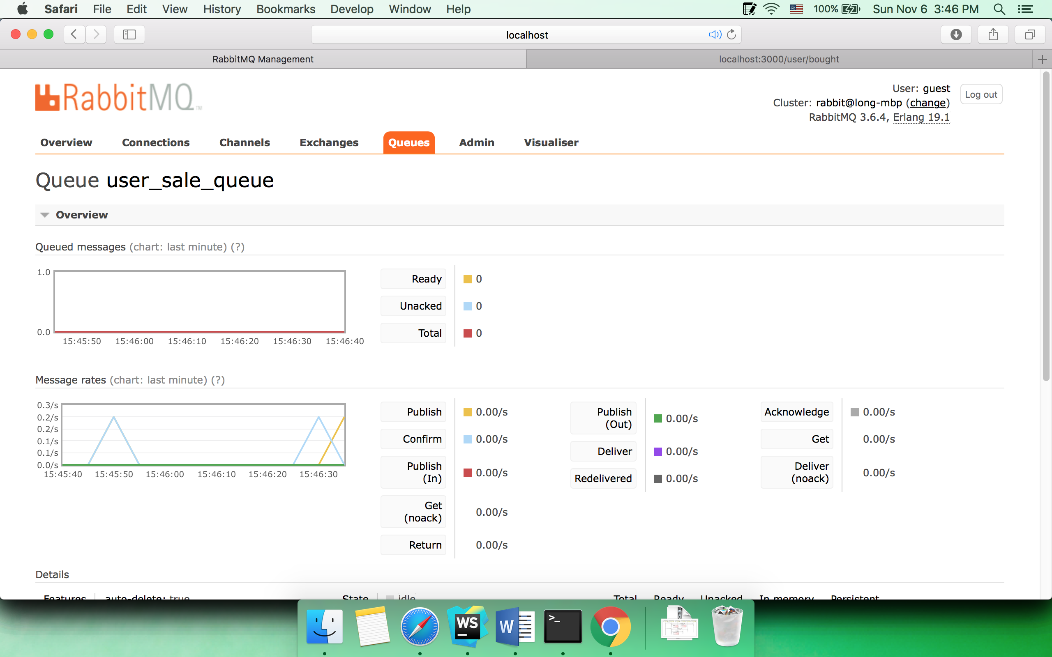

* 1. All auction

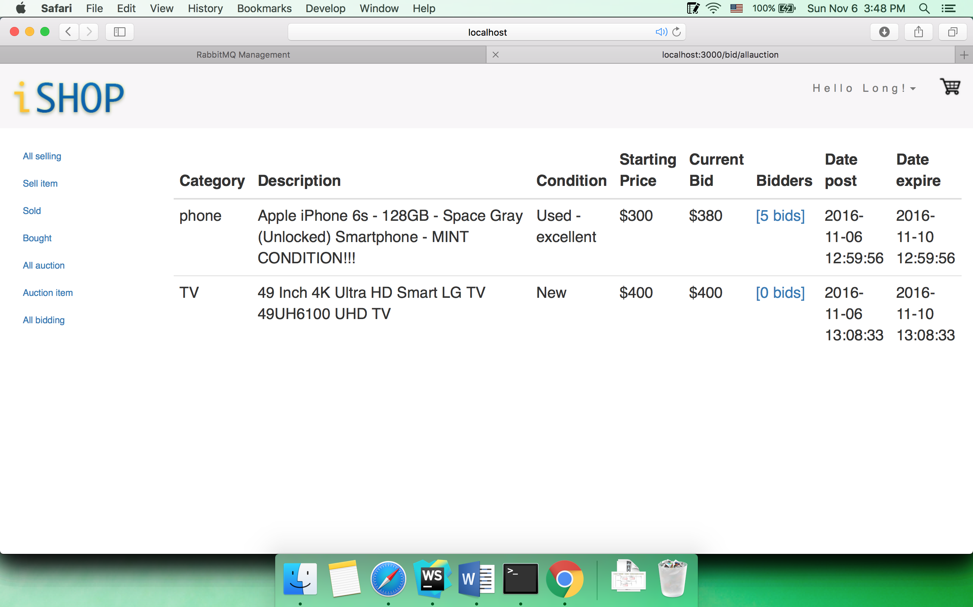

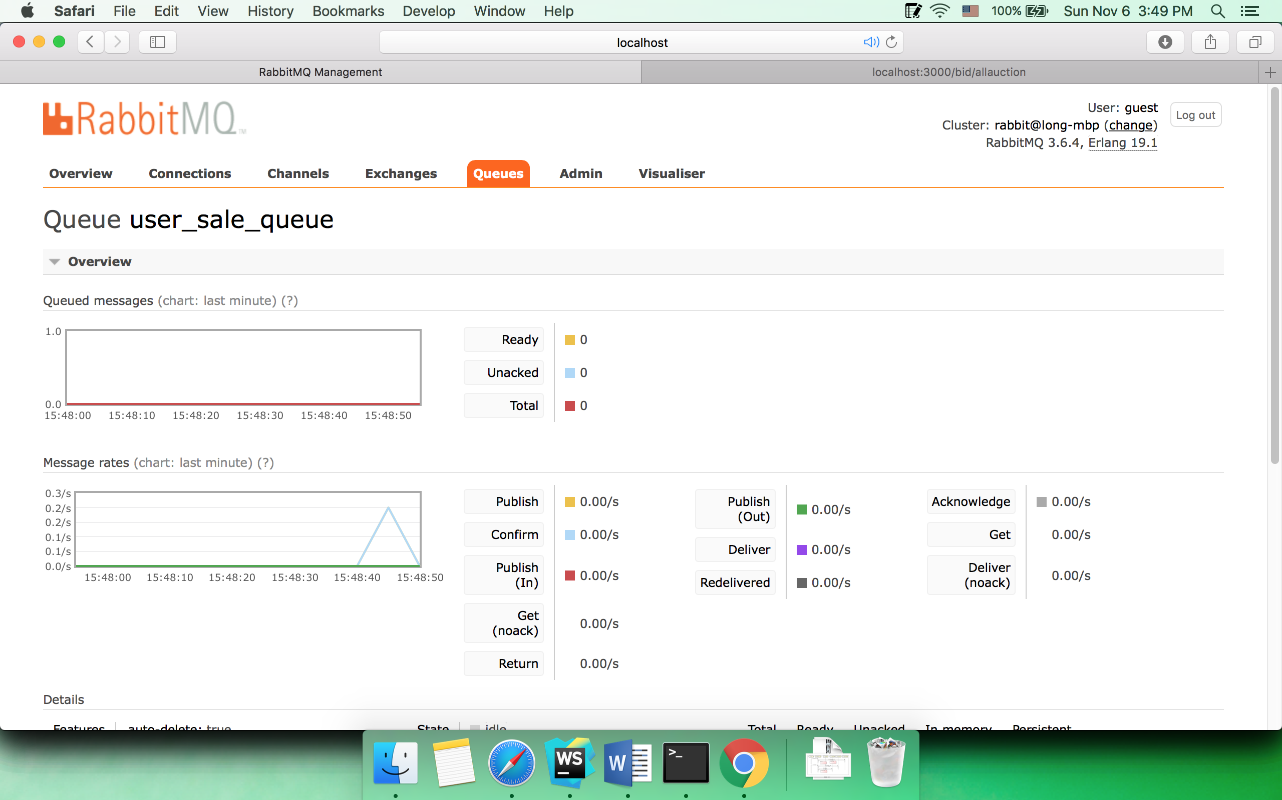

Click on bidders to view bid history

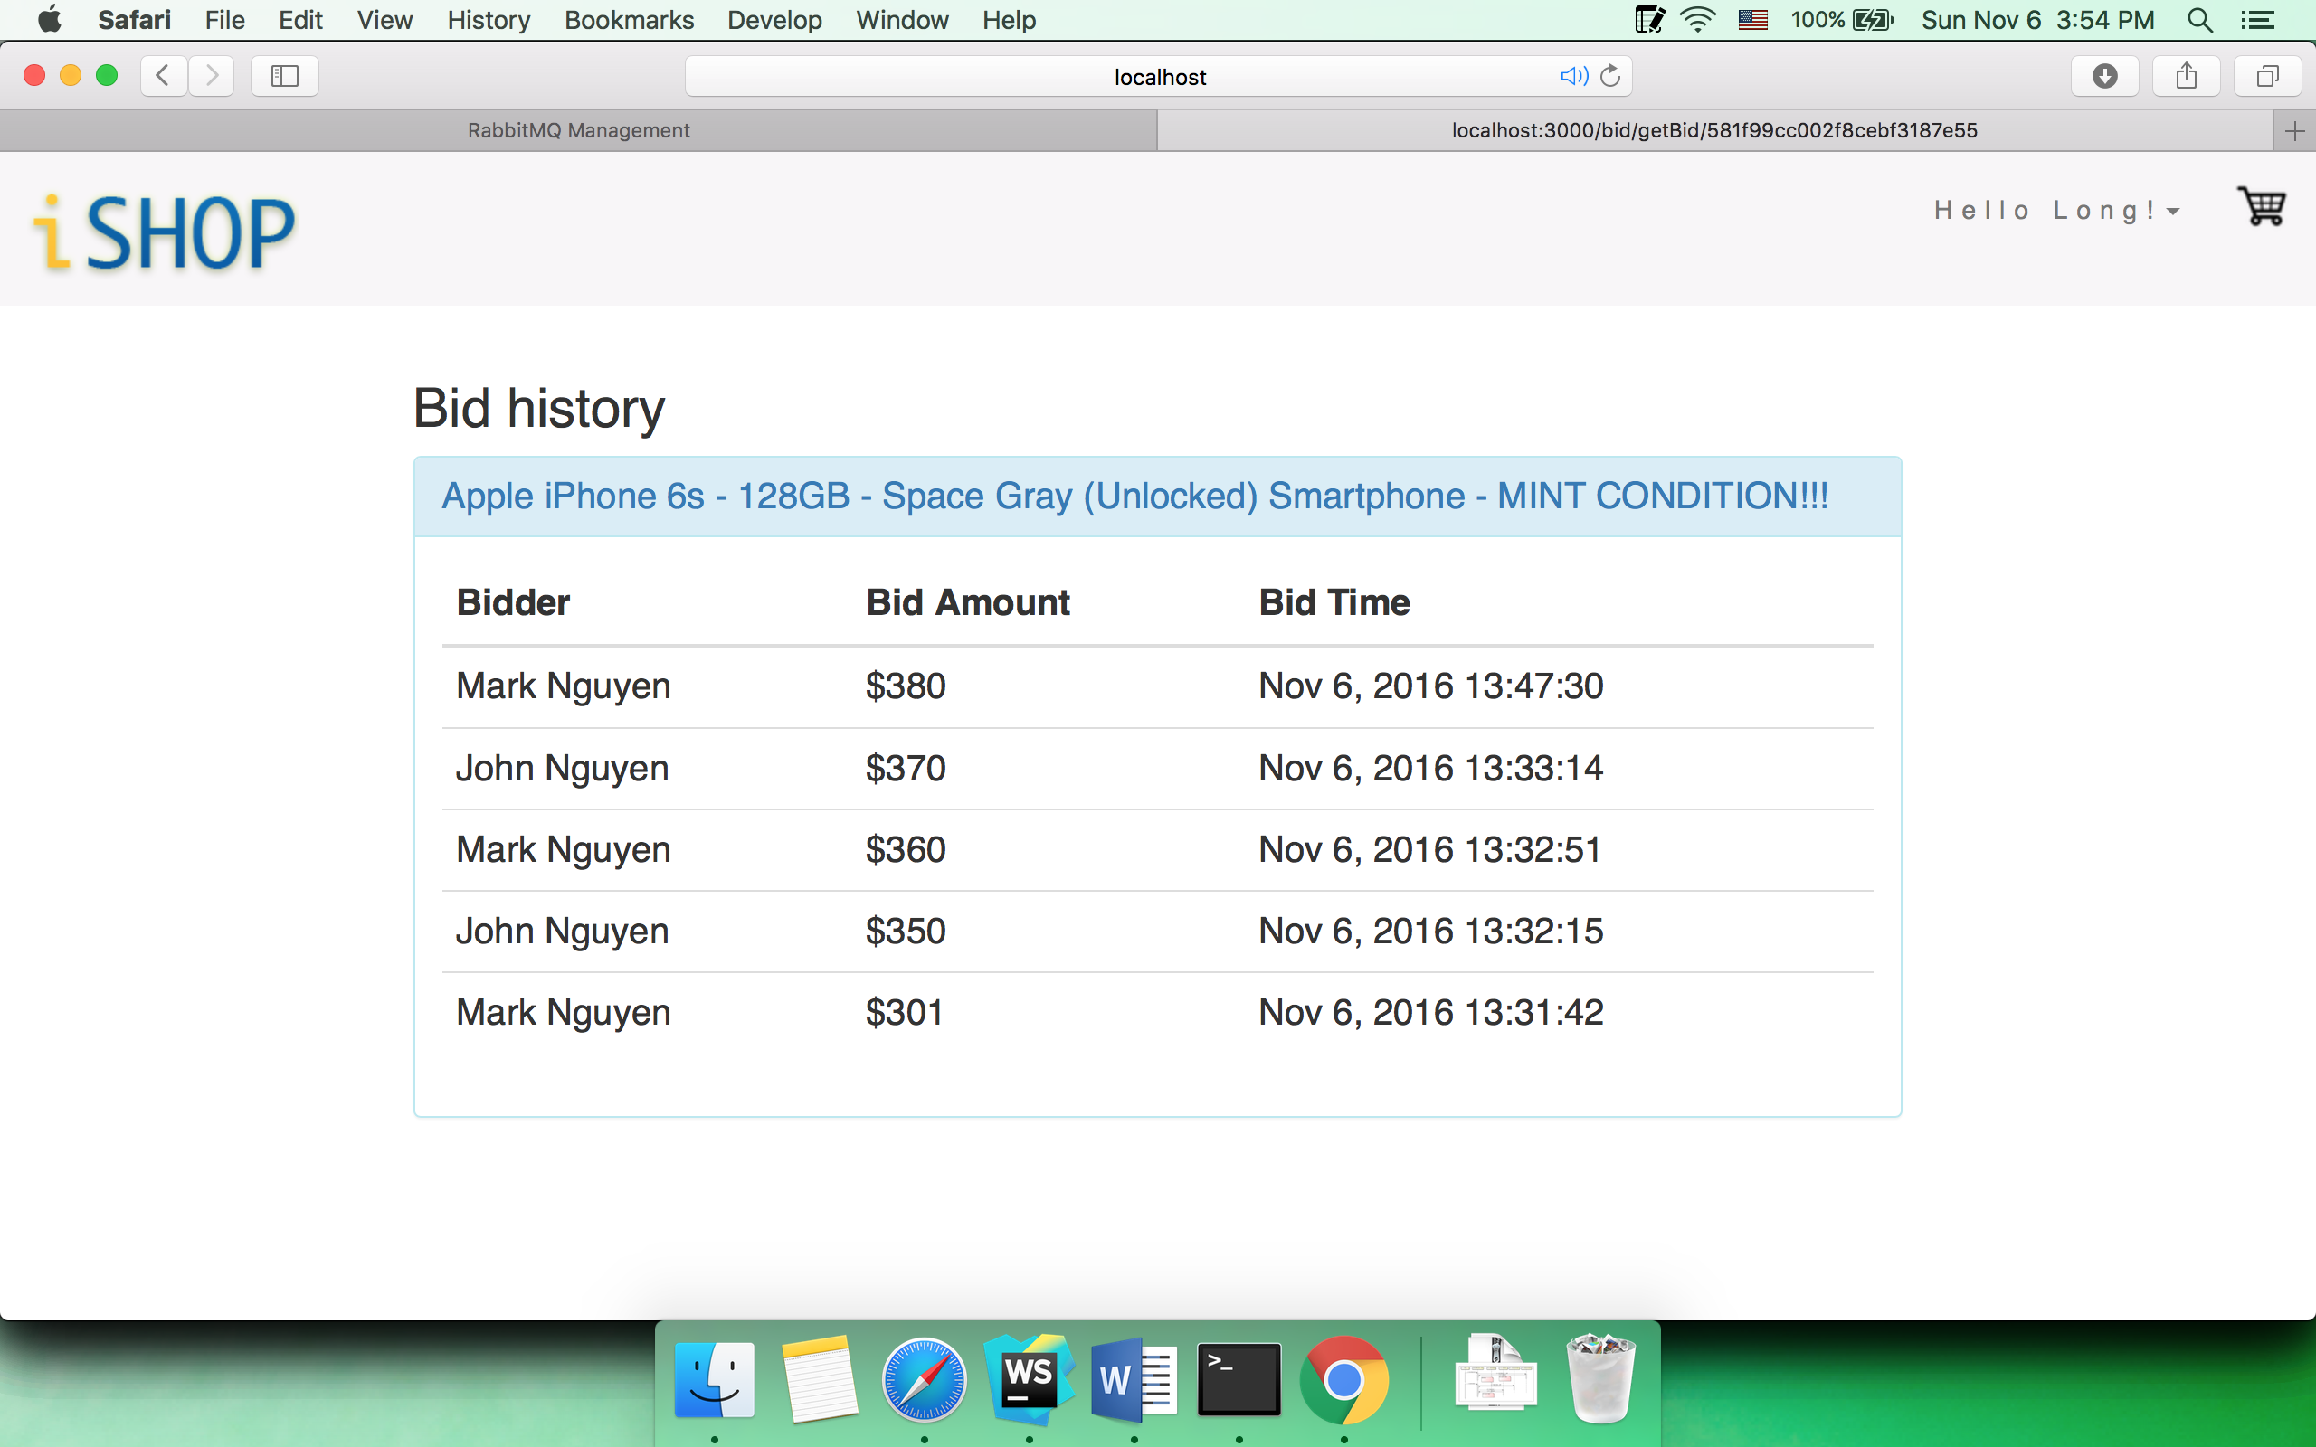

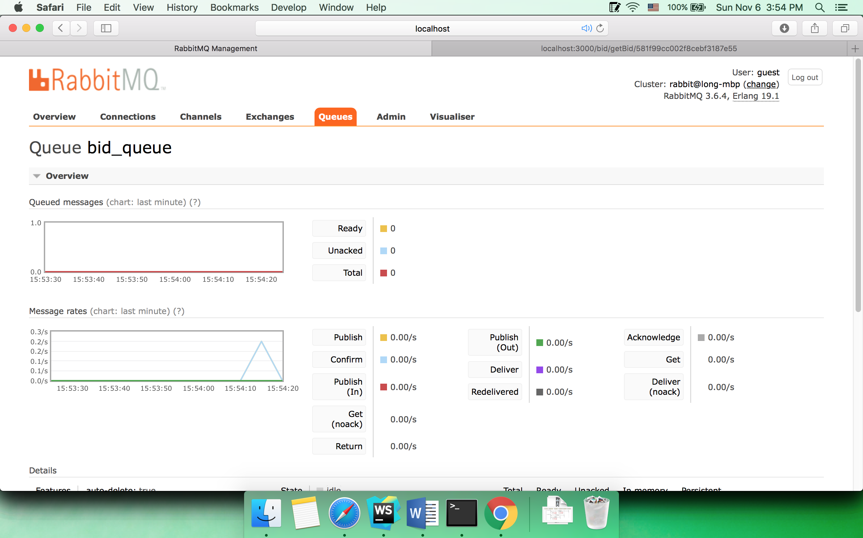

* 1. Register auction item

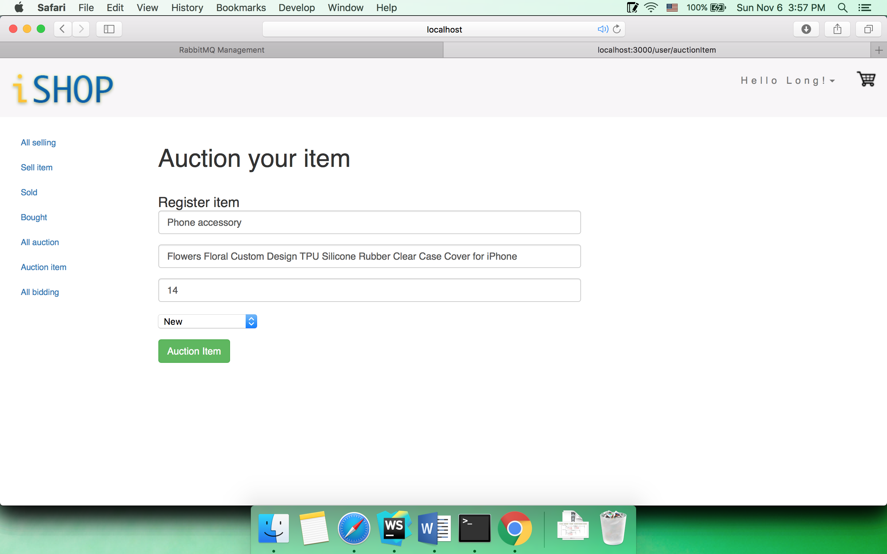

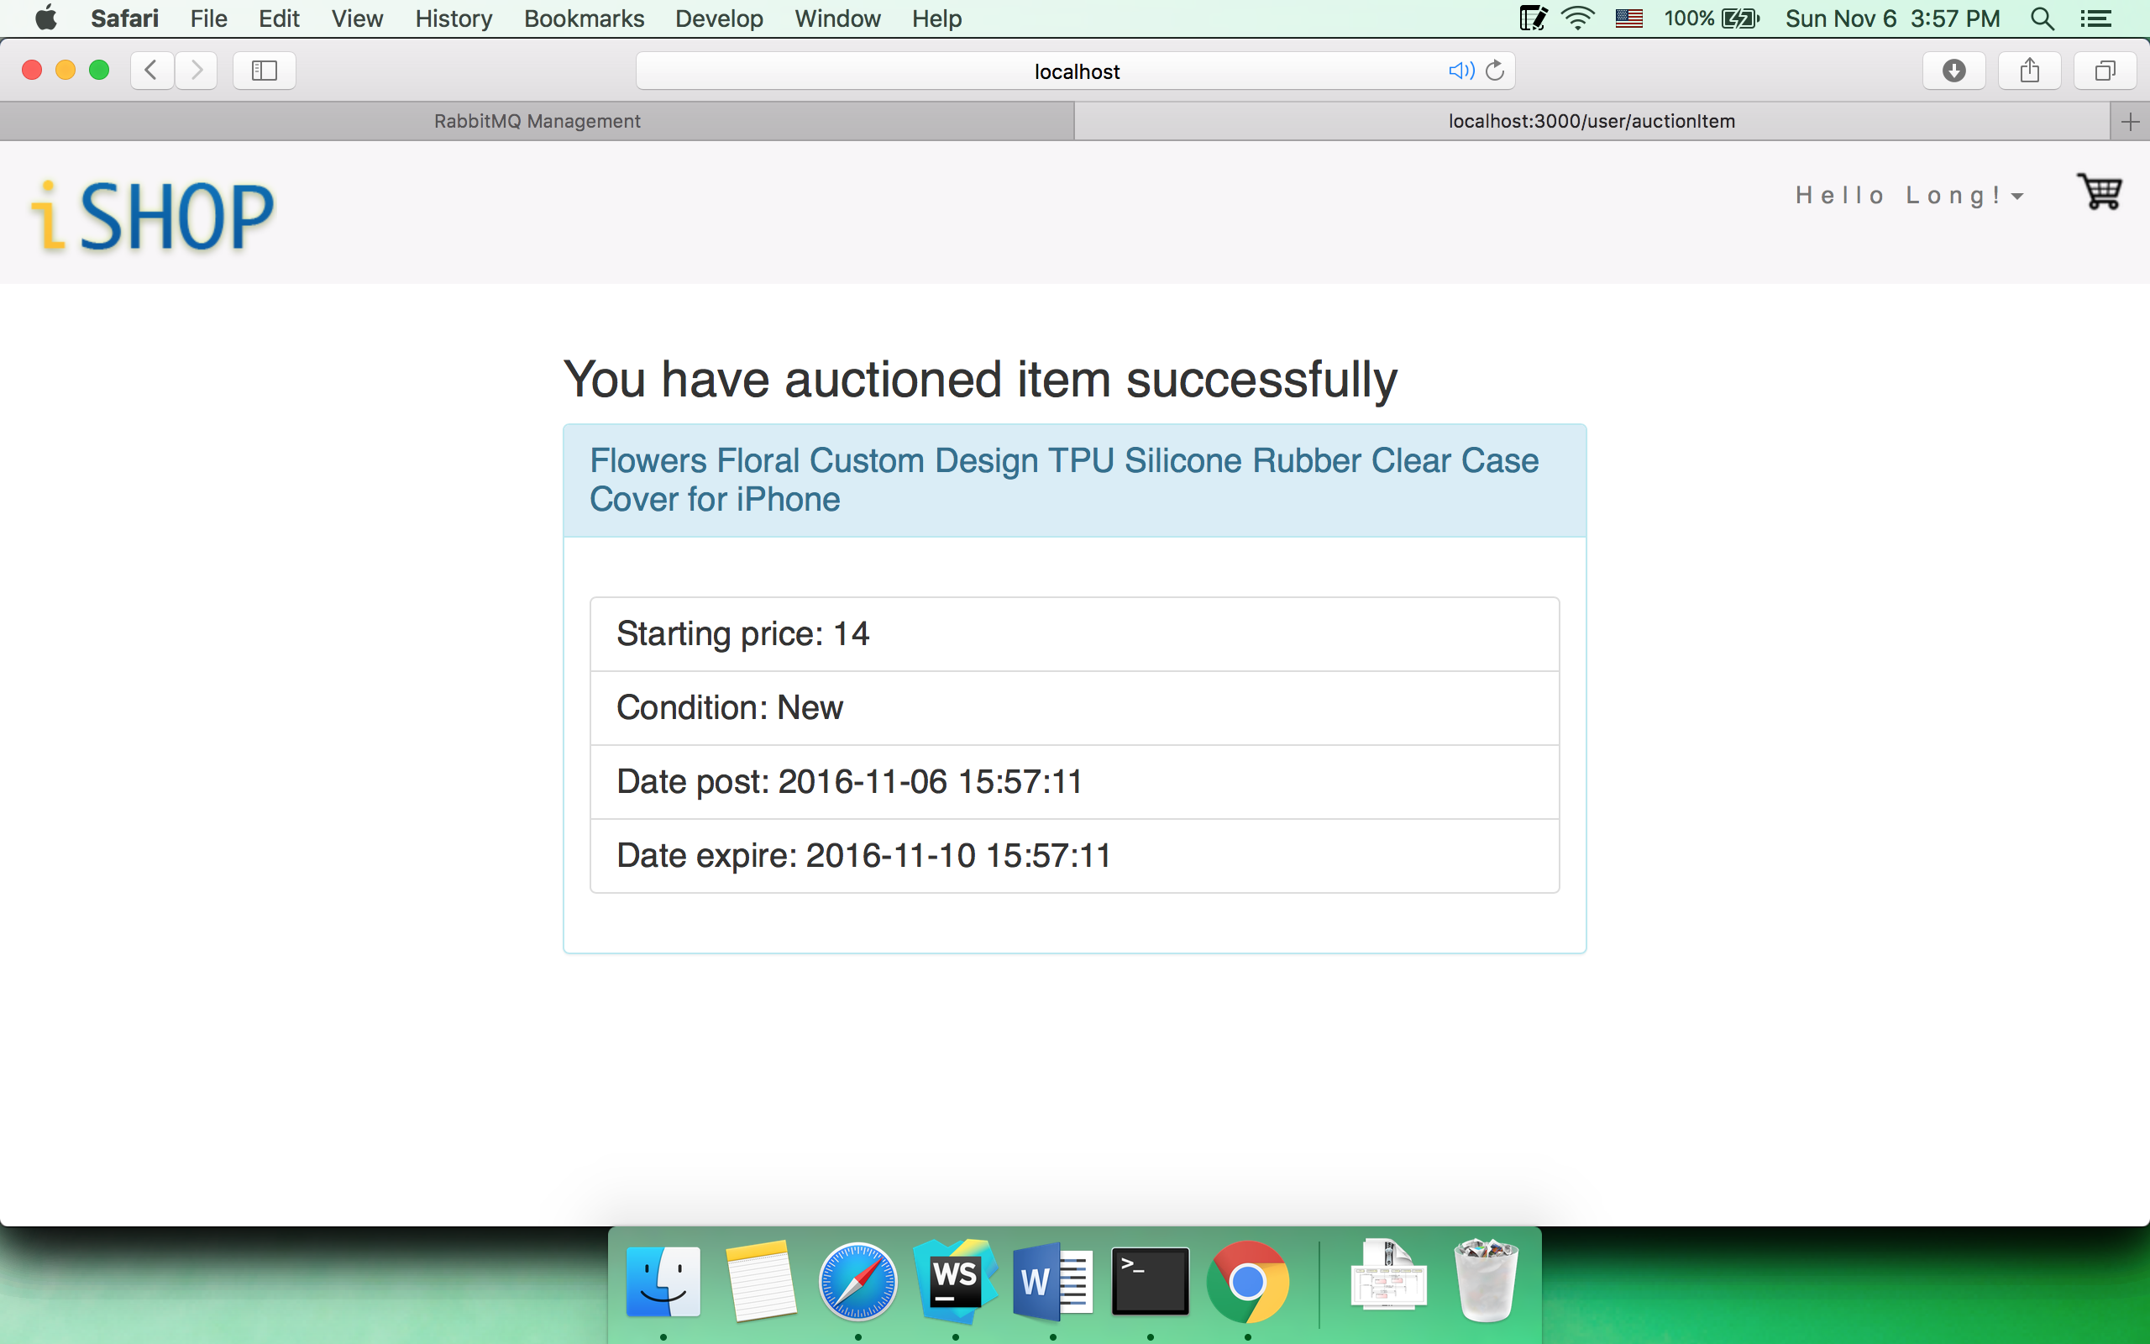

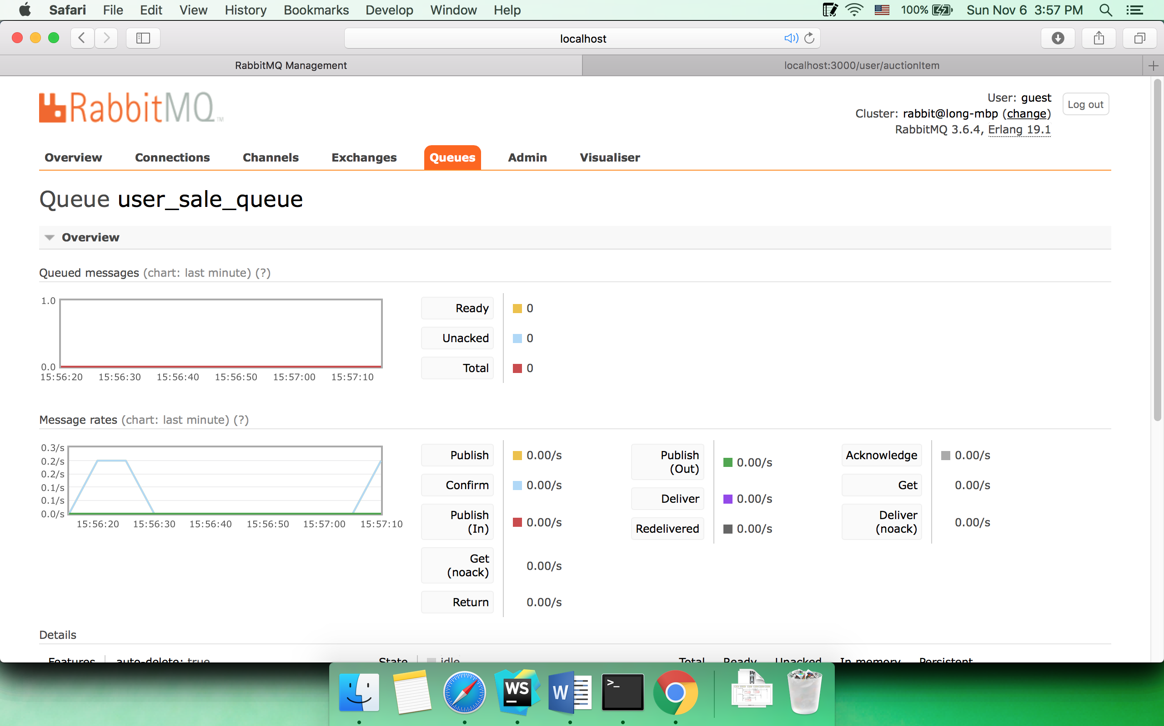

* 1. Current bid

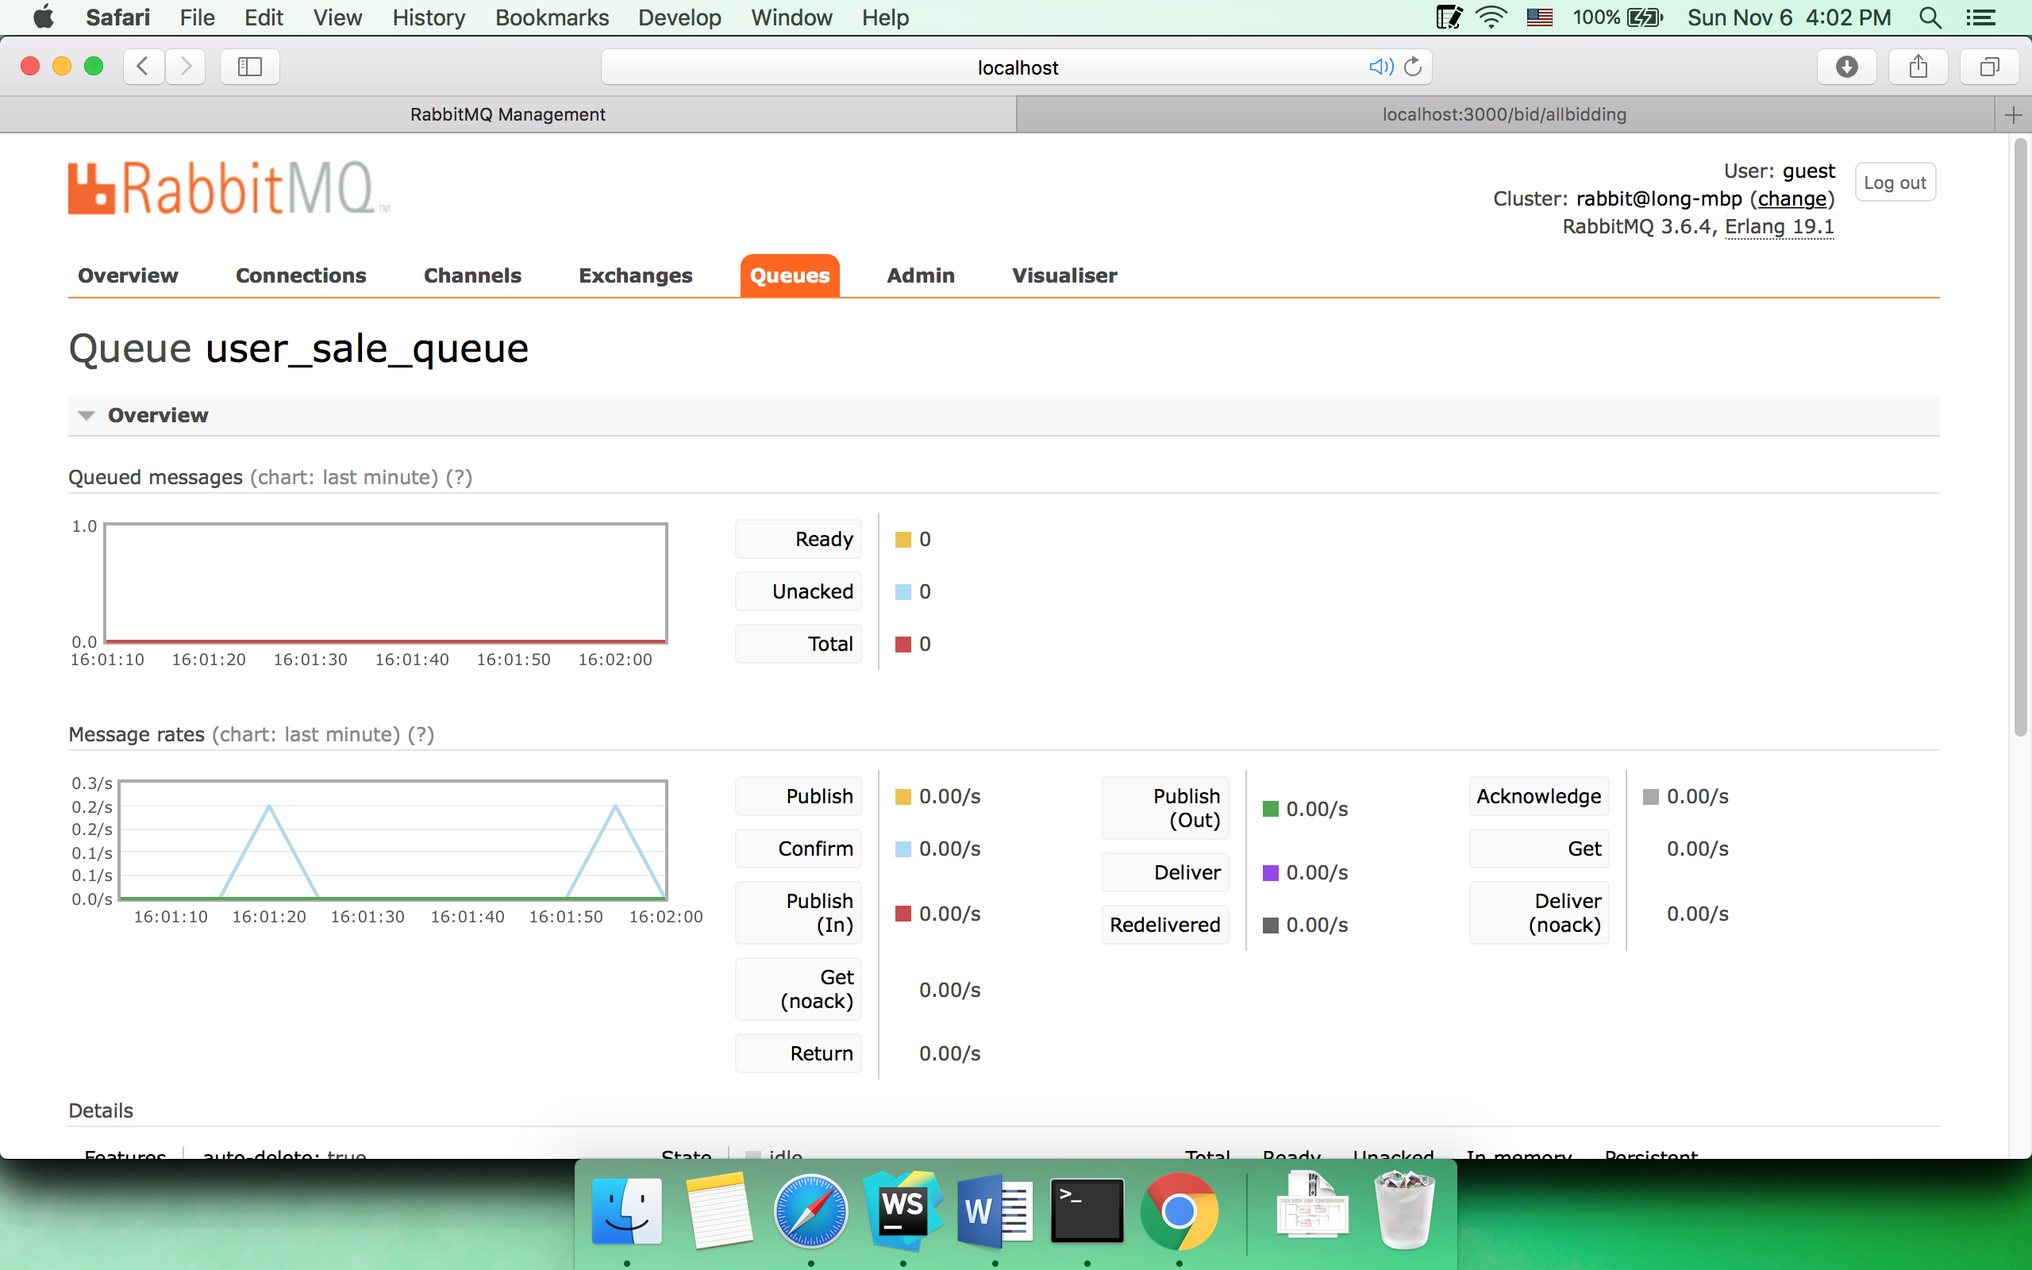

1. Performance graphs (using JMeter)

* Average processing time without connection pool is much higher than one with connection pool implementation.
* The average time without connection pool increases dramatically when the number of concurrent users increases while it almost stays the same with connection pool.

1. Part 2 Question’s answer